miR-EdiTar: A database of predicted A-to-I edited miRNA target sites

Alessandro Laganà,^{1,5} Alessio Paone,¹ Dario Veneziano,^{1,2} Luciano Cascione,^{1,2} Pierluigi Gasparini,¹ Stefania Carasi,¹ Francesco Russo,² Giovanni Nigita,³ Valentina Macca,³ Rosalba Giugno,² Alfredo Pulvirenti,² Dennis Shasha,⁴ Alfredo Ferro² and Carlo M. Croce^{1,5}

¹Department of Molecular Virology, Immunology and Medical Genetics, Comprehensive Cancer Center, The Ohio State University, Columbus OH, USA
²Department of Clinical and Molecular Biomedicine, University of Catania, Italy
³Department of Mathematics and Computer Science, University of Catania, Italy
⁴Courant Institute of Mathematical Sciences, New York University, New York NY, USA

⁵Corresponding authors. E-mail: alessandro.lagana@osumc.edu, carlo.croce@osumc.edu

ABSTRACT

A-to-I RNA editing is an important epigenetic mechanism which consists of the conversion of specific adenosines into inosines in RNA molecules. It is a physiological process that contributes to the diversity of the transcriptome. Its dysregulation [are you sure this is better than misregulation?] has been associated to several human diseases including cancer. Recent work has demonstrated a role for A-to-I editing in microRNA (miRNA) mediated gene expression regulation. In fact, edited forms of mature miRNAs can target sets of genes that differ from the targets of their unedited forms. The specific deamination of mRNAs can generate novel binding sites in addition to potentially alter existing ones. This work presents miR-EdiTar, a database of predicted A-to-I edited miRNA binding sites. The database contains both existing predicted miRNA binding sites potentially affected by A-to-I editing and novel predicted sites that could be created by editing. We present an experimental example of a miRNA binding site created by editing events. The goal of miR-EdiTar is to facilitate the identification of existing miRNA binding sites potentially affected by A-to-I editing as a function of the number of base pair matchings, the degree of accessibility of the binding site and the stability of the interaction, and to aid the discovery of new potential miRNA binding sites that might be created by editing events.
[Site availability: http://microrna.osumc.edu/mireditar.]

INTRODUCTION
Non-coding RNAs have been recently proven to be key molecules in several cellular processes through the regulation of gene expression. microRNAs (miRNAs) are a class of small endogenous post-transcriptional regulators able to reduce the expression of specific target mRNA transcripts. They bind their target molecules, for the most part, by partial complementarity, resulting in the target translational inhibition and/or degradation (Bartel, 2009).
Their crucial role in a variety of physiological processes has been widely demonstrated, as well as their involvement in many diseases including cancer (Croce 2009; Esteller 2011; Lovat et al. 2011). In fact, their misexpression [is this the same as dysregulation], sometimes due to mutations and/or epigenetic events, has been linked to altered cell behavior and the establishment and maintenance of malignant phenotypes (Croce 2009; Laganà et al. 2010; Sato et al. 2011).
A-to-I editing is an essential post-transcriptional mechanism common to all eukaryotes. This form of editing is catalyzed by enzymes of the adenosine deaminase acting on [you need either “the” or “an” here] RNA (ADAR) family and results in the conversion of single adenosines into inosines which are recognized as guanosines by various cellular machineries (Bass 2002). This can affect splicing and alter coding and non-coding sequences in RNA molecules, thus contributing to the diversity of the transcriptome (Rueter et al 1999; Yang et al. 2008). For example, the editing of the glutamate receptor subunit, GluR-B, leads to the generation of an impermeable Ca⁺²-ion channel due to a glutamine/arginine (Q/R) substitution (Sommer et al. 1991).
A-to-I editing can also influence miRNA-mediated gene regulation (Nishikura 2010). Several cases of A-to-I editing of miRNA precursors have been reported (Kawahara 2007; Alon 2012). This phenomenon can suppress processing by Drosha and Dicer and the presence of inosines in the mature sequences can alter the recognition of their target sites (Yang et al. 2006). For example, a seed-edited version of miR-376 in mouse was proved to target a different set of genes than its unedited form (Kawahara 2007).
A-to-I editing is most abundant in the 3' UTR regions of the human transcriptome (Ohman 2007). This can affect existing miRNA binding sites as well as generate novel binding sites (Liang and Landweber 2007). For example, it has been demonstrated that editing events occurring in the 3' UTR of the gene DFFA create a binding site for miR-769-3p. The edited miRNA, which doesn't normally control DFFA, is able to regulate the expression of the deaminated form of the gene (Borchert et al. 2009).
Alterations [is this the same as dysregulation?] of A-to-I editing have been associated to several human diseases, such as infections, neurological diseases and cancer (Maas et al. 2006; Dominissini et al. 2001; Gallo and Locatelli 2012; ). Recent studies revealed an antiviral effect of ADAR1 on hepatitis C virus through editing of viral RNA (Taylor et al. 2005) and a proviral effect on HIV-1, partly through editing-dependent mechanisms (Phuphuakrat et al. 2008; Doria et al. 2009).
The reduction of editing of GluR-B at the Q/R substitution is linked to sporadic amyotrophic lateral sclerosis (Kawahara et al. 2004) and glioblastoma multiforme (Maas et al. 2001). Reduced editing due to ADAR2 low expression or inactivation was reported in bladder and colorectal cancer (Galeano et al. 2010), while increased editing of miRNAs, like miR-376a and miR-376c, was observed in neuroblastoma (Schulte et al. 2010).
[It’s not bad, but could we say it more simply? See my proposed sentence below.] Given the role of RNA editing in miRNA expression and activity and its evident involvement in diseases, there is a strong need for computational tools linking RNA editing and miRNA mediated regulation. The importance of RNA editing in miRNA expression suggests the need for a database of existing and potential editing sites as well as tools to analyze the probable effects of those sites.
This work presents miR-EdiTar, a database of both existing predicted miRNA binding sites potentially affected by A-to-I editing as well as predicted novel binding sites that the editing may generate. In this paper we describe the database and then provide a sample validation of a novel miRNA binding site created by editing events. Finally, we suggest some plausible scenarios of the involvement of editing in miRNA activity.

RESULTS
Prediction of A-to-I edited miRNA binding sites and overall descriptive statistics
We collected 1139 human 3' UTR sequences with 10.571 total A-to-I editing sites from the DARNED database (Kiran and Baranov 2010) and used the computational method miRiam to predict miRNA-target interactions that involve the edited sites (Laganà et al. 2010). miRiam makes use of empirical binding rules and thermodynamics features, such as the structural accessibility of the target site and the energy of the miRNA/target duplex. We performed the predictions on the complete set of 1922 human miRNA sequences retrieved from miRBase Release 18 (Kozomara and Griffiths-Jones 2011). The duplexes were then classified into two categories, depending on whether the edited adenosines were located on a miRNA seed binding region or not. In the first case, the editing of the seed binding region could have a direct effect on the target site recognition and binding, while editing events outside the seed region could alter the secondary structure and, consequently, affect the structural accessibility of the target site and/or the free energy of the duplex, as previously described for SNPs (Shen et al. 1999; Haas et al. 2012).
Seed matches were classified as 6mer, 7mer-A1, 7mer-m8 and 8mer, according to Bartel (2009).
9.532 out of 10.571 (90%) edited adenosines were predicted to fall in at least one miRNA binding site. 1102 UTRs (96.75%) had at least one edited adenosine on a miRNA seed binding site, while 771 (67.7 %) had all their edited adenosines on at least one miRNA seed binding site. On the miRNA side, 1664 miRNAs (86.6 %) had at least one seed binding site potentially affected by editing.
We also wanted to find all the novel miRNA binding sites potentially generated by A-to-I editing. We changed all the edited adenosines in guanosines in the set of the 1139 human 3' UTR sequences and repeated the analysis with miRiam.
1076 UTR sequences (94.45%) had at least one novel binding site created by editing events and 1400 miRNAs (72.8%) had at least one target site potentially created by editing.
The descriptive statistics are summarized in Table 1.

miR-EdiTar contents and web interface
miR-EdiTar contains a collection of predicted human miRNA binding sites on A-to-I edited 3' UTR sequences. In particular, the database includes both existing miRNA sites potentially affected by editing as well as novel miRNA sites potentially created by editing. The website can be searched by miRNA and/or by target. The screenshots of a typical search are shown in Fig. 1.
Given a miRNA, the list of its predicted targets is shown in a box. When a target is selected, the corresponding interaction details are displayed on a table. The binding sites are grouped into two categories based on their type (affected existing sites or newly created sites). Several data elements are provided, such as the position of the binding site on the UTR, the seed type, the free energy of the duplex, the structural accessibility degree, the interaction score and the duplex structure. The edited bases are highlighted in bold characters and the corresponding alignment pipes are replaced with an X, indicating the potential disruption of the corresponding bond. In the case of affected existing sites, an entry indicates if the edited bases are located in the seed region. Moreover, the values of seed type, free energy, accessibility, interaction score and duplex structure are provided for both the edited and the unedited forms of the site (See Fig. 1).
Similar results can be obtained by choosing a target from the list and then selecting one of its predicted miRNAs.
Check boxes can be used to filter the results visualized. In particular, users can choose to filter the interactions based on the type of predicted site (affected or created), the fact that the seed region is edited or not and the type of seed match (6mer, 7mer-A1, 7mer-m8 and 8mer).
When filters are set or changed, the results on the page are dynamically updated.
Finally, miR-EdiTar is connected to miRo', a web environment which provides users with miRNA functional annotations inferred through their validated and predicted targets (Laganà et al. 2009). In particular, miRNA and target entries include links to the diseases, processes and functions in which the corresponding miRNA or target is involved.

Analysis of A-to-I edited miRNA binding sites
In order to evaluate the biological significance of the editing events on miRNA binding sites we performed a variety of permutation tests (Efron and Tibshirani 1993). Starting with the 10,571 editing positions of the 873,332 adenosines in the 1139 UTR sequences, we counted the number of miRNA binding sites and found 9532. Randomly and without replacement, we placed 10,571 edits among the 837,332 adenosines and found an average of 9122. This difference, while small in magnitude, was statistically significant (P < 0.001). This is consistent with a recent work on A-to-I editing of miRNA binding sites in mouse (Gu et al. 2012).
We grouped the targets based on the number of editing sites and compared the distribution of frequencies to the empirical background. We found that the observed number of genes with 1 to 5 or more than 30 edited sites is greater than expected in the random replacement test, while it is less in the other cases (P < 0.05) (see Fig. 2a). We do not yet have an interpretation of this result.
We also wanted to investigate whether editing affects the miRNA seed binding region differently from the non-seed portion of the binding site. We traced a profile of editing events on the binding sites for both the observed and random instances and normalized by the total number of adenosines occurring in each position. The results do not show any significant difference in editing between the seed and the rest of the binding site (Fig. 2a), though there is a noticeable dip at around position xx.
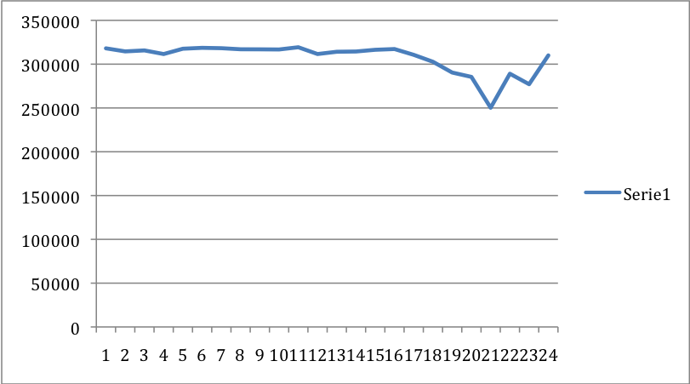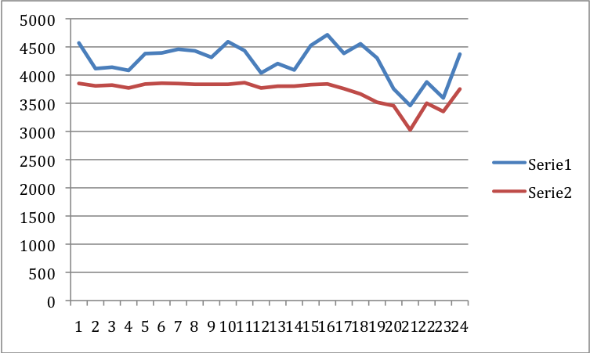
FOR DENNIS: The diagram on the left shows the distribution of the total adenosines in the miRNA binding sites. The diagram on the right shows the distributions of edited adenosines in the observed (blue) and random (red) instances. The random distribution fits perfectly the distribution of the total adenosines. The seed binding region is 18-23. There are less adenosines in the seed regions than in the other parts of the binding sites. Below is the diagram of the normalized distributions (Blue is observed, Red is random). The peak in the seed area disappears once we normalize. [Alessandro, in looking at this, one is struck by the dip at around 20. Could it be that evolution has decided that certain positions should not be vulnerable to this kind of editing?]
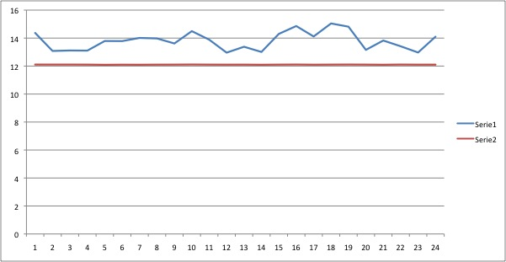

We also counted the number of times that each position on a miRNA seed binding site is edited. We considered only the "6mer core" of the seed, that is the 6 nucleotides from position 2 to 7 of the miRNA, which is the minimal seed type responsible for target recognition (Bartel 2009). The results show that the values are significantly higher than in the random replacement test (P < 0.001) (See fig. 2b). [If we’re going to include this last experiment we have to explain what was replaced. Also we should give an interpretation]

A-to-I editing can generate a novel binding site for miR-500a-3p on MDM4
As a proof of principle we validated one of the predicted novel binding sites. We chose the gene MDM4, an important negative regulator of the tumor suppressor p53 (Markey 2011). The 3' UTR of MDM4 presented a cluster of 4 edited adenosines generating a novel binding site for miR-500a-3p. A fragment of the Wild Type (WT) 3' UTR of MDM4 gene containing the predicted binding site was cloned downstream of the luciferase gene on a reporter construct. A mutant version of the plasmid (MUT) mimicking the editing events was generated by replacing the adenosines reported to be edited into guanosines (Fig. 3a, b).
We transfected H460 cells (large cell lung carcinoma) with the luciferase reporter construct along with a precursor of miR-500a-3p or a scramble miRNA as negative control. We didn't observe any significant difference in the luciferase activity between the cells transfected with the WT plasmid together with either the scramble miRNA or miR-500a-3p precursor. On the contrary, a 32% reduction in the luciferase activity (P<0.01) was observed in cells transfected with MUT and the miR-500a-3p precursor compared to cells transfected with MUT and the scramble miRNA (Fig. 3b).
This data clearly confirms that the editing process can produce new binding sites for miRNAs on specific regions of the 3'UTR of a gene.

DISCUSSION
The modifications of existing miRNA binding sites are classified into two categories, based on whether the editing events occur in the seed region or in another part of the duplex. The replacement of adenosines with inosines in the seed region can change A-U matches into G-U wobbles which are sometimes tolerated, especially in the presence of compensatory matches elsewhere in the duplex, but which have been reported to weaken the interaction or even abrogate the binding (Brennecke et al. 2005).
For instance, a predicted site for miR-511 on the 3' UTR of the gene CTSS contains 6 edited bases, 4 of which are in the seed binding region (Fig. 4a). This would introduce 4 GU wobbles in the seed region and destabilize the duplex, as shown in the figure. Another example is shown in Fig. 4b, where a binding site for miR-26a-5p on RAD1 is altered by 3 inosines, potentially disrupting the seed match.
Editing events which occur outside of the seed binding region could also influence the targeting. They might either reduce the stability of the duplex, through the introduction of G-U wobbles and mismatches, or increase it by improving the seed match or by creating new matches outside the seed area. For example, the presence of an edited adenosine in a predicted binding site outside the seed region for miR-192-5p on XPNPEP can negatively affect [Alessandro: when you say “can negatively affect” do you mean this is a possibility or it is a fact? If a fact, then please say “negatively affects”] the stability of the duplex by altering its structure (Fig. 4c). On the other hand, an edited adenosine in a potential binding site for miR-324-5p on the UTR of MRI1 can improve [Alessandro, same comment] the seed match by adding an extra CG bond and changing the type from 7mer-A1 to 8mer (Fig. 4d). The same outcome occurs on a binding site on ARSD for miR-1227, where editing could change a 6mer seed match to a 7mer-m8 seed match (Fig. 4e).
The presence of inosines in miRNA binding sites could also alter their secondary structure and, as a consequence, increase or reduce the chance of binding. It has been demonstrated that SNPs can significantly change mRNA secondary structure (Shen et al. 1999; Halvorsen et al. 2010) and that changes in secondary structure can significantly affect the binding of miRNAs (Kertesz et al. 2007; Haas et al. 2012). Therefore, it is plausible that editing events may yield similar effects. As found in our database, editing of 7 adenosines in the binding site for miR-590-3p in the 3' UTR of the gene ARHGAP26 has no effect on the seed match but causes a 40% decrease of the estimated structural accessibility (Fig. 5a). Conversely, an edited adenosine in a non-seed area of the binding site for miR-486-5p on the 3' UTR of PLCXD1 increases the accessibility 2.6 times (Fig. 5b).
Other than affecting existing miRNA binding sites, A-to-I editing can generate novel miRNA/target interactions by either changing mature miRNA sequences or creating new sites on UTRs, as already reported by a few studies. An edited version of mature miR-376 specifically targets a different set of genes compared to its unedited version (Kawahara et al. 2007). miR-513 and miR-769-3p have repression activity on reporters mimicking the effect of A-to-I editing, and experiments have confirmed that miR-769-3p is able to repress endogenous DFFA protein expression in cells where editing creates a novel binding site for the miRNA in the DFFA 3' UTR (Borchert et al. 2009). As shown in our example, deamination of the 3' UTR of the gene MDM4 could generate a novel binding site for miR-500a-3p.
Although all these hypotheses and preliminary experiments require further deep investigation, they suggest a new layer of dynamic regulation in miRNA-mediated gene expression control. A-to-I editing is a physiologically important mechanism which is essential for normal life and development, and the specific deamination of miRNAs and their target sites could constitute an epigenetic fine-tuning of their regulatory activity.
The database presented in this paper, miR-EdiTar, constitutes a resource for researchers interested in investigating the involvement of A-to-I editing in miRNA-mediated gene expression regulation. We plan to update the database with new editing sites and new predictions as soon as new data is available, as well as consider other types of RNA editing, like C-to-U editing. We also plan to include data about the editing of miRNA sequences along with their affected and newly created predicted targets, in addition to data on tissue specificity of both miRNAs and editing events.

METHODS

Data sources
The complete list of human A-to-I editing sites was obtained from the DARNED database (Kiran and Baranov 2010) and mapped onto the human 3' UTR sequences downloaded from UCSC Genome Browser (Dreszer et al. 2012), with a total of 10.571 edited bases mapped on 1139 UTR sequences.
Human miRNAs were downloaded from miRBase Release 18 (Kozomara and Griffiths-Jones 2011).

miRNA target prediction
miRNA binding sites on the 3' UTR sequences were predicted by miRiam, our computational tool that makes use of empirical binding rules and thermodynamics features (Laganà et al. 2010). miRiam exploits binding rules inferred based on experimentally validated miRNA/target pairs and the structural accessibility of the target sites. This last feature is estimated based on the local pairing probability computed by RNAplfold of the Vienna RNA package (Bernhart et al. 2006) with the parameters W=80 (sliding window length), L=40 (interactions outside the span size of 40 are not allowed) and u=4 (the stretch of consecutive bases for which the probability of being unpaired is computed), as recommended in (Marí́n and Vaníček 2011). In particular, the accessibility is computed as the average probability of stretches of 4 nucleotides to be unpaired in the predicted binding site.
The score of the duplex structure and its free energy are also computed. In particular, the latter is computed by using the tool RNAduplex from the Vienna RNA package (Lorenz et al 2011). For each affected existing binding site the accessibility, the duplex structure and the free energy are computed for both the unedited and the edited version of the duplex, in order to evaluate the effects of the editing events on the binding.

Database implementation and web interface
All the data are collected and maintained up-to-date in a MySQL database (v5.1) running on an Apache server (v2.2.15). The web application was implemented in Ruby on Rails (v2.3.5), a framework based on the MVC (Model-View-Controller) design pattern, allowing a fast development and management of the application. The queries that the database allows to perform were coded leveraging on the association mechanisms between models that the framework provides. The interface makes use of the Ajax technology to improve the usability through a fast client-side update of selections and results.

Cloning of the 3' UTR of MDM4
The WT plasmid of the MDM4 3'UTR was produced as described in the results section. The region of the 3'UTR sequence (base 6657 to base 7017, counting from the beginning of 3’ UTR) was amplified from human genomic DNA (Clontech Laboratories Inc., CA) through PCR using the TaKaRa Ex Taq™ DNA Polymerase (Clontech Laboratories Inc., CA) following the manufacturer's instructions, using the following primers:
FRW-XhoI-agctttgtttaaacggcgcgccggtgaggcttcctttctgtgtg
REV-NotI- ataagaaatgcggccgctaaactatagaaggaagcctgacctcaa
The PCR fragment was cloned downstream of the luciferase gene in the psiCHECK™-2 plasmid (Promega, WI) using respectively XhoI and NotI restriction enzimes (New England Biolabs, MA) following the manufacturer's instructions. The ligation reaction was performed using Rapid DNA Ligation Kit (Roche Diagnostics Corporation, IN) following the manufacturer's instructions.

Mutagenesis
The MUT plasmid was produced using QuikChange XL Site-Directed Mutagenesis Kit (Agilent Technologies, Inc., CA) using the following primers:
MDM4-a183g_FRW 5'-ctgggcaacatggtgaagccctgtctctacca-3'
MDM4-a183g_REV 5'-tggtagagacagggcttcaccatgttgcccag-3'
MDM4-a199-200-01-03g-FRW5'-atggtgaaaccctgtctctaccaagggtgcaaaaaaaaagctgggcatggtgg-3'
MDM4-a199-200-01-03g-REV 5'-ccaccatgcccagctttttttttgcacccttggtagagacagggtttcaccat-3'

Transfection
H460 cells (large cell lung carcinoma) were seeded in 12 well plates and co-transfected with 1 μg of WT or MUT plasmid in combination with 50nM of hsa-miR-500a-3p or negative control miRNA from Ambion (Life Technologies, NY) and 3 μl of Lipofectamine 2000 from Invitrogen (Life Technologies, NY) for each well, following the manufacturer's instructions. After 24 hours the cells were harvested and the luciferase activity measured using the Dual Luciferase Reporter Kit (Promega) following the manifacturer's instructions.

ACKNOWLEDGMENTS
Valentina Macca has been supported by a fellowship sponsored by ”Associazione Sclerosi Tuberosa”, A.S.T.

FIGURE LEGENDS
Figure 1. Screenshot of a typical search in miR-EdiTar. The search for miR-511 returns a list of its existing predicted targets potentially affected by A-to-I editing and novel predicted sites that could be created by editing. Chosen a target, CTSS for example, the targeting details are displayed on a table. In the case of an existing predicted target that could be affected by editing, both the un-edited and the edited version of the binding site are given, together with relevant information such as the type of seed, the energy of the duplex, the degree of structural accessibility of the target site and the duplex score. Filters allow the refinement of the results according to the specified seed type, seed editing and site type.

Figure 2. Analysis of A-to-I edited miRNA binding sites. (a) The diagram shows the real distribution of edited sites per gene as compared to the empirical distribution obtained through a random replacement test. The observed number of genes with 1 to 5 or more than 30 edited sites is significantly higher than expected in the random replacement test, while it is lower in the other cases (P < 0.05). (b) The diagram shows the distribution of observed editing events over the individual positions in the seed region of a miRNA binding site as compared to the empirical distribution obtained through a random replacement test. The observed values are significantly higher than in the random replacement test in every position (P < 0.001).

Figure 3. Experimental validation of a novel predicted site for miR-500a-3p created by editing in the 3' UTR of MDM4. (a) A 24 nt long fragment of the 3' UTR sequence of MDM4 with 5 edited adenosines and the corresponding mutated version mimicking the editing events. (b) The predicted duplex of the miRNA/target interaction created by the editing events. (c) Renilla luciferase activity following co-transfection of a negative control miRNA (SCR) and miR-500a-3p along with the non-edited luciferase reporter construct (WT) and its mutated version (MUT) into H460 cells. A 32% reduction in the luciferase activity (P < 0.01) is observed in the cells transfected with MUT and the miR-500a-3p precursor compared to the cells transfected with MUT and the negative control miRNA. No effect is observed in the cells transfected with miR-500a-3p/SCR and WT.

Figure 4. Examples of predicted miRNA binding sites potentially affected by A-to-I editing. Predicted binding sites for (a) miR-511 in the 3' UTR of CTSS, and (b) miR-26a-5p on RAD1 altered by editing events, potentially disrupting the seed match. (c) The presence of an edited adenosine in a predicted site for miR-192-5p in the 3' UTR of XPNPEP may negatively affect the stability of the duplex by altering its structure. (d) An edited adenosine in a potential binding site for miR-324-5p on the 3' UTR of MRI1 may improve the seed match by adding an extra CG bond and changing the type from 7mer-A1 to 8mer. (e) An edited adenosine in a potential binding site for miR-1227 on the 3' UTR of ARSD may change a 6mer seed match to a 7mer-m8 seed match.

Figure 5. Examples of variation of structural accessibility of predicted miRNA binding sites affected by A-to-I editing. (a) The estimated structural accessibility of a predicted binding site for miR-590-3p in the 3' UTR of the gene ARHGAP26 decreases by 40% due to editing events. (b) Two edited adenosines in a non-seed area of the binding site for let-7a-3p on the 3' UTR of ZNF529 increase the estimated degree of accessibility 2,15 times. The predicted interactions are shown along with the secondary structures of the un-edited and edited versions of the binding sites. Structural accessibility is computed as the average probability of stretches of 4 nucleotides to be unpaired in the predicted binding sites. Individual probabilities are calculated by the tool RNAplfold on 40 nt windows. Secondary structures of the targets are shown as computed by RNAfold on an 80nt window encompassing the predicted binding site.

FIGURES
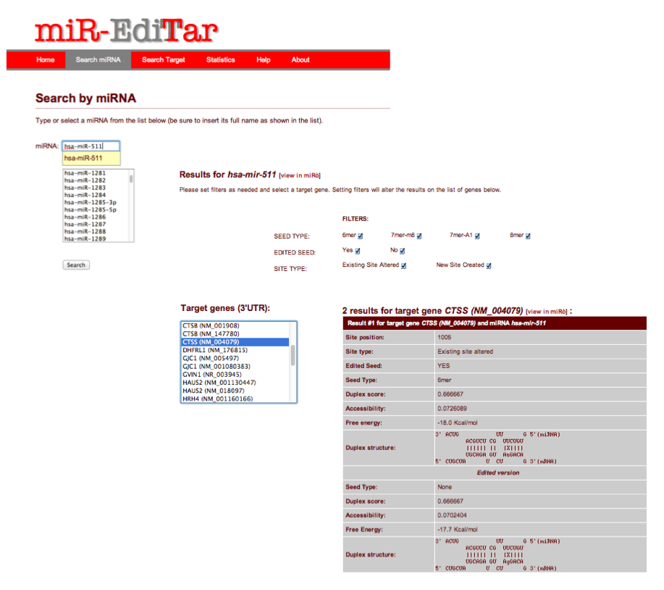
Fig. 1

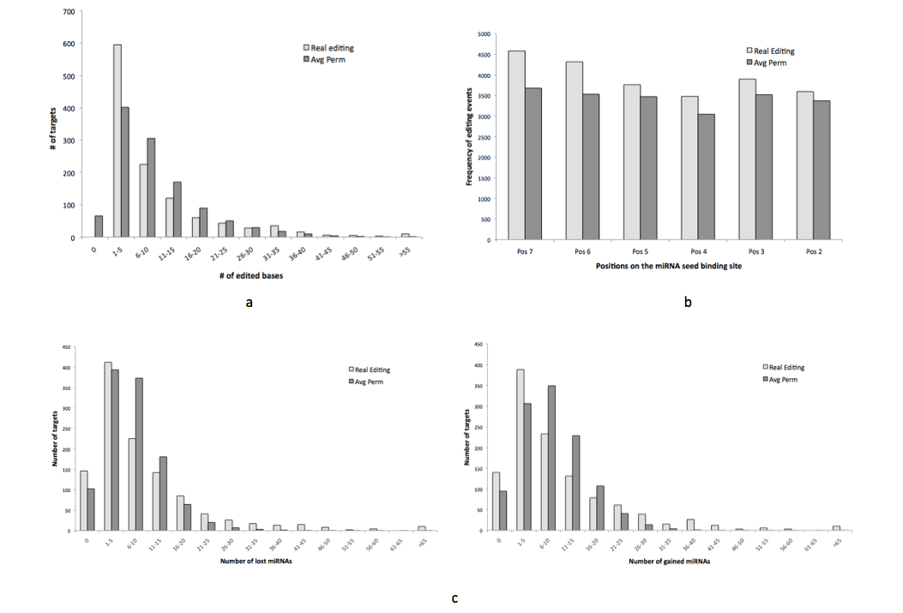
Fig. 2

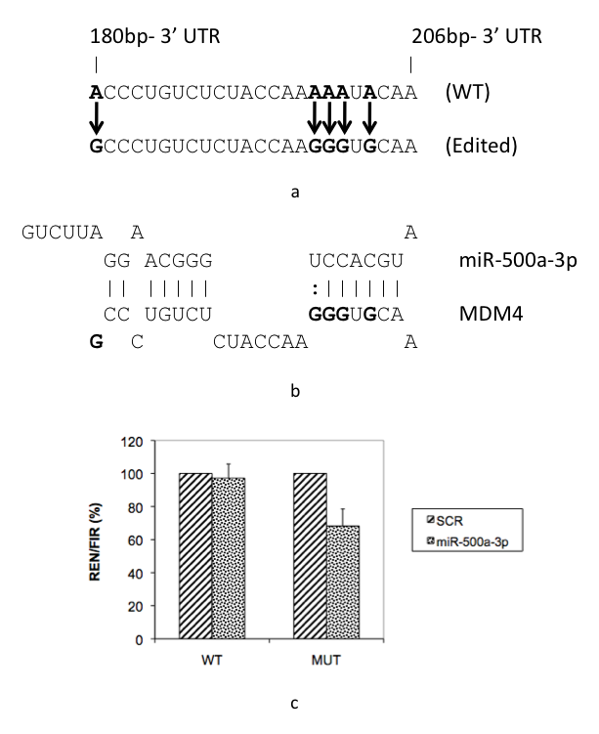
Fig. 3

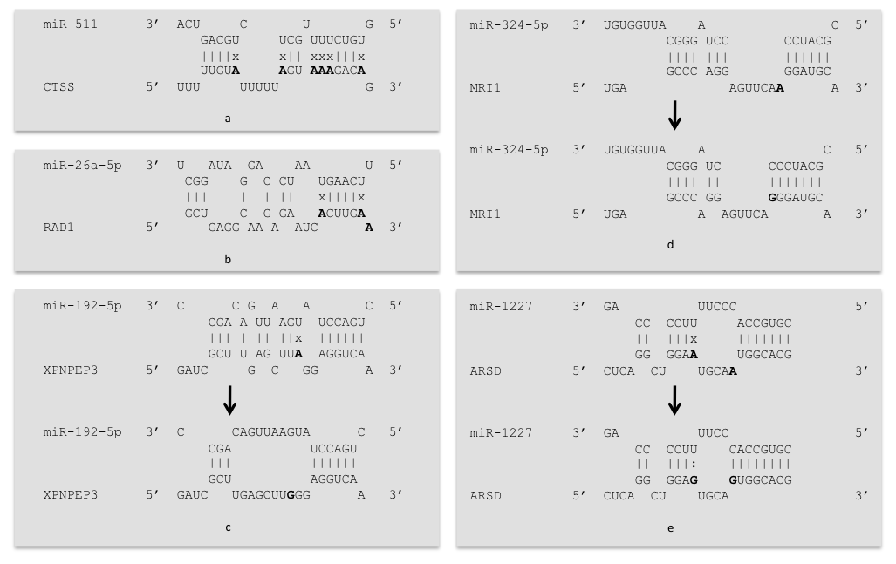
Fig. 4

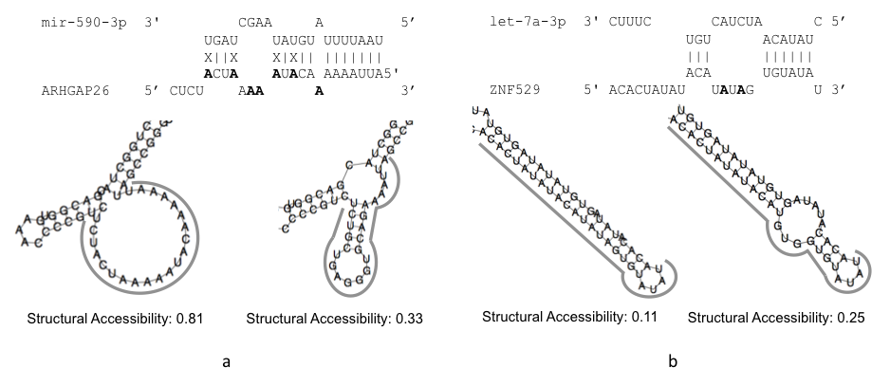
Fig. 5

TABLES
Edited sites
Edited sites on the 3' UTRs | 10571
Edited sites on a predicted miRNA binding site | 9532
Targets
3' UTR sequences affected by editing | 1139
Predicted binding sites affected by editing | 115664
Predicted binding sites with edited bases in the seed region | 40659
Predicted binding sites created by editing | 112980
Targets with at least one edited base in a miRNA binding site | 1102
Targets with all their edited bases in a miRNA binding site | 771
Targets with at least one novel binding site created by editing | 1076
miRNAs
miRNAs | 1922
miRNA with predicted sites affected by editing | 1664
miRNA with predicted novel sites created by editing | 1400

Table 1

REFERENCES
Alon S, Mor E, Vigneault F, Church G, Locatelli F, Galeano F, Gallo A, Shomron N, Eisenberg E. 2012. Systematic identification of edited microRNAs in the human brain. Genome Res doi:10.1101/gr.131573.111.
Bartel DP. 2009. MicroRNAs: target recognition and regulatory functions. Cell 136(2): 215- 233.
Bass BL. 2002. RNA editing by adenosine deaminases that act on RNA. Annu Rev Biochem 71: 817-846.
Bernhart SH, Hofacker IL, Stadler PF. 2006. Local RNA base pairing probabilities in large sequences. Bioinformatics 22(5): 614-615.
Borchert GM, Gilmore BL, Spengler RM, Xing Y, Lanier W, Bhattacharya D, Davidson BL. Adenosine deamination in human transcripts generates novel microRNA binding sites. Hum Mol Genet 18(24): 4801-4807.
Brennecke J, Stark A, Russell RB, Cohen SM. 2005. Principles of microRNA-target recognition. PLoS Biol 3(3): e85. doi:10.1371/journal.pbio.0030085.
Croce CM. 2009. Causes and consequences of microRNA dysregulation in cancer. Nat Rev Genet 10(10): 704-714.
Dominissini D, Moshitch-Moshkovitz S, Amariglio N, Rechavi G. 2011. Adenosine-to-inosine RNA editing meets cancer. Carcinogenesis 32(11): 1569-1577.
Doria M, Neri F, Gallo A, Farace MG, Michienzi A. 2009. Editing of HIV-1 RNA by the double- stranded RNA deaminase ADAR1 stimulates viral infection. Nucleic Acids Res 37(17): 5848-5858.
Dreszer TR, Karolchik D, Zweig AS, Hinrichs AS, Raney BJ, Kuhn RM, Meyer LR, Wong M, Sloan CA, Rosenbloom KR et al. 2011. The UCSC Genome Browser database: extensions and updates 2012. Nucleic Acids Res 40(Database issue): D918-923.
Efron B, Tibshirani, RJ. 1993. An introduction to the bootstrap. Chapman & Hall, New York.
Esteller M. 2011. Non-coding RNAs in human disease. Nat Rev Genet 12: 861-874.
Galeano F, Leroy A, Rossetti C, Gromova I, Gautier P, Keegan LP, Massimi L, Di Rocco C, O’Connell MA, Gallo A. 2010. Human BLCAP transcript: new editing events in normal and cancerous tissues. Int J Cancer 127(1): 127-137.
Gallo A, Locatelli F. 2012. ADARs: allies or enemies? The importance of A-to-I RNA editing in human disease: from cancer to HIV-1. Biol Rev 87: 95-110.
Gu T, Buaas FW, Simons AK, Ackert-Bicknell CL, Braun RE, Hibbs MA. 2012. Canonical A-to-I and C-to-U RNA Editing Is Enriched at 3'UTRs and microRNA Target Sites in Multiple Mouse Tissues. PLoS ONE 7(3): e33720. doi:10.1371/journal.pone.0033720.
Haas U, Sczakiel G, Laufer SD. 2012. MicroRNA-mediated regulation of gene expression is affected by disease-associated SNPs within the 3'-UTR via altered RNA structure. RNA Biology 9:6.
Halvorsen M, Martin JS, Broadaway S, Laederach A. 2010. Disease-associated mutations that alter the RNA structural ensemble. PLoS Genet 6(8): e1001074. doi: 10.1371/journal.pgen.1001074.
Kawahara Y, Ito K, Sun H, Aizawa H, Kanazawa I, Kwak S. 2004. Glutamate receptors: RNA editing and death of motor neurons. Nature 427(6977): 801.
Kawahara Y, Zinshteyn B, Sethupathy P, Iizasa H, Hatzigeorgiou AG, Nishikura K. 2007. Redirection of Silencing Targets by Adenosine-to-Inosine Editing of miRNAs. Science 315(5815): 1137-1140.
Kertesz M, Iovino N, Unnerstall U, Gaul U, Segal E. 2007. The role of site accessibility in microRNA target recognition. Nat Genet 39(10): 1278-1284.
Kiran A, Baranov PV. 2010. DARNED: a DAtabase of RNa EDiting in humans. Bioinformatics 26(14): 1772-1776.
Kozomara A, Griffiths-Jones S. 2011. miRBase: integrating microRNA annotation and deep- sequencing data. Nucleic Acids Res 39(Database issue): D152-157 doi: 10.1093/nar/gkq1027.
Laganà A, Forte S, Giudice A, Arena MR, Puglisi PL, Giugno R, Pulvirenti A, Shasha D, Ferro A. 2009. miRò: a miRNA knowledge base. Database (Oxford) doi: 10.1093/database/bap008.
Laganà A, Forte S, Russo F, Giugno R, Pulvirenti A, Ferro A. 2010. Prediction of human targets for viral-encoded microRNAs by thermodynamics and empirical constraints. J RNAi Gene Silencing 6(1): 379-385.
Laganà A, Russo F, Sismeiro C, Giugno R, Pulvirenti A, Ferro A. 2010. Variability in the incidence of miRNAs and genes in fragile sites and the role of repeats and CpG islands in the distribution of genetic material. PLoS One 5(6): e11166. doi:10.1371/journal.pone.0011166.
Liang H, Landweber LF. 2007. Hypothesis: RNA editing of microRNA target sites in humans? RNA 13: 463-467.
Lorenz R, Bernhart SH, Höner Zu Siederdissen C, Tafer H, Flamm C, Stadler PF, Hofacker IL. 2011. ViennaRNA Package 2.0. Algorithms Mol Biol 6: 26.
Lovat F, Valeri N, Croce CM. MicroRNAs in the pathogenesis of cancer. 2011. Semin Oncol 38(6): 724-733.
Maas S, Patt S, Schrey M, Rich A. 2001. Underediting of glutamate receptor GluR-B mRNA in malignant gliomas. Proc Natl Acad Sci U S A 98(25): 14687-14692.
Maas S, Kawahara Y, Tamburro KM, Nishikura K. 2006. A-to-I RNA editing and human disease. RNA Biol 3(1):1-9.
Markey MP. 2011. Regulation of MDM4. Front Biosci 16: 1144-1156.
Marí́n RM, Vaníček J. 2011. Efficient use of accessibility in microRNA target prediction. Nucleic Acids Res 39(1): 19-29.
Nishikura, K. 2010. Functions and regulation of RNA editing by ADAR deaminases. Annu Rev Biochem 79: 321-349.
Ohman M. 2007. A-to-I editing challenger or ally to the microRNA process. Biochimie 89(10):1171-1176.
Phuphuakrat A, Kraiwong R, Boonarkart C, Lauhakirti D, Lee TH, Auewarakul P. 2008. Double- stranded RNA adenosine deaminases enhance expression of human immunodeficiency virus type 1 proteins. J Virol 82(21): 10864-10872.
Rueter SM, Dawson TR, Emerson RB. 1999. Regulation of alternative splicing by RNA editing. Nature 399(6731): 75-80.
Sato F, Tsuchiya S, Meltzer SJ, Shimizu K. 2011. MicroRNAs and epigenetics. FEBS J 278(10): 1598-1609.
Schulte JH, Marschall T, Martin M, Rosenstiel P, Mestdagh P, Schlierf S, Thor T, Vandesompele J, Eggert A, Schreibe S et al. 2010. Deep sequencing reveals differential expression of microRNAs in favorable versus unfavorable neuroblastoma. Nucleic Acids Res 38: 5919–5928.
Shen LX, Basilion JP, Stanton VP Jr. 1999. Single-nucleotide polymorphisms can cause different structural folds of mRNA. Proc Natl Acad Sci USA 96(14): 7871-7876.
Sommer B, Köhler M, Sprengel R, Seeburg PH. 1991. RNA editing in brain controls a determinant of ion flow in glutamate-gated channels. Cell 67(1): 11-19.
Taylor DR, Puig M, Darnell ME, Mihalik K, Feinstone SM. 2005. New antiviral pathway that mediates hepatitis C virus replicon interferon sensitivity through ADAR1. 79(10): 6291-6298.
Yang W, Chendrimada TP, Wang Q, Higuchi M, Seeburg PH, Shiekhattar R, Nishikura K. 2006. Modulation of microRNA processing and expression through RNA editing by ADAR deaminases. Nat Struct Mol Biol 13(1): 13–21.
Yang Y, Lv J, Gui B, Yin H, Wu X, Zhang Y, Jin Y. 2008. A-to-I RNA editing alters less-conserved residues of highly conserved coding regions: implications for dual functions in evolution. RNA 14(8): 1516-1525.

