Notes for 11/22/2010:

Graph Theory:

. Node/ Vertex

______ Edge connecting nodes:
- Directed Edge, with arrow , like one-way road.
- Undirected Edge, without arrow, like two-way road.

Hub: key point, disconnect a hub will make the network disconnected or will remove many possible paths.

Concept 1: Minimum Spanning Tree:

Using when choosing least-cost path only required basic connection.

Algorithm: Result={ }
Until every pair of nodes is connected (i.e. path from one to the other
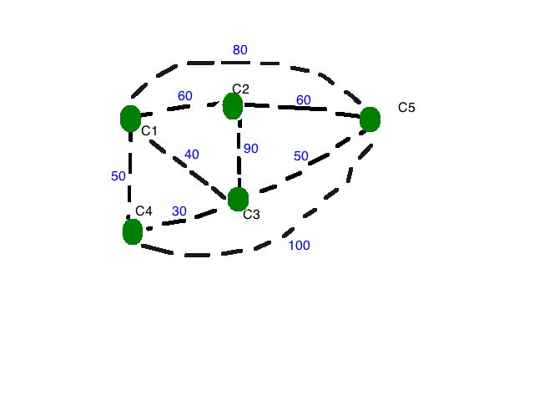
Find the least-cost edge that connects two cities that are not already connected, then add to result.

Example: Try to connect five cities by building road with the least cost.

- C4-C3
- C1-C3
- C3-C5
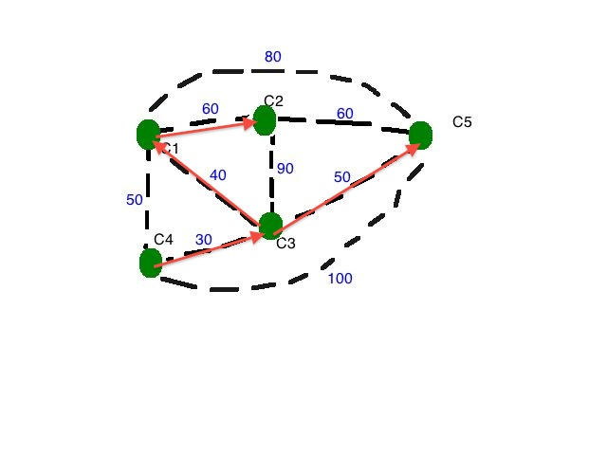
- C1-C2/C2-C5

Concept 2: Shortest Path Problem

Strategy: Ask who’s my closest neighbor from start point

Algorithm: Frontier = { }
Until frontier includes destination.
Add to frontier Node V with cost C, such that V is not already in frontier and C is the cost from start point to V and for any other node V’, the cost from start point to V’ is greater than or equal to C.

Example 1:

What’s the shortest path from C4 to C2?

Solution: {C4,0}{C3,30}{C1,50} {C5,80}{C2,110}

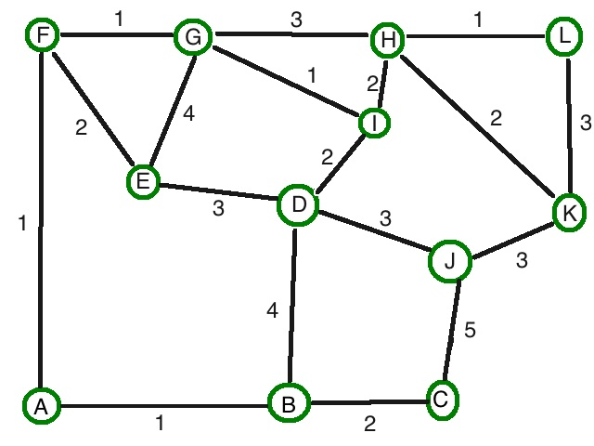

Example 2:

Try to find the shortest path from E to L.

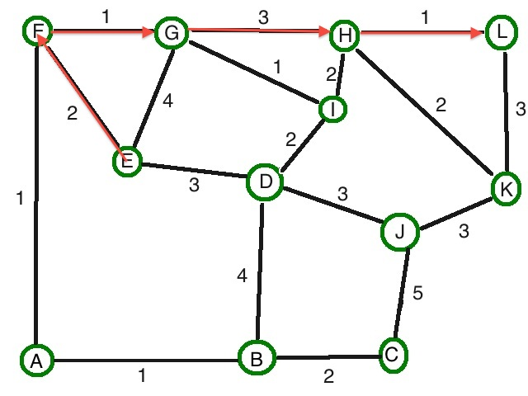
Solution:
{E,0}
{F, 2, (E)} #cost=2, route passes E
{A, 3, (F,E)} / {G, 3, (F,E)} / {D, 3 , (E)}
{B, 4, (A,F,E)} / {I, 4, (G,F,E)}
{H, 6, (G,F,E)/(I,G,F,E)} / {J, 6, (D,E)} /
{C, 6, (B,A,F,E)}
{L, 7, {H,G,F,E)/(H,I,G,F,E)}

Remark: no negative cost.

