USING THE BASIC STAMP

The purpose of this assignment is to get you familiar with the Basic Stamp programming environment and with simple wiring schemes for input and output.

At the workstation you should find everything you need complete the assignment.
- the "board of education" programmer and breadboard, connected via serial cable and powered.
- a box of reandom electronic goodies all of which you are welcome to use or you can bring your own.

The board should be set up to demonstrate simple wiring of a switch for input control and an LED for output.
**You should leave it this way for the next person after you complete your project.

To start:
- open PBASIC editor v2.2.5
- open the program "sample.bsx" (found in BASIC code folder where you should store your code)
- Click on the arrow button (it looks like a "play" button on a VCR. The program should execute on the board, and the LED should light up. If not, the board is wired incorrectly.
- Press and hold the switch, this should make the LED flash.

Your assignment is to make this do something else, you can:
Alter the code,
Change the output,
Change the input,
Add complexity, and
return it to this funcitoning state when you are done so the next person can use it

A very bad wiring diagram for this is:

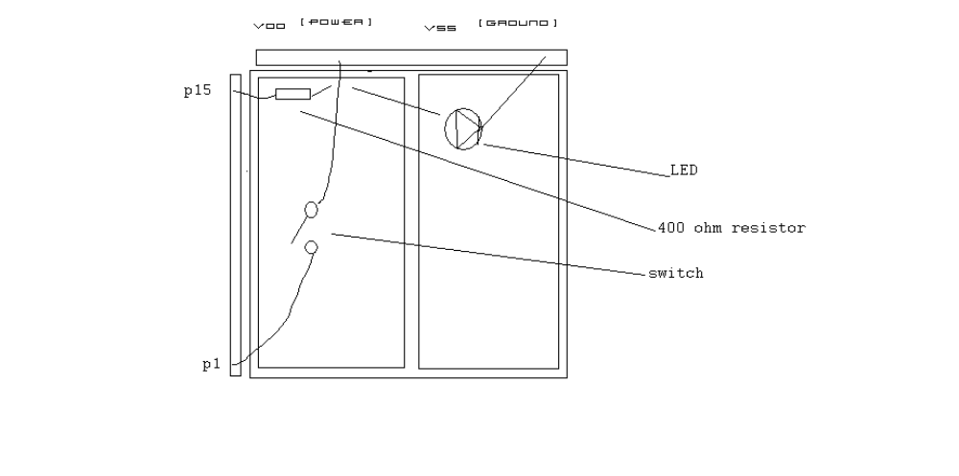
I have included a number of resources, such as web pages on programming in basic and some simple electronics with the Basic Stamp.
Also the HELP menu in the editor has an index of just about every PBASIC command you would want.

If you have any questions email Evan at: evanbarba@gmail.com

