**Puzzle Corner 2017 – Answer**

**Jim Larsen (James L. Larsen ’65)**

**J/A 1 Chess**

The maximum number of legal moves from a reachable position is 324. Those moves can be made from the following position.

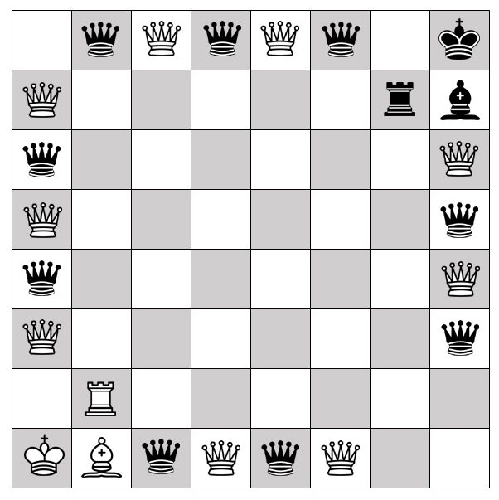

Reaching this position is fairly straightforward. There are many ways to get to the final set of desired pieces, but in general, eight pieces must be sacrificed to doubling up pawns on each of the files. Those pawns can then progress to queening. The four pieces needed for the optimal solution are reserved and the remaining eight pieces are sacrificed to the doubling process. A simple way to do this is to work in file pairs. It is fairly easily get any piece to any necessary position with the exception of bishops which are restricted to a particular color. They can be handled by advancing the attacking pawn an additional square. The only remaining issue is protecting the kings from check. This can be handled fairly easily with simple sequencing of king moves, clear outs, and/or barriers.

To get to the maximal number of moves the pieces with the maximum number of moves are needed. First this requires changing all pawns to queens. Then, the four pieces are selected that work best to complete the solution.

Experimentation shows that the most effective location for most pieces is on the perimeter where they are allowed the maximum run. Pieces away from the perimeter, block and shorten those runs. Keys to the final solution are the pattern of queens along the edges, the White/Black organization to allow for the highest number of capturing moves, and the location of the kings. Kings cannot be in check because if they were, their player’s next move would be severely restricted to only those moves which relieve the check. The most effective locations for the kings are in the corners where they are most easily protected and do not block other runs or force unfavorable White/Black organizations. An early assumption was that the final solution would be symmetrical. This proved to be true with the most effective axis of symmetry being a diagonal. The final choices of the rook and the bishop placements were made to protect the king (bishop) and still allow the most moves for the last four pieces. There are many organizations that provide 322 and 320 moves, but I’ve found only this organization to yield 324.

The following diagram shows the number of moves available to each piece. In each case the top number is the number of moves to free squares and the lower number is the additional number of moves that occur with capturing pieces of the opposite color. These moves are summed for each column at the bottom and the columns are summed for the grand total.

