Sue Wesley

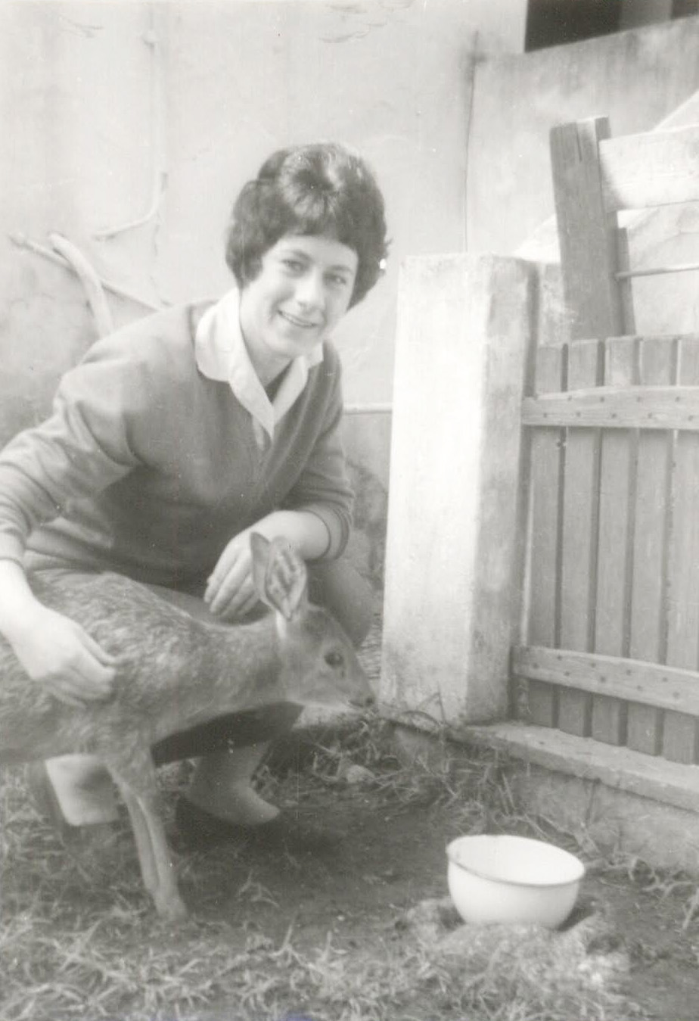

In her Veterinary Years

Some years back, I gave what I thought was an unsuccessful presentation at St. Andrews University in Scotland. Cutting my stay short, I booked flights from Edinburgh to Heathrow, London, and thence to Boston. I was a bit depressed and in a sour mood. I had a window seat adjacent to a single aisle seat. Seated, I kept looking out of the window and wishing that the plane would lift off. I waited and waited. Finally an announcement came through that we would be taking off just as soon as a special passenger was enplaned and seated. Special ? I looked around; all seats seemed to be taken with the exception of the one adjacent to mine. Oh Gawd ! A few moments later, an attendant pushed a young woman in a wheel chair through the aisle and then helped her to sit next to me. Looking at her I could see that her left arm was fairly immobile and that the left side of her face was slack. I said "Hello", nothing more, and I went back looking at the clouds out of the window.

An hour or so into the long flight, the flight attendants came through and placed a meal in front of us. My neighbor turned to me and said "Could you please help me cut this piece of chicken ?" And responding to this request I became human again and this began my acquaintance with a lively, spirited, courageous young woman that lasted for years.

She opened up and I opened up. Her speech was slow and a bit muddy, but perfectly comprehensible. Sue was traveling through to Philadelphia where she would be visiting her god-children and their parents. Her physical difficulties came from a fall from a horse. She had a purseful of medications and written statements from her doctor to ward off any thought that she might be smuggling forbidden material. She was living by herself in a room in Cambridge but was high on the list for a council flat. She grew up in Wisbech, in the Fenlands of Cambridgeshire and had training as a veterinary. In World War Two, her father was a "spark", i.e., a wireless operator. Now he was farming in a village near Kings Lynn. She had a brother in New Zealand and a married sister. All this and more. Before deplaning, I gave her my address and she promised to write once she was back home.

In the years that followed, we were together many times; in Cambridge where she lived near the RR Station in George Pateman Court on Tenison Road. In those years I had several professional friends in the University: Profs. Mike Powell and Arieh Iserles ; the Bursar of Pembroke College who arranged for my stays in the College's Guest Suite. There were also Victor and Tess Rothschild . On trips to Cambridge, I would try to see them all. Reciprocally, Sue came to visit us in Providence several times and she hesitated not at all to pick up her phone, make an overseas call to us and just chat away.

It is not possible to describe in a few paragraphs the essence of a person and of a friendship, but here are a few "clips." When I first knew Sue, she walked slowly but fairly well; later she used a walker and still later a small electric cart got her around town.

Sue was very political: a rock ribbed Tory and not afraid to write to her MP Robert Rhodes James when she saw a deficiency in the medical treatment she was receiving from the National Health Service (NMS). She was totally up on the municipal politics. From her I learned about James' father, Montagu Rhodes James, an academic and a writer of famous ghost stories. I recall walking to the Cambridge Public Library and asking for M.R.James' stories. I found them not to my taste.

More than a Tory, Sue was a Royalist. one of the high spots of her years was when her niece married a nephew of the Queen. There is group picture of the wedding party with the bride, groom, Elizabeth II and Prince Philip in the center, and Sue sitting front row right.

Sue was a devout member of the Church of England with regular attendance at the church just around the corner from where she lived. She asked me whether I would enjoy meeting her Padre. I said I would and she arranged for me to meet him on one of my trips. A very decent fellow and the conversation did not turn to Sue's various difficulties.

She listened to classical music on the radio and had no desire to own a Telly. Though she was totally aware of what was possible and was not possible for her to do, she was not self pitying. She composed a little booklet describing how a one-armed person might carry out certain tasks, e.g., slicing an onion.

She had a regular relation with the drivers of the Panther Taxi Company, paying them with vouchers issued by the NHS (?) the City of Cambridge (?). I took her out a number of times to lunch at The Little Rose, a restaurant adjacent to Pembroke College, She would arrive in a taxi, and the friendly driver would help her with her walker. The owner of the Little Rose was from Greece. I got to know him and he would set up a convenient table for us. Sue had an excellent appetite and she would dig into her entrée with a special utensil that combined a knife and a fork in one piece.

Over the years, we met her father and mother. I recall we were once taken out for lunch by them and were regaled with dishes of gooseberries and cream, a treat not available in the USA. We met her sister and brother-in-law and were invited to their cottage home in Saffron Walden, a small town, not far from Cambridge,and were regaled with the national dish of roast beef and Yorkshire pudding.

Inevitably, as the years went on, Sue was not able to manage for herself in her flat. I phoned her several times at her Nursing Home, and found conversation with her increasingly difficult. The curtain rang down on a fine and tender friendship.

P.J. Davis

March 13, 2012

