Cretan Olive Oil
The Greek Connection

Philip J. Davis
`
I came to olive oil relatively late in life. It was not in my mother's larder. What was there instead was a large can of Mazola Oil. (Mazola = Maize = Corn ) My mother used a fair amount of this corn oil instead of butter for her various pastries including strudel and buns. This would make the pastries pareve.

As a child I looked forward to her discarding an empty Mazola can. Here's why. If you pinched a hole in the side of the can with a nail and filled the can with water. The water would stream out in a beautiful parabola. The lower you punched the hole, the larger and stronger the resulting parabola, reacting to a larger pressure head. (My early and intuitive introduction to physics.) Here's a contemporary physics problem.

Tank Filled with Water
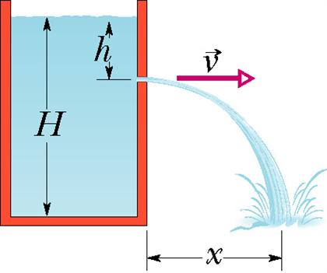

A tank is filled with water to a height H, 3 feet. A hole is punched in one of the walls at a depth h, 1 foot., below the water surface (see the figure). What is the distance x from the base of the tank to the point at which the resulting stream strikes the floor?
Could a hole be punched at another depth to produce a second stream that would have the same range? If so, at what depth?
At what depth should a hole be punched to make the emerging stream strike the ground at the maximum distance from the base of the tank?

***
In the mid-Thirties when I began to read the Sunday comic strips and go to the movies, there was Popeye The Sailor Man and his girl Olive Oyl.

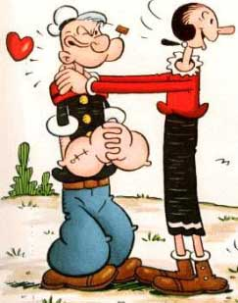

And there was Claudette Colbert in the movie Cleopatra taking a bath in mare's milk. I believe the historic Cleopatra would have bathed in olive oil whose 101 virtues were well known and can now be found via Google



In 1944, the year Hadassah & I were married, the JTSA pioneered with an NBC radio show entitled The Eternal Light. It was made possible by David Sarnoff, who was the boss of NBC and was put on on Sundays. It lasted many episodes, many of which were written by Morton Wishengrad. Each show was prefaced by a male voice slowly reciting this verse from Exodus

"And thou shalt command the children of Israel, that they bring thee pure oil olive beaten for the lamp, to cause it to burn always."

In March of 1949, when our daughter Abby was born, we were living in 2 Potter Park, Cambridge, Mass. This had been a rather palatial town house at one time but had been converted to three flats by the owner, a Mr. Francischelli who lived down the street. We occupied the third floor which was essentially a two bedroom apartment. Underneath us lived the Grammas family, Father, Mother, two young daughters, and grandmother, Mrs. Velagrekis. Mr. Grammas, whom we rarely saw, owned and operated a store in Boston that featured various Greek imports and specialized in Greek Orthodox religious items.

Mrs. Velagrekis, on the other hand, frequently knocked on our back door. (The three apartments shared a back hallway.) One day when Abby had a bit of discomfort,
Mrs. Velagrekis held forth on the virtues of olive oil, applied both outwardly or inwardly. It was , she said, a universal cure-all, a sovereign remedy. It was, as well, a powerful additive to any diet designed to gain or lose weight (she herself was no sylph), and if she had been familiar with Psalm 133, she would have asserted that it was a precious ointment on Aaron's head and ran down even to the skirts of his garments. But for all her praise, Mrs. Velagrekis brought us no sample of olive oil from what must surely have been her vast reservoir.

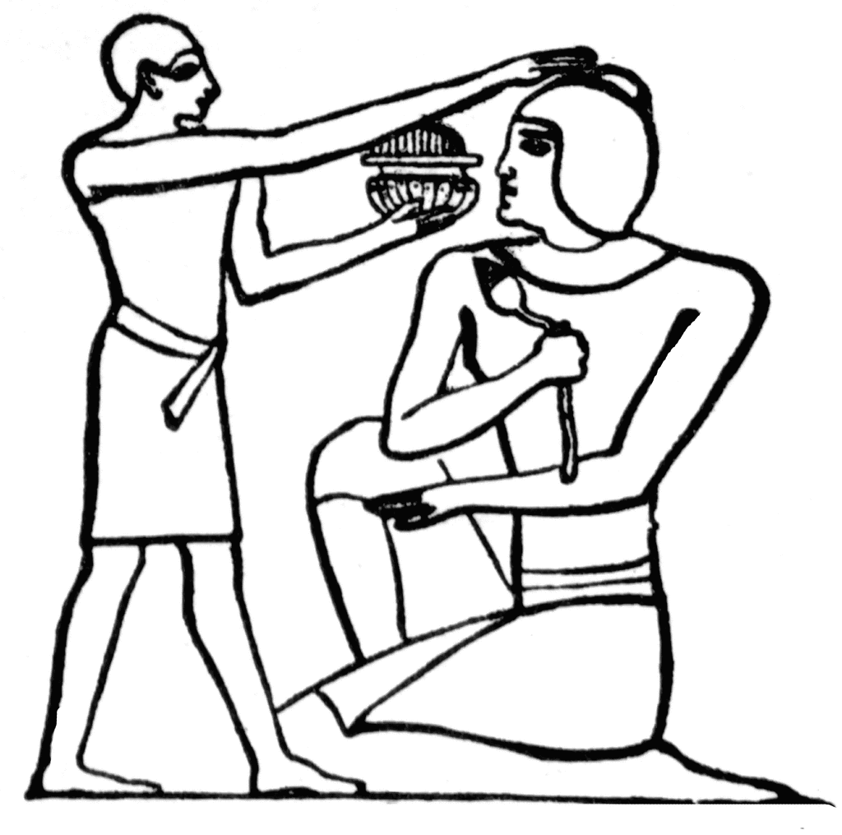

Anointing monarchs with oil at their coronation is standard operating procedure. In England, the Dean of Westminster puts a small dab of consecrated oil on the head, hand and heart of the monarch. What kind of oil is used? Where do they buy it ? At Saintsbury's? This is a Project for investigative reportage. But a kibitzer, reading this over my shoulder, piped up: " For Queen Elizabeth I ? Double Virgin Olive Oil, obviously. "

It was not until years later in Chania, Crete ( Χανιά), that I had my first taste of the celebrated Cretan olive oil (Κρητικό ελαιόλαδο) . Here's the story. It turns out that my British cousin-in-law Benedict, married a Greek girl with family ties to Crete. About a dozen years ago, I traveled to Chania, Crete, met up with the extended family, and was invited to a gala family dinner at their farm. The entrée was cooked on an outdoor grill. I was seated at the end of a long table. Dish after dish came my way from which I took this and that. Then a large dish came by in which some preparation floated in a veritable sea of golden olive oil. I recalled Mrs. Velagrekis' saying that olive oil was a sovereign remedy, and I dug into the viands with considerable gusto.

During my stay in Chania, I learned the origin of the geometrical word trapezoid., meaning a quadrilateral with two parallel sides. In Greek: τράπεζα, a bank (for money), or a table. The banks in Chania all bore a sign with the trapezoidal word. This has nothing to do with olive oil, but I insert it anyway. For further adventures in Chania , read my article ΤΌ ΤΑΞΕΙΔΙ ΜΟΥ ΣΤΗΝ ΚΡΗΤΗ (My Trip to Crete ).

Flying back to London via Ολυμπιακές Αερογραμμές (Olympic Air Lines ) with cousins Teddy and Benedict , Benedict took with him a large keg of first quality Cretan Olive Oil. The keg was too large to stow in the overhead racks, but had to be shipped in the hold of the plane along with a passenger's dog. Having deplaned, we waited and waited, but finally, the dog came out first and then the keg of olive oil rolled out and found its way to Teddy's car. Thence to Blackheath where Felitsa (Mrs. Benedict) was waiting with great anticipation for the precious cargo. The trip by car from Heathrow to Blackheath by car took longer that the flight from Athens to Heathrow.

There ensued the following conversation in the Blackheath kitchen:

PJD:What do you do with so much olive oil ?

Felitsa: Everything.

PJD: What do you mean by everything ?

Felitsa: Everything means everything. Δεν καταλαβαίνετε ? (Don't you understand ?).

All this was some time ago .But time flies. It is now now. ( I once asked my physicist friend David Park " When is 'now' and where is 'here' ? " But an answer came there none. )

I read, courtesy of Google, that during the ancient Panathenaic races, organised to honour goddess Athena, the winner of the chariot race got large quantities of olive oil as a prize.

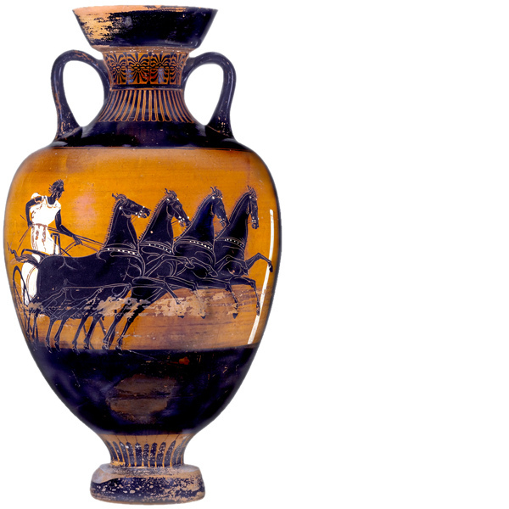

Olive oil is now a staple in our household. Whenever I'm asked "What do you use it for ? " I answer "For everything; from carmelizing onions to oiling squeaky door hinges."

