How I became a Member of an important Kitchen Cabinet

A Study in Biography

Philip J. Davis

Kitchen Cabinet: Def. In politics, an informal group of advisors thought to be often more influential than the regular Cabinet. Said to have originated in the Presidency of Andrew Jackson meeting with his cronies in the White House kitchen.

Ever since our children grew up, Hadassah and I have had an occasional breakfast or lunch at a convenient restaurant in Wayland Square. Over the years, this place has changed hands a number of times. Formerly it was called Ruffuls after the owner. Now it is called the Wayland Square Diner and is owned and run by a lady whose name I don't know. For simplicity, let me call her Betty. Betty employs three waitresses: Dot, Heather and Mickey. Dot has been there the longest; she was certainly there when the place was Ruffuls. Betty is most often in the kitchen, but now and then she comes out to help serve.

At the time of my induction, Hadassah was enjoying a short stack with a side of mixed fruit. I was enjoying a Veggie Delight. A Veggie Delight is a grilled sandwich, cut in two, containing (among other things) cheese, tomatoes, sautéed onions and green peppers, avocados and lettuce. I am no stranger to Veggie Delights having had in the past months a number of these unique assemblages or constructions. As I was digging into the first half of my Delight, Betty, recognizing us as "regulars," came over to our booth. There then ensued the following conversation which is true in spirit, if not in a word by word sense: se non è vero, è ben trovato , as one says.

Betty: How's everything ?

P.J.D. : Great. You know, the Veggie Delight is a great discovery.Let the Executive Chef know.

Betty: I'll tell him.

Dot: (Coming by) More coffee ?

P.J.D.: Just a splash. Yes it's a great invention.

Betty: Do you think it needs the lettuce? Should we leave out the lettuce ?

P.J.D. Hmm. Let me think about it.

Betty left and returned to the kitchen. A few minutes later she was back.

Betty: Well? Shall we leave out the lettuce ?

P.J.D. I've thought it over and I'd advise you to keep the lettuce in. It lends crispness to the combination.

Betty: I'll do as you say. I'll keep it in.

P.J.D. A wise decision.

Dot: (Returning and pointing to my plate) Are you still working on that ?

***
And that, dear Reader, is the short version of why I added to my curriculum vitae: Advisor to the Wayland Diner Management.

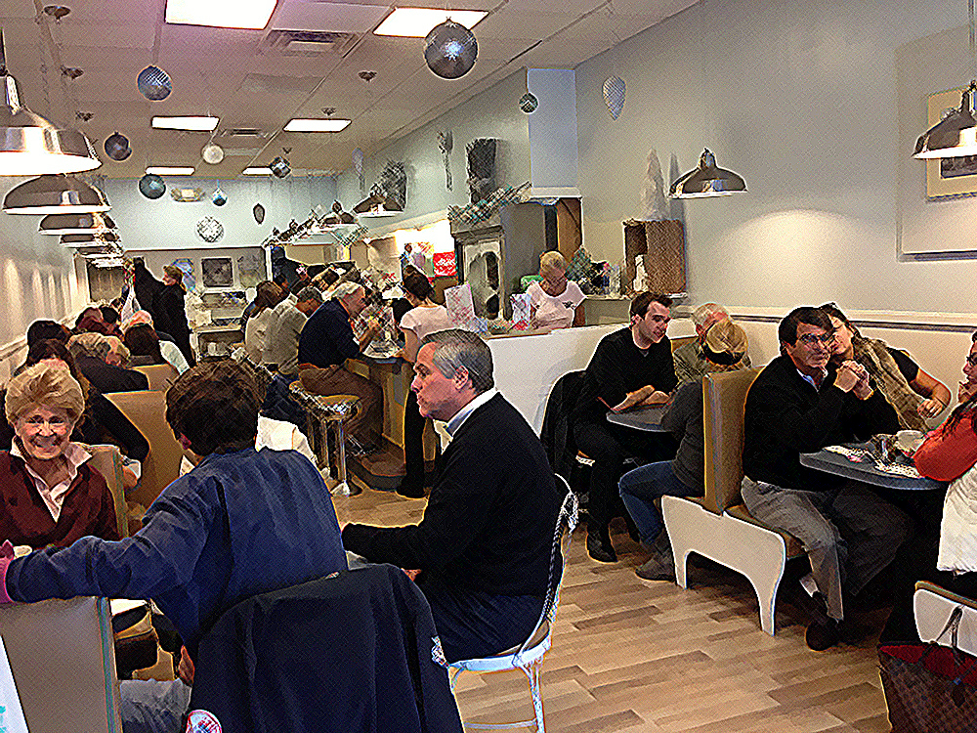
Wayland Square Diner

