Judgment and Righteousness

In the late fifties, when I was working in Washington at the National Bureau of Standards, I met and spoke to Chief Justice Earl Warren briefly. It came about in this way.

My father-in-law called me up from New York and told me that he had an appointment with Warren late on the next afternoon. Following his appointment he would come up to Chevy Chase to visit with us a bit. Then, as an afterthought, he added,

“Would you like to meet the Chief Justice?”

“Of course I would.”

“In that case, why don’t you come down to the Supreme Court Building at such and such a time, I’ll be winding up my business. You’ll meet him and then we’ll go back to your house.”

Earl Warren, former Governor of California, was named to the court by President Eisenhower in 1953, and by the time of the conversation just recorded he had established a reputation as one of the most liberal justices. The term “Warren Court” was used both as praise and condemnation.

Parking not being easy in downtown governmental Washington, I decided to take the bus. I got off the bus and walked to the front of the Supreme Court Building. In all the years I’d lived in the city, this was the closest I’d been to it. Classical architecture, graceful proportions, a long set of steps leading to a portico, and on both sides of the steps there was something I’d never noticed in photos of the building: two large ornamental basins filled with water and flanking the steps. I couldn’t tell whether the basins were catch basins for fountains.

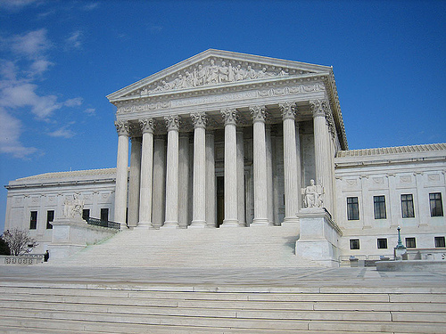

U.S. Supreme Court Building. One basin just barely visible to right.

These two basins together with my knowledge that Warren had recently been subject to much adverse comment put me in mind of a verse I knew from the Old Testament: “Let judgment run down as waters, and righteousness as a mighty stream (Amos, 5:24).

My personal interpretation of this parallelism is that it points to the unresolved tension or the conflict that can exist between the formal law (justice) and the human, informal qualities of mercy and tenderness (loving kindness, righteousness). In a flash, as I walked up the flight of steps, I imagined that when I met the Chief Justice, we would exchange a few words, and then it being the end of a long day, we three would walk out together, he to his limo and we to our taxi. In the course of which, we would pass the two water basins and (clever me) I would quote the verse of Amos to him by way of praise that he had managed to balance the two conflicting ideals.

Well, it didn’t work out that way. I walked in the front door of the Supreme Court Building. I was met by a uniformed usher. I gave him my name and stated my business. The usher phoned to the Chief Justice’s chambers. I was expected. The usher led me to the chambers. My father-in-law, already with hat in hand, introduced me to Earl Warren whom I recall as a very relaxed and informal sort of man. We exchanged a few polite words about where and what my job was. He replied with the response frequently heard by mathematicians: “Well, I was never much good at mathematics.” The meeting was over. My father-in-law and I were ushered out. And I never had the chance to quote the words of Amos.

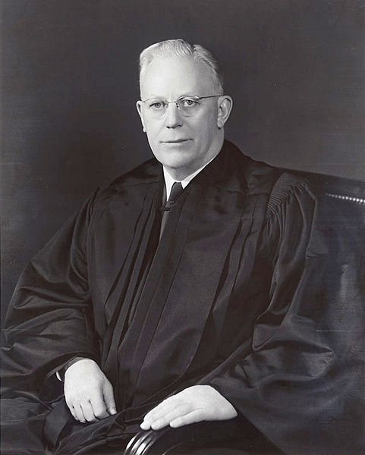

Chief Justice Earl Warren

Why have I recalled this event that took place a half century ago ? The moral it draws is relevant to the close questioning of Sonia Sotomayor, selected by President Obama for the Supreme Court. It would seem, according to her critics, that personal background and experience must be suppressed; counted as nothing. All that can matter in arriving at a judgment is strict adherence to an objective (not subjective) reading of the letter of the law. Pay no attention to the words of Amos. Will she be able to adhere to these strictures ? Luckily, happily, such draconic scenarios of judgment are rare.

--- P.J. Davis, June, 2009.

