Edmund & Lotte

A generation ago, I was invited by Prof. Peter Gruber, a prominent member of the Technical University (TU) in Vienna, to give some talks at its Mathematics Department. June, 1987 was the date of my first of many later trips to Vienna. Gruber gave me a red carpet treatment, driving me all around and showing me the sights. He took me to the (Upper) Belvedere Palace, now an art museum. On the wall were documents dating from 1955 when the independence of Austria from Russian, British, French, and American control was restored. The ceremony was held in the Belvedere and John Foster Dulles signed for the United States.

I recall also seeing in the Belvedere a number of paintings by Gustav Klimt including the famous (or notorious because it fetched so much money) Goldene Adele now hanging in Die Neue Galerie in New York.

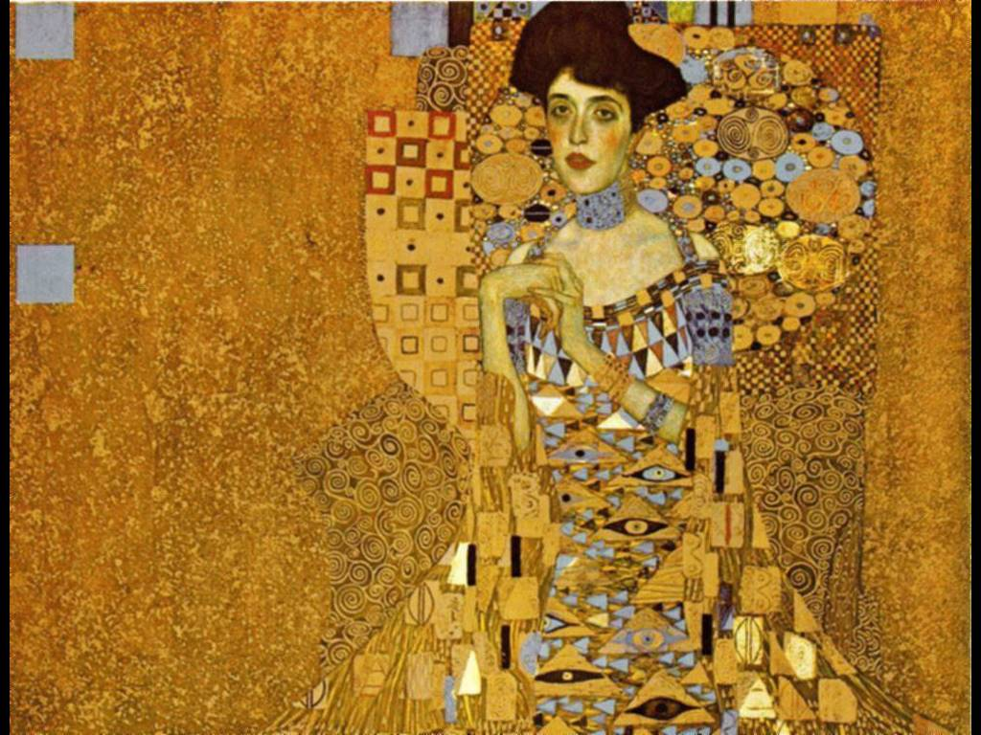
Adele

Not neglecting the inner man, Gruber took me to a restaurant around the corner from the TU where I had my first Topfenstrudel.

During this first trip to Vienna, I made a number of friendships that became permanent. Gruber put me in charge of Christa Binder, then an assistant professor of mathematics at the TU, who, escorting me in and out of the omnipresent Viennese streetcars, introduced me to the famous Kunsthistorische Museum with its famous collection of Breugels, Arcimboldos and much, much more of interest to me.

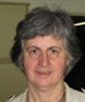

Christa Binder

Days later, also catering to the inner man, we went to a restaurant up the hills in the Wienerwald where we ate Backhendl -- chicken roasted on an open spit. Over the years, I have seen Christa periodically, especially at the Österreichische Symposion zur Geschichte de Mathematik which she organizes and runs.

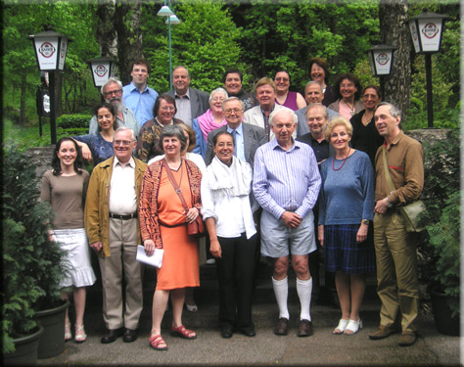

Christa: Front Row, Third from Left. Miesenbach Conferees.

The trip in 1987 was the occasion also of my first encounter with Prof. Edmund Hlawka (1916-2009) who, I was told, was the doyen of the Austrian mathematicians and had received National Honors. We got to talking. Hlawka’s English was better than my German, but we went in and out of these two languages. Over the next few days, he gave me some reprints of his work, which I studied. Hlawka was a master and a very influential figure in mathematical analysis, the theory of numbers, and of a special topic known in German as Gleichverteilung (in English: equidistributed sequences.) I had known about Gleichverteilung from my undergraduate days and, in the early experimental days of electronic digital computers, I put to the theory to use for Monte Carlo methods for the computation of multidimensional integrals on SEAC , one of the first generation of electronic digital computer at the National Bureau of Standard in Washington. (Mid ‘50’s)

Edmund Hlawka

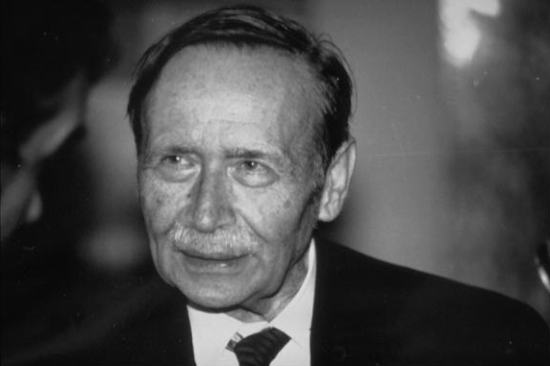

I was delighted to meet a master of the Gleichverteilung theory . My interest in it led Hawke to give me his paper on the equidistributed aspects of a mathematical spiral, known in German as the Quadratwurzelschnecke (literally: the square root snail or spiral). This work grabbed my attention and for a long while I spent much energy on it. The spiral in its primitive form consists of a sequence of points. (In the figure below, the outer vertices of the various triangles.)

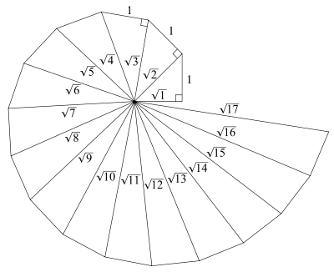

As a student and theorist of interpolation and approximation, I wished to draw a continuous curve through these points. This can, of course, be done in an unlimited number of ways, but I wanted to do it by means of an analytic curve (in a technical sense) and in a way that would be unique given certain natural geometric constraints. Inspired by the classic work of Leonhard Euler on the Gamma Function, I devised a formula that would do the trick. I had now elevated the Quadratwurzelschnecke to a continuous, analytic curve whose various representations and properties could be studied in great depth.

Pleased with what I had accomplished, and for certain historical reasons, I rebaptized the Quadratwurzelschneke and the curve I had devised the Spiral of Theodorus. (Theodorus of Cyrene, 5th Century BCE) This is a name that has stuck, although Theodorus, as far as I know, had nothing to so with the spiral. In the months that followed, I enlisted the assistance of Profs. Walter Gautschi of Purdue University and Arieh Isserles of Cambridge University, two experts at this sort of mathematics, who amplified my material greatly, and I put together a book entitled Spirals: From Theodorus to Chaos.

As soon as the book was hot off the press, I sent a copy to Hlawka and Vienna, and pointed out to him that I had included in it his article Gleichverteilung und Quadratewurzelschnecke and that the whole enterprise resulted from his giving me a copy of that article. Hlawka was pleased and our friendship was sealed. Incidentally the theory of the Spiral of Theodorus is still alive, with, e.g, the recent work of Detlef Grunau at the University of Graz.

In the years that followed, I would see Hlawka regularly whenever I was in Vienna; I attended his Privatissimum (special lectures) whenever it was possible; I had lunch or dinner with him either in the Mensa (TU’s cafeteria) or in the nearby Chinese restaurant. But strangely, except in a general sort of way, we never really talked about mathematics any longer.

On the occasion of Hlawka’s 75th birthday in November, 1991, a grand celebration was held. I was invited to give a talk on the analytic Spiral of Theodorus, and invited later to an informal feast at the Beethoven- Heurigen . A Viennese Heurigen is an informal , frequently outdoors or partially outdoors, restaurant for beer and wine drinking and eating deli food. The patrons sit on long wooden benches, and get their own food from the food counter. The conversation is loud and there is often a house accordionist playing and group singing can develop. Christa Binder, who had been Hlawka’s Ph.D. student and was now his Assistant, arranged for the Heurigen. She told me she would seat me opposite a very interesting lady. She was right; and this was the origin of my friendship with Lotte Ingrisch.

Lotte’s English was much worse than my German and how we managed to communicate above the din is a mystery but we managed it somehow. She told me that she spoke to spirits and asked me whether spirits ever spoke to me about mathematics. What have we here ? I asked myself. But creative oddness is always intriguing, even seductive, and over the following months and years, I found out.

Lotte Ingrisch (geb. Charlotte Gruber) is a novelist , a media personality with a considerable public presence in Austria and is prominent in the society of Viennese writers. Tiny, weird, fey, cheerful, pixie , the wife of the distinguished Austrian composer Gottfried von Einem, (who on this occasion was sitting on another bench in the Heurigen,) she has written numerous novels in the New Age line – a good half dozen are in the Brown University Library --- and also written librettos for von Einem's operas. A recent book (2005) carried the title Die Physik des Jenseits (The Physics of the Hereafter.)

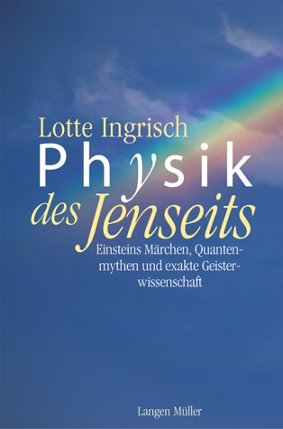

Lotte thinks of herself as a Reiseführerin ins Jenseits. (A group leader for travels to the Hereafter.)

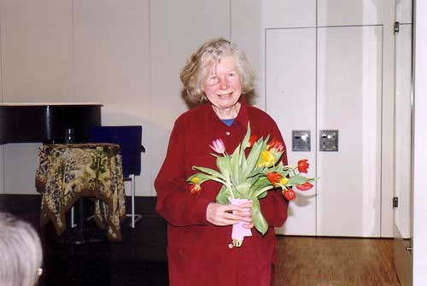

Lotte Ingrisch (1930 - )

Sometime after von Einem's death, I was taken to a memorial production of his opera based on Nestroy's Der Zerissene. The opera was put on in a former mental hospital that had a small theatre. (It was explained to me that years ago there was a theory that acting in plays had therapeutic value for certain mental patients.) Though I knew the general idea of the libretto, I couldn't understand a word that was sung (anyway, this always is the case with operas, even when sung in English.) As the regards the music, it was not to my taste, but I was diplomatic and didn't express my opinion to Lotte when I met her in the lobby.

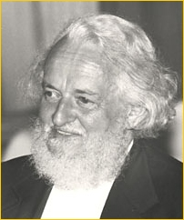

Gottfried von Einem (1918 - 1996)

Lotte's stepson was a Cabinet member (who dropped the "von" when he entered politics,) and Lotte is in the newspapers every once in a while. She is sufficiently prominent so that a few years into my friendship with her – 1996 -- a package bomb was sent to her, but luckily no one came to harm. It turns out that she had written the libretto for von Einem’s mystery play Jesu Hochzeit (Jesus’ Wedding) and a deranged person, believing it to be heretical, had sent the bomb.

I was in Vienna at the time. We had a Jause (afternoon tea) together near Stefansplatz a day or two later and she was as cool as a cucumber about the incident. I asked her whether the bomb was politically motivated. She thought not. I asked her how she accounted for her nonchalance. She answered that it was due to her understanding of the Jenseits and her frequent conversations with her late husband. I asked her whether her husband had told her anything interesting. Her answer was something like:

"O Ja. Er hat mir gesagt dass im Jenseits ist man ins elektronische Geräte verwandelt."

which translates to: in the Hereafter, one morphs into some kind of electronic form (or apparatus.) Interesting , I thought, but rather vague.

In following years, I would look Lotte up whenever I was in Vienna. I would meet her at the Stefansuhr (A large clock near the Cathedral of St. Stephen) close to her apartment in the Hofburg (the former “downtown” Imperial Palace) and then we would go up to her place where I would say hello to her four cats and listen to a lecture of the theory of Jenseits or hear about the Jenseits Gesellschaft of which she was a prominent member. She would serve me tea and cookies, eating very little herself. She is so slight that I’ve often thought she must live on air. My side of the conversations must have been sufficiently amusing, for she always looked forward to the occasion.

Back in Vienna around the year 2002, I asked Lotte to do two favors for me. The first was to get me an interview with the Minister of Education. The educational systems all over the world were (and still are) in turmoil -- except possibly in Beijing and Singapore. I thought it would be instructive to write up the Austrian situation for the SIAM NEWS.

The second favor was to get me an interview with Elfrieda Jelinek. I had read Jelinek’s Die Klavierspielerin and seen the movie (walking out when it became too masochistic.) But in an interview, Jelinek said something about her early encounter with mathematics. This was before she won the Nobel Prize for Literature. I speculated that there was probably little love lost between these two authors who had absolutely different cosmic views, but Lotte was obliging. Nothing ventured, nothing gained.

We were in her apartment in the Hofburg among her four cats.
Lotte picked up her phone immediately. Drring, drring, drring. ♫ ♫ Well, no luck with the Minister of Education. The Minister's schedule wouldn't allow it. No sweat, said Lotte, or the Austrian equivalent thereof. What can you expect from a politician ? And not much loss there, I was later told by friends at the University because the Minister of Education knows nothing at all about higher education. The Minister was an Elementary School teacher with national aspirations.

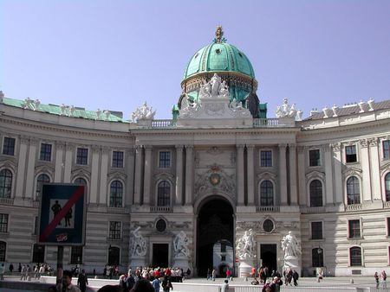

Lotte's Front Door at the Hofburg

Another drring, drring, drring, and I struck out again. Elfriede, Lotte was informed on the phone, and then told me, lived the life of a recluse. Thus, zero accomplishment for three attempts.

Truth to tell, I had no firm idea what questions I would have asked Elfriede if I had been able to arrange an interview. Nonetheless, in the days that followed, and out of my disappointment, I fantasized that the interview might go along lines that would interest the SIAM NEWS readership.

Edmund, of course, had known Lotte for years. He fed her scientific facts which she translated immediately into her conception of Jenseits. Five years ago, more or less, was the last time that Lotte, Edmund and I were together. She invited us to her apartment in the Hofburg and served us tea and cookies. Her friendly cats were present, wandering around, climbing on laps, etc.

Edmund, as usual and as befits a professor, gave a lecture. Mathematics, physics, science; quantum theory. Lotte listened with all ears. I remained silent. At the end , as we both expected, she turned much of what Edmund said into confirmation of her theories of Jenseits. Edmund sighed. So did I. It was a great occasion.

--- Philip J. Davis, February, 2009.

A.K. Peters Ltd, 1993.

