Harkavy's Triumph

I inherited from my brother-in-law Jack Joslow a copy of Harkavy's Complete English-Jewish Dictionary, 2nd Edition, New York, 1895, 759 pp. I suspect that Jack Joslow inherited the book from his father. The book was pre-owned by a certain Israel Grossman who signed the flyleaf as of 131 Main Street, Cambridgeport, Massachusetts. Judging from the original but discarded distinction of Cambridgeport as a separate village, Mr. Grossman must have bought the dictionary shortly after its appearance. I have no notion as to what connection there was (if any) between Mr. Grossman and Mr. Joslow.

For a number of years, Harkavy's Dictionary remained gathering dust in the bookcase next to my bed. Recently, having no better book to fall asleep on, I pulled it out and flipped its yellowing pages. I was astounded by what I found there. I had thought the entries would be confined to the definition and explication of English words of what might be called the "kitchen variety"; and that would correspond nicely to my own knowledge of Yiddish which I considered to be of that precise variety. I thought that I would surely know the definitions of all his English language entries. But no; this was not the case by far. Harkavy's pages are full of technical terms from the sciences, arcane words, out- of - date words (this last was surely to be expected) and words which at first glance I thought that Alexander Harkavy had himself invented. Not at all: every word in Harkavy can be found in some English dictionary. It became clear to me that this lexicographer's intent was to bring the Jewish immigrant, newly arrived in America, into the mainstream of English language culture in the widest popular, scientific and intellectual sense.

Every entry of the approximately 40,000 entries consists of a transliteration into the Hebrew alphabet of the English pronunciation followed by a definition, or occasionally several definitions, in Yiddish.

Any substantial English dictionary, such as Webster-Merriam, will have words on practically every page that I have never heard of. That same is true of Harkavy. But those in Harkavy seemed to me to have a special flavor which I will try to illustrate this with a number of sample entries and follow them with my comments.

Strait-jacket: א צװאנגס יק a zwangs yak ; an enge yak fir mishegeyim, ( A confining jacket; a narrow jacket for crazy people.) Of course , I knew this term, but I was amused by the Yiddish translation. [In successive entries, I'll only use the English transliterations of the Hebrew letters.]

Macaronic: lacherlich; spass (Laughable, humorous, jokey) . I knew the word, but never I knew what it really meant. Harkavy doesn't have it exactly right. The word means the use of a mixture of languages, e.g., vernacular and Latin, for comic effect. Somewhere in Maurice Samuel's wonderful The World of Sholem Aleichem he comments on the frequent use of playing the Germanic or Slavic components of Yiddish against the not quite equivalent Hebrew expressions. An example: the Germanic "Buch" suggests the secular, the day-to-day, the evanescent; the Hebrew "Sefer" suggests the spiritual, the transcendental, the eternal. Sholem Aleichem juxtaposes the two types with artistry and often for comic effect. The effect is often created by simple concatenation: a buch, a sefer. In my own writing I occasionally use this device and for years I've wondered whether there was an adjective to describe it. Now I know. So you see how I've profited from surfing Harkavy.

Madripore: shtern koral; a min koral (A star coral; a certain type or variety of coral) There are many words in Harkavy from botany, biology, zoology, etc. He doesn't go into details, but simply says: a min .... , i.e., a variety of ....
"Min is Hebrew. The first occurrence of it is in Genesis 1:11 where it states "And God said, Let the earth bring forth grass, the herb yielding seed, and the fruit tree yielding fruit after their kind.." (l'minehem: למינהם)

I've read somewhere that Yiddish is poor in botanical and other terms that refer to nature and Harkavy's impatience with the details is part of this poverty. Current dictionaries spell the word "madrepore" and go on to talk about the reef building corals of the South Seas.

Friars-lantern: a min licht vos bevaizt sich in der luft iber zumpfige erter. (A kind of light that appears in the air over marshy places.) A now obsolete term for the ignis fatuus or Will-o'-the-wisp. Milton uses the older term. I wonder why "friar." There's probably an interesting legend behind this.

Metathesis : In grammatik. Die ibershtelling fun buchshtaben in a vort. (The transposition of the letters in a word .) When I type fast, I perform metathesis frequently; for example, if I type peotic for poetic. And so do many people. Automatic spellers can catch this type of error. I have never seen a cognition or brain-oriented explanation of this kind of error.

Paralogism : a falsher schluss: (An illogical conclusion) A good word to describe political rhetoric. Suggested usage: Senator Claghorn provided a lengthy paralogistic explanation of the current crisis.

Rimose: mit shpalten. (With cracks) having a surface covered with a network of cracks or small crevices. Sounds like our driveway.

Dotation : nadan (Charitable donation.) I could have guessed this one. Nadan is a Hebrew entry into Yiddish. A Hebrew cognate: nadiv, a philanthropist , a word I learned from having visited the tomb of Edmond de Rothschild in Zichron Yaakov, Israel and seen the lapidary inscription.

Tide-rode: (Fun a shiff; i.e. naut.) vos liegt gegenkert fun a shtrom. (In other words: swung by the tide when at anchor.) The online version of Brewer's Dictionary of Fact and Fable points out that metaphorically, a person is tide-rode when circumstances over which he has no control are against him, especially a sudden glut in the market. I am beholden to my reading of Harkavy for pointing out to me that Brewer, one of my favorite bed-time dictionaries, is now on line.

Womby: briet; groiss (Capacious; hollow ). This word is obsolete but is found in Shakespeare. "That caves and womby vaultages of France/ Shall chide your trespass and return your mock /In second accent of his ordnance." -- Henry V. I should point out that Harkavy does not give clips to illustrate his entries.

Grass-week : azoi haysst bei kristen die voch zwischen dos finften un sechsten zontag noch zayer pesach . (In other words: Mardi Gras Week. ) Bravo for Harkavy that he didn't translate this simply as "Groz-Voch."

Contractility: die fayhigkeit zusammenziehing (The capacity for becoming short. I could have guessed this one. Harkavy puts in as separate entries lots of variants that depend on suffixes such as -ness , -al, -ist, - ble, -ic , etc.

Woodreve: waldmeister. (The steward or the overseer of a wood.) I might of guessed this from having read The Canterbury Tales. As with the words for many professions or crafts such as carpenter, fuller, slater, etc. Woodreve is not an uncommon surname.

Gwiniad: a min fish. (A kind of fish [allied to the lake whitefish] ). We buy our whitefish paté at Davis' on Hope Street. Who knows but that all these years, we've been getting gwiniad paté,

Elutriating : die obgiessen (pouring out), die obscheiden (separating). The word refers to the purification, separation, or removal (as e.g., ore) by washing, decanting and settling. The word derives from the Latin eluere, meaning to wash out. But I wouldn't care to report that Dick and Jane have been elutriated even though their marriage might have been a washout.

Disparadized: heroisgetrieben fun (Gan) Eden (Expelled from the Garden of Eden.)

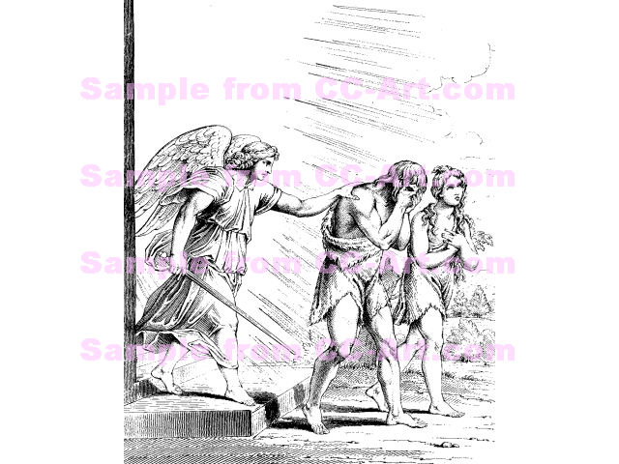

The Disparadization of Adam and Eve

Disparadization is an excellent word to keep in one's quiver of words and use metaphorically. There is much linguistic precedent. Historians write about the "Defenstration of Prague," an event that occurred twice, once in 1419 and again in 1618. During Protestant-Catholic tensions, some of the former threw some of the latter out of the Prague Castle window. In 1618, those defenstrated fell fifty feet into a pile of manure and survived. The Catholics claimed that their survival was due to the Grace of God and the righteousness of their cause. The Protestants claimed that it was due to the pile of manure. One can speculate on how it is that humanity survived disparadization from Eden. The correct answer is that given by the Protestants.

Pandiculation ; dos oysziehen sich (The act of stretching onesself.) Suggested usage: "It was getting late. I yawned, pandiculated, and hit the hay."

Pickeer: zich shlogen in blut herein in a shlacht. (To be in a bloody battle. ) Actually: to make a raid for booty; to maraud; also, to skirmish in advance of an army.

Inclavated: eingeschlossen (Closed or locked in). I supposed from the Latin clavis, meaning a key. Cognate: Enclave. Well, if Harkavy has this word for locked in, I wondered whether he listed exclavated for locked out. I looked: nope. He doesn't list it. Suggested usage: I accidentally inclavated my car key; I called the AAA and told them that I was exclavated.

I recall that in Macaulay's brief biography of Sanuel Johnson (which we read as Juniors in High School,) he makes fun of Johnson's tendency in his great dictionary to be partial to pompous Latinisms. Macaulay cites Johnson's definition of a network: "Any thing reticulated or decussated, at equal distances, with interstices between the intersections." Harkavy is definitely a Johnsonian.

Desquamate: abshaylen (To peel off). My suggested usage: add 1/2 teaspoon of lemon desquamation to the mixture.

Curvirostral: voss hot krummen shnobel (Having a curved beak. ) A macaw, I would suppose, is curvirostral.

Phytography : die wissenschaftliche beschreibung fun plantzen (The scientific description of plants). Which, as I remarked earlier, Harkavy is loathe to give.

Estovers: A gezetzliche unterhalt oder שטיצע. (I don't know what this Yiddish word means.) (Maintenance established by law.) But Harkavy is vague here. More precisely: Estovers is one of the rights that were granted to some tenants under the medieval feudal system. It allowed them to take wood from the estates of the manor. The "rights" of wood carried over to New England. I recall reading that when Blue Hill, Maine hired a new clergyman for its church, his pay included a certain number of cords of wood delivered. This must have been in the early 1800's.

What's missing from Harkavy's Dictionary? Plenty, I suppose. In mathematics, for example, some of the words pertaining to simple arithmetic are in, "Subtraction" is listed but is not given a Yiddish equivalent. Even more specialized words in geometry, trigonometry are out. Why should they be in ? But "sine" is in whereas "cosine" is out. In the domain of every-day words of Harkavy's period, "night-cart" -- the wagon that went around from house to house removing toilet wastes -- is in. Today a truck goes around collecting medical wastes from hospitals, doctors' offices, etc. I don't think it has a special name. Spitoon is in but on the other hand, "cuspidor" is out. Yet, when I was a kid, every family had a cuspidor in their house. Perhaps the Yiddish equivalent of cuspidor is cuspidor.

***

Enough about the entries ! From this small sample readers will surely get the flavor of Harkavy's Dictionary. And now the question arises: who were the hundreds of thousands of people who bought this dictionary in its many editions and forms? The average immigrant right out of the steerage? No way. Intellectuals, writers for whom English was an acquired language? Perhaps. But how many of those could there have been? Libraries? Schools? A few. The Brown University Library has an 1891 edition of the English-Jewish Dictionary. But I have another answer to my question and I will illustrate it by a personal story padded out with a reasonable conjecture.

In the early months of 1924, a man entered my father's store carrying a satchel and said

"Mister Davis? Yich hayss Mister Goldfarb. Yich ferkafe bicher, das hayyst yich bin a mocher sfoirim. Un man hat mir gesagt dass yihr seid ein frumer oifstandiger ehrlicher un glichlicher mann. A Yid vos halt die Loshen Koidesh un die Toire sehr taier. Un yetzt verkafe yich a buch --nein, nit a buch, a sefer - a sefer vos yihr un yihre familie, yihre geliebte mishpoche muss alle hobn. Mistome yihr hat kinder? Gewiss! Nu, yich verkoif die Yiddishe Entzyklopedie... "

(I'm Goldfarb the bookseller. I heard that you're a devout, respectable and successful Jew who regards learning highly. Well, I'm selling the Jewish Encyclopedia in Twelve Volumes.)

This encounter took place during the time when my father had indeed a fair amount of loose change. Mr. Goldfarb clung to him for several days like velcro during which time he went around to other prospects in Lawrence and made the same sales pitch. My father consulted my mother. My mother replied "Vos ken dos shaden? Zoll arumdrehen an Entztylopedie." (What damage can it do? Let's have it around in the house.)

The twelve volumes came into our house sometime during the first months of 1925. The first volume contained a bound-in parchment sheet affirming in colored diploma-like Hebrew letters that this set was the property of Efroiyim Davis and signed on November 12, 1924 by a sales representative of the Funk and Wagnalls Publishing House. In the years that followed, I don't recall that my father, my mother, my older brothers or sister ever once opened the Jewish Encyclopedia. But I did and did it at the age of four or five. I cut my "reading teeth" on its pages, learning about strange and far away places, strange people wearing strange costumes, and strange rituals such as halitza in which a surviving unwed brother released his widowed sister-in-law of her scriptural obligation to marry him and to marry whomever she wanted.

The Funk and Wagnalls Jewish Encyclopedia is a very scholarly work , put together by authorities all over the world who were paid for their labors with peanuts. One of the editors and contributors was the famous scholar Louis Ginzberg. I met Professor Ginzberg years later and regret that I didn't tell him my story and ask for tales about how the volumes were put together.

Yes, I think that a good fraction of the hudreds of thousands of copies of Harkavy's Dictionary that were sold served as an icon, a talisman of identity, a symbol of the aspirations and the phosphoresence of learning. And with luck, someone, somewhere opened the dictionary up and learned something.

***

The end of the 19th Century was a great time for Jewish lexicographers. The two most significant ones were Alexander Harkavy and Eliezer ben Yehuda (Perleman) (1858-1922). The contrast between their labors is significant. The former worked in Yiddish, the latter in Hebrew. Ben Yehuda was part of the revival of Hebrew as a living, colloquial language. He brought Hebrew up to date by adding words while Harkavy brought Yiddish speakers in contact with a full variety of English words including recent ones. As far as I can see, Harkavy did not create new Yiddish words. As one of his default options, he went into the German or into the English. Ben Yehuda's great work was his Milon haLashon haIvrit haYeshana v'ha Chadasha. (Dictionary of Ancient and Contemporary Hebrew,) 1910 - 1959, 17 volumes.

***

Now a word about Alexander Harkavy himself and some of his other books. I assume his surname is allied to the Ukranian city of Kharkov . In cyrillic: Ҳарькoв. But this is pure conjecture on my part. The name is rare as a Jewish name (as compared, e.g., with Levy), but there are many occurrences and plenty of Harkavys are on line As far as I can determine there is no in depth biography of Alexander Harkavy, and what little I know comes from the Encyclopaedia Judaica.

Harkavy (1863-1939) was born in Novogrudok, Belorussia. He was related to Albert Harkavy (1839- 1872) , the famous Russian Jewish orientalist and historian. After a traditional education, and as a young man looking for a living, Alexander Harkavy wandered to Paris, New York, Montreal, Baltimore, and settled finally in New York around 1890. He taught, he lectured, he translated, he produced a variety of dictionaries and phrase books, e.g., his American Letter Writer contained sample letters. He did an English translation of the Bible. He translated Don Quixote into Yiddish: Die Geshikhte fun Don Kikhot (I wonder whether he translated from the Spanish or the English.) Besides all this, he was a dedicated member of the New York Jewish social community. His great success was in his dictionaries which he put out in many forms and editions and which, as I have said, sold by the hundreds of thousands.

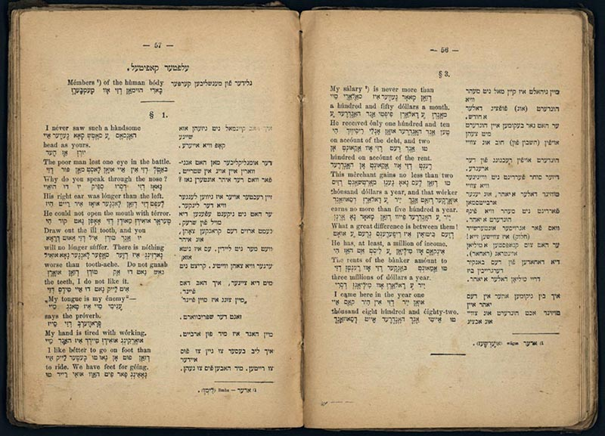

Harkavy's English-Yiddish Phrase Book

Look at some of the strange entries: e.g., "His right ear was longer than the left."

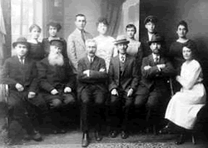

Alexander Harkavy sits in the middle of the first row.

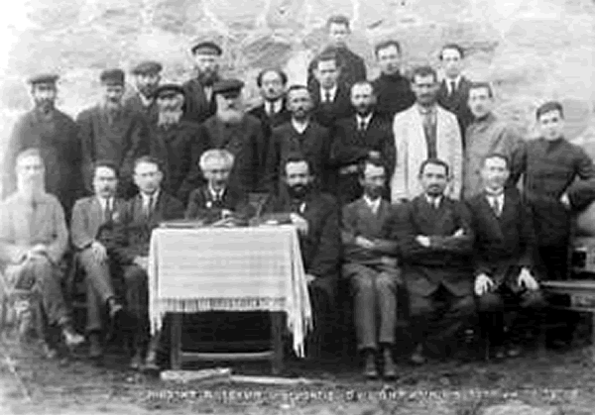

Alexander Harkavy, Seated Center, White Lapel Button,
c. 1920.

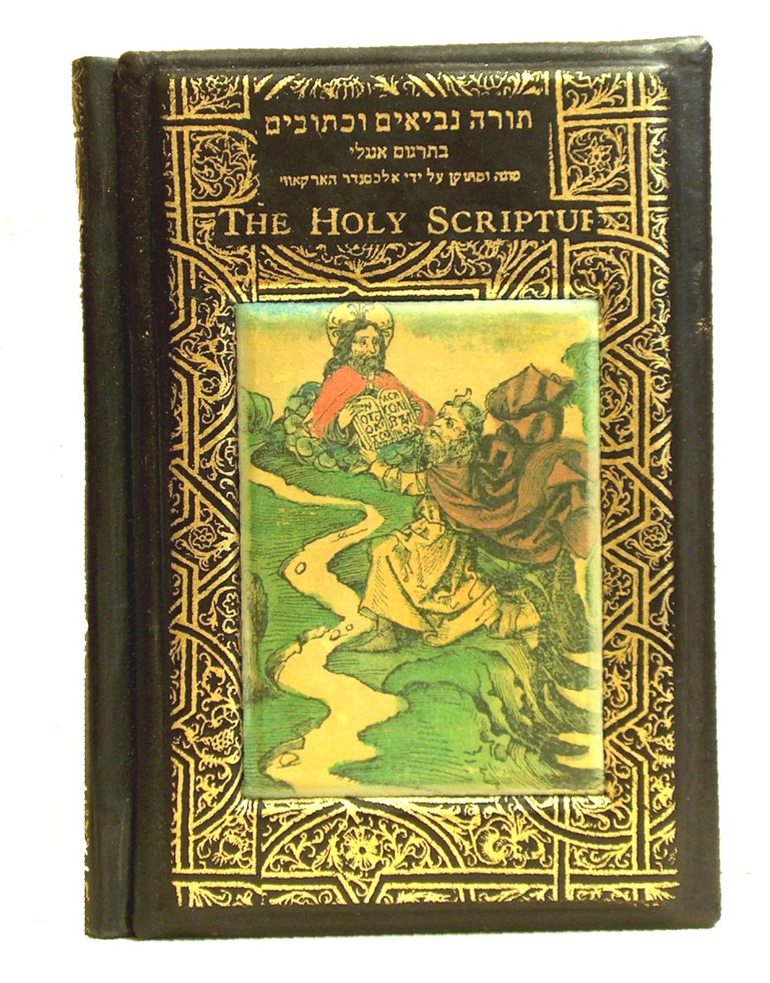
Harkavy's Translation of the Bible into English.

The cover depicts Moses receiving the Law on Mount Sinai from a God who wears a very un-Jewish nimbus. There must be a story behind this.

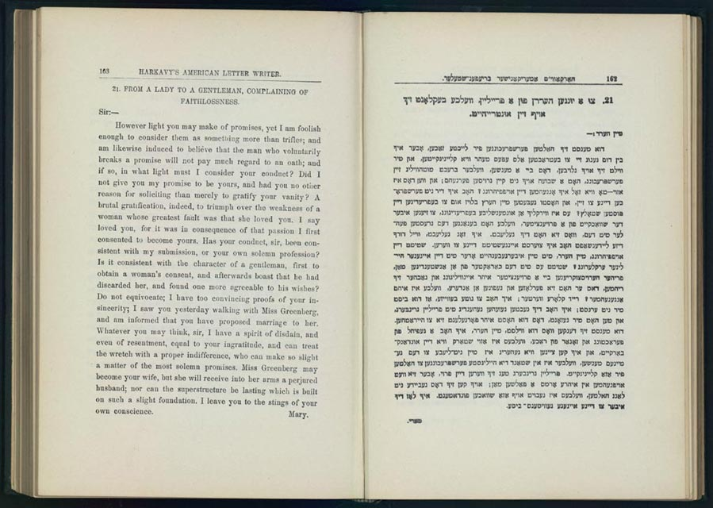

Harkavy's American Letter Writer (Amerikanisher Briefnshteler)

The sample letter displayed here deals with the anguish of a parent whose Americanized daughter has cast off traditional ways. A universal theme that will never disappear.

***

Harkavy's Residual Papers (Nachlass)
Collection Type: personal papers
Repository: American Jewish Historical Society, New York, New York
Span: 1886 - 1932
Physical Size: 1 box, .25 linear feet
Materials: Books, Poems
Subjects : Emigration and Immigration, English Language
Collection Description: The papers of Bella Segalowsky Harkavy are contained within the collection of papers of her husband, noted lexicographer, linguist, journalist and author, Alexander Harkavy. Bella Segalowsky Harkavy's file contains an autograph book (1886-1893) in which Harkavy's friends inscribed their names, short messages and witty or sentimental verses. Many of the inscriptions are from Jews, and most are from women. Some list Jewish dates, such as her birthday and Purim. Also of interest are Alexander Harkavy's handwritten copies of the tombstone inscriptions on Bella Segalowsky Harkavy's parents' graves, photos of their gravesites, and a "keepsake" pamphlet prepared by Alexander Harkavy with portraits of Bella's parents and a short biographical notice.
The autograph book is in English. The papers relating to the tombstone inscriptions are in Hebrew.
For information regarding rights of publication and reproduction, literary or electronic, contact the American Jewish Historical Society directly.

