WHEN I WAS A BOY

Philip J. Davis
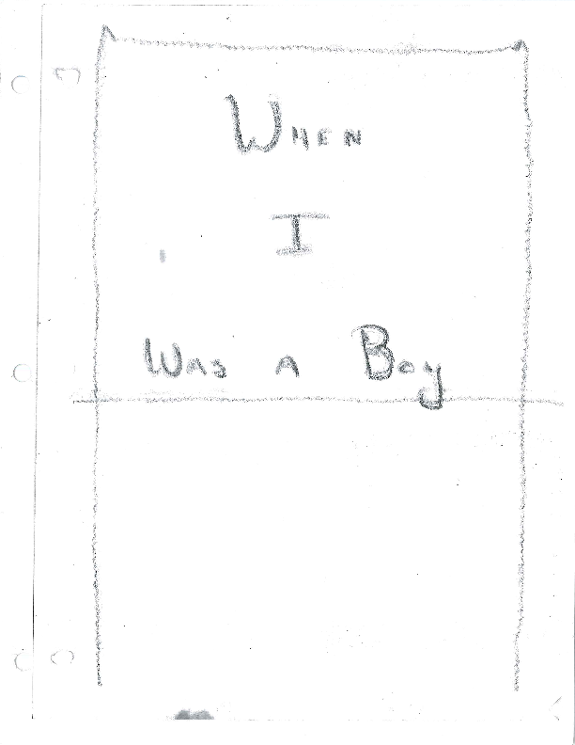

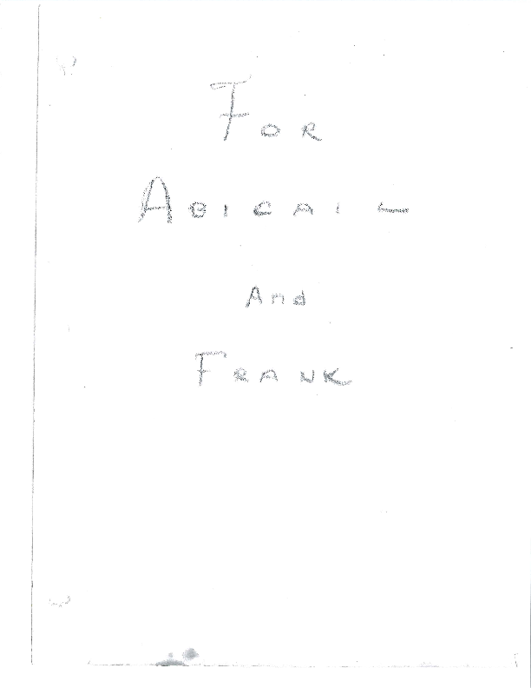
TABLE OF CONTENTS

THE GAS BUGGY 6

THE OLD EMPTY HOUSE 13

THE TALKING SNOWMAN 18

HALLOWEEN 1932 23

THE TOTAL ECLIPSE 35

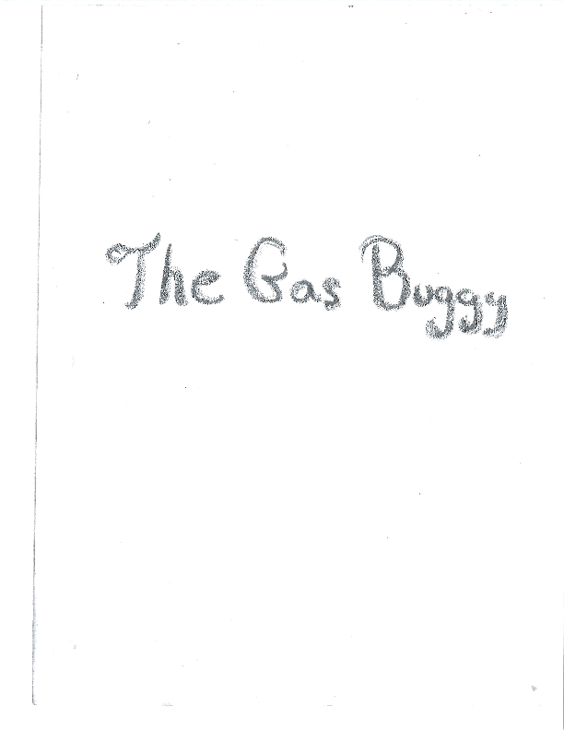

THE GAS BUGGY

When I was a boy, I lived in Lawrence, Massachusetts. Lawrence was a very busy city, and there were always lots of people who wanted to go to Boston or Portland, or even to Canada. So there was a Railroad Station downtown on Essex Street very close to the stores and to the people’s houses. It was an old building made of red stone. It had a tower, and was altogether made in a very funny shape. This station was called the depot, but some people called it the ‘deeple’, and the children used to say
“See the steeple on the deeple”.
Now this station was very convenient for downtown, but it was not placed on the main tracks of the railroad which went through South Lawrence. So the railroad ran a little shuttle train which went from the depot to a platform on the main tracks where the big train from Portland would stop on its way to Boston. The little shuttle train had just one car, a gas motor, and a bell, and all it every did the whole day was to go from the depot to the platform in South Lawrence, taking the passengers to the train or back from the train. It must have gone ten or fifteen times a day with its gas engine making a funny put put sound and its bell clanging like an old sour fire engine.
But the people of Lawrence were very fond of the little shuttle and called it the Gas Buggy. And when visitors would come to the city and would hear a funny noise near the railroad tracks, they would ask, “What on earth is that?” And someone would always answer, “Oh, that’s our old Gas Buggy!”

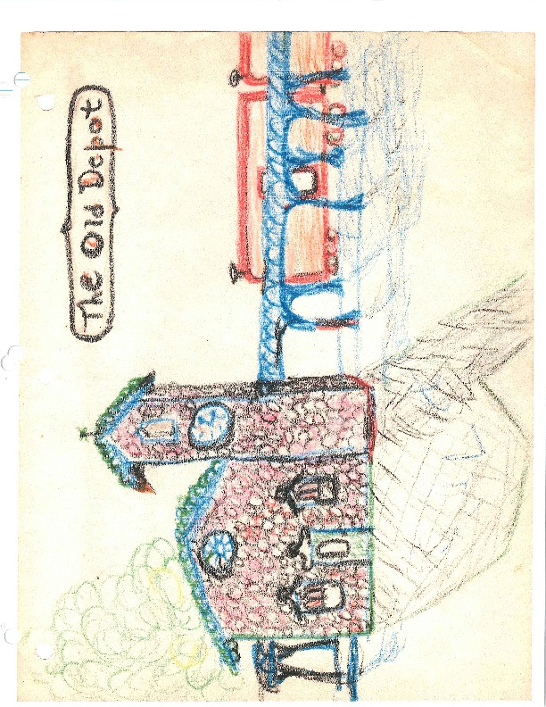
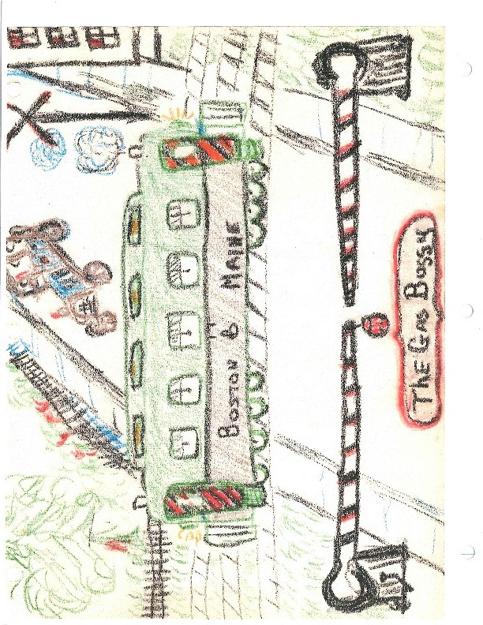
I loved to ride on the Gas Buggy. In fact, I think I like to ride on it better than on the big train to Boston. The ride on the Gas Buggy was a short one. First it went across Essex St., then across Water St., then across Broadway, and on these streets there were gates which men had to lower when the Gas Buggy came by. Then it went across the Merrimack River near the dam on an iron bridge, and if you were sitting on the right hand side, you could see the water falls and hears its roar. But by the time the Gas Buggy got to the other side of the river, its trip was practically over. All the passengers had to get off and into the Boston train.
As the years went on, and the Gas Buggy became older, it broke down more and more. There were weeks upon weeks when it just refused to run. And the depot grew older and older. Its roof leaked, its cellar was flooded, but more than this, it was just too small to take care of all the people who wanted to buy tickets for the railroad train.
The railroad people said to themselves, “We must do something about this situation. Let’s build a brand new station on the main tracks in South Lawrence, and then we won’t have to run the Gas Buggy at all.” And this is just what they did. They built a brand new station across the river. It was a large one, and had six ticket windows and a tunnel that went from the station under the tracks to the platform to Boston.
The new station was fun, because if you were lucky you might see the streamline “Yankee Clipper” speeding past to Portland. But I really didn’t like it so much whenever I thought that the Gas Buggy wasn’t running any more.

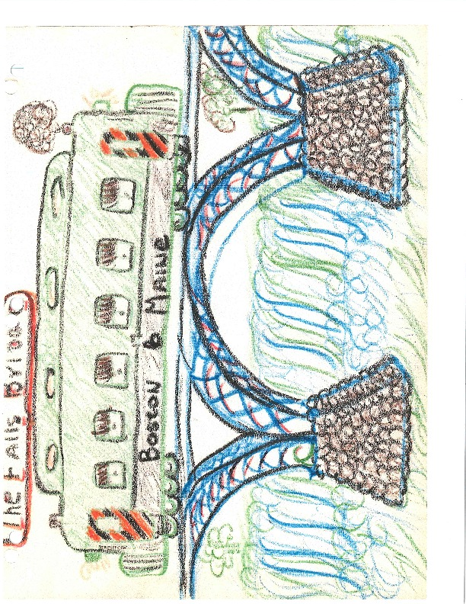
And that was the end of the old depot and the Gas Buggy. They pulled the depot down stone by stone. And the Gas Buggy was left standing on a side track just where the depot used to be. The kids used to to in it and play, and I would stand up at the front pulling the levers and making believe that I was driving it across the bridge in front of the dam.
Five years later a man whose name was George Pappadikis bought the Gas Buggy for $100 and turned it into a lunch wagon. The people liked to go into it and eat and George made a lot of money. It was a very lucky train.
THE END

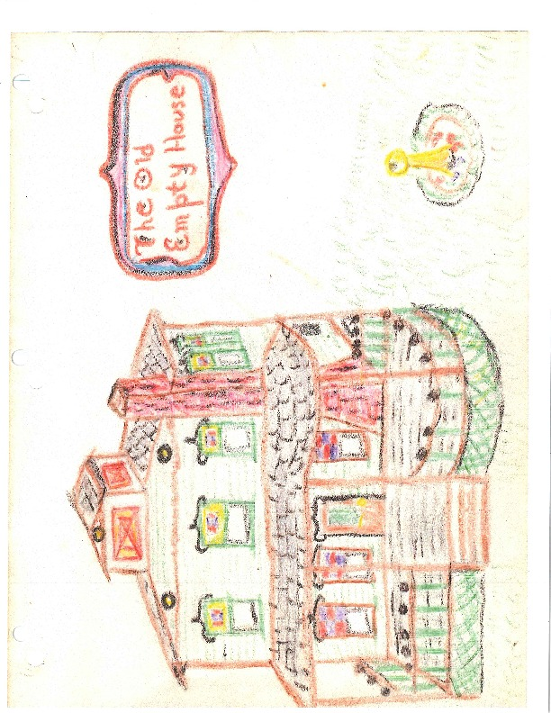

THE OLD EMPTY HOUSE

On a hot afternoon in the middle of the summer, I climbed over the fence in our back yard and dropped down on the other side where my friend Bobby lived. He was waiting for me to come, for we had planned to go up to the old empty Donovan house.
“I’m glad that the Donovans moved out in the spring,” said I.
“So’m I,” said Bobby, “I don’t think they’d ever let us climb on the cherry tree if they were living there now.”
“Let’s first climb up the cherry tree, all the way up to the secret place, and then let’s eat some cherries, and then let’s go into the summer house where the old lawn swing is ….”
“And then let’s play with the sun dial, and the old silver ball,” said Bobby.
So Bobby and I ran up to the Donovans’ yard, and climbed up the cherry tree. We went as far as the secret place where we had a flashlight and an Indian tomahawk hidden.
“Y’know what let’s do?” asked Bobby.
“What?” said I, picking a bunch of cherries.
“Let’s see if we can get into the Donovans’ house.”
“It’s awful spooky.”
“I know,” said Bobby. “My Aunt Ann says that there is a secret room in the Donovans’ house.
“I think we can get in through the windows that are on the front door,” said I.
“Let’s go,” said Bobby, and started climbing down the cherry tree. “Look,” he said when he had reached the ground, “a whole branch has fallen off. And it’s just full of cherries.” And we picked it up and took it over to the Donovans’ porch with us.
We tried the windows on the porch. There were three of them, and all were locked. We tried the front door, but it was locked. We tried the back door, but it was locked. We tried the cellar door and the ash barrel door, where they used to take the ash barrel out in the winter time. But they were all locked. And the window on the back porch was locked, and all the cellar windows too.
“I guess we just can’t get in,” said Bobby.
“We could shinny up the poles on the front porch, and climb on the roof, and see whether the bedroom windows on the second floor are open.”
“Naw,” said Bobby, “we would be seen. We’ve got to do this secretly.”
“This thing is funny,” said I, and pointed to a kind of a handle that stuck out of the wall on the house.
“That’s an ice door for a built-in ice chest,” explained Bobby. “My Grandmother has one just like that.”
I pulled on the handle, and the heavy door flew open. It covered a hole in the side of the house which led to a wooden built in ice chest in the back hallway. I could see all the way into the hallway.
“Look,” I said, “We can get in this way/”
“But we’ve got to make sure that we can get out again. Are you sure that the door won’t slam?”
“It can’t,” said I, “because the latch is broken off, and you can push it open.”
We took turns climbing in through the ice door, first Booby and then I. Over the slate where the huge cakes of ice used to stand and then over the shelving of the wooden built in ice chest.
We landed in the hallway. The house was dark, because all the shades were pulled, and it was dusty because it had been such a long time since people had lived in it. There was absolutely no furniture in it. Just some old newspaper scattered around on the floor. The house was so big and so empty that our voices echoed through the halls. We crept up to the second floor and looked in all the rooms. We found the attic door and climbed up into the attic, but the attic was dark and empty.
“Where’s the secret room?” I asked.
“It’s got to be somewhere,” answered Bobby. “Listen to the echo here.”
“Halloooooow”, we yelled.
“Halloooooooooooooow!” the echo yelled back at us. We crept down the attic stairs. Just before we reached the second floor, we found the door to the secret room. It was hidden in the wall of the attic steps. We opened the door and found another set of very steep steps. We followed them and they took us to a room tht was way about the roof. It was like a tower with windows on four sides, and full of sunlight. It was so high that we could see the buildings and mills way off downtown.
“Look,” said Bobby, pointing to a pile in the corner of the room. “Treasure.” We rushed over to see what it was. It turned out to be old ledgers and check books and cash books that had been left over from the year 1906. “Now we can really play store,” we agreed.
We hauled the books out of the secret room and down to the back hallway. Bobby climbed through the wooden ice chest and out through the ice door and I handed him the ledgers and the check books. Then I climbed through the hole. And as I was crawling over the slate, I looked down, and saw something shiny. It was a dime. I picked it up and said “Treasure! Let’s go to the store and buy two ice cream cones.”
Ten minutes later, we were walking back on Dartmouth Street. I was carrying the big branch of cherries and an ice cream cone. Bobby was carrying the ledgers and the check books and a big ice cream cone. We were both eating the cherries with the ice cream. I was smacking my lips, please with what we had done that afternoon.
“Stop licking your chops,” said Bobby, “or Aunt Ann will suspect something.”
THE END

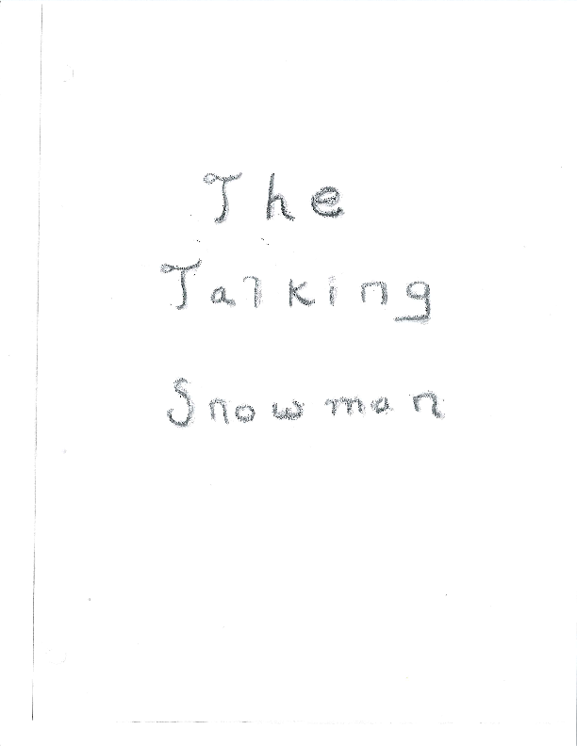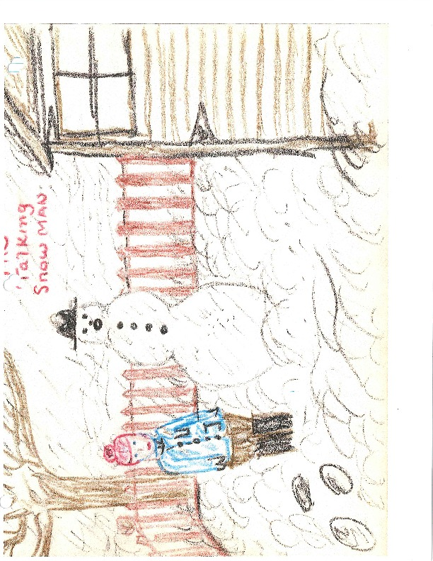

THE TALKING SNOWMAN
It began to snow about eleven o’clock in the morning. The snowflakes were fat and wet and by two o’clock several inches had already fallen. Then the snowflakes became smaller and more powdery, and by three o’clock it was quite deep./ Bobby came by walking on top of the snow with his new snowshoes.
“Come on out in the snow,” he said. We can have lots of fun.”
I put on my coat and hat, gloves and great big rubber boots, and went out into the snow.
“I’m going to make a talking snow man!” I said to Bobby.
“HA HA,” he laughed, “there’s no such thing as a talking snow man!”
“HA HA,” I answered him. “I know how to make him and you don’t.”
“I bet you can’t!” he said, and shuffled off on his snowshoes and made huge footprints all over the field.
After Bobby had gone away, I rolled two huge balls of snow and put one on top of the other. These were for the snowman’s body and his feet. Then I took a long broom handle and poked a hole down his middle. I pushed one end of the garden hose through it. Then I made a small ball for his head. I poked a hole for his mouth, and drew the garden hose up through it. I ran the other end of the hose into the garage, and I covered it up with snow so nobody would know that it was really there. When the snowman was all finished, I called Bobby over from the field.
“This snow man can talk,” I said.
“I don’t believe you,” Bobby said.
“You wait just a minute here and don’t watch where I’m going, and I’ll show you.”
I sneaked secretly into the garage and closed the door behind me. Then I took the free end of the hosepipe and talked into it.
“Hello. This is the talking snowman talking!” The sound went all the way through the pipe and came out of the snowman’s mouth in the yard.
“HHELLOOOOOOO, THISSSS ISSS THE TALKING SNOOOOOWMAAAAAN TAAAAALKING!”
Booby heard it and jumped up and down. “The snowman’s really talking,” he called out to me.
I spoke into the end of the pipe again.
“Hello, I know your name is Bobby!” The sound of my voice went through the pipe and came out of the snowman’s mouth again.
“HELLOOOOOOOOOO, I KNOOOOOOOOW YOOOOUR NAAAAME IS BOOOOOOOOBBY.”
Then I ran out of the garage, and said, “See, I really did make a talking snowman.”
“How does he work?” asked Bobby.
“I’ll tell you if you let me try your snowshoes.” He agreed to this because we were friends and I told him the secret. Bobby went off to the garage to work the talking snowman and I put on the snowshoes and shuffled over to the field.

THE END

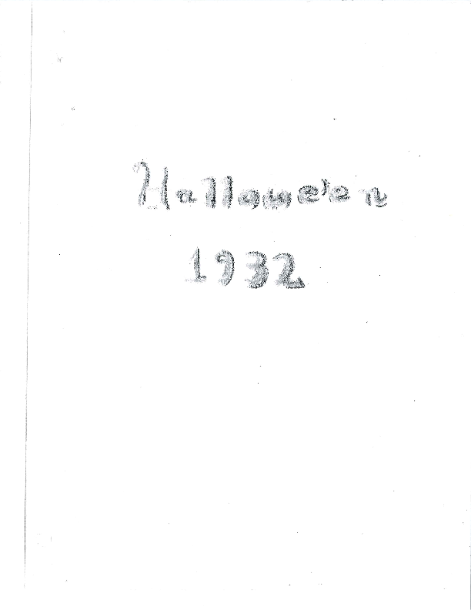

HALLOWEEN 1932
That Sunday evening in October 1932 was very warm. The crickets and the locusts were still buzzing. I remember that I was sitting under the old crabapple tree when Bobby came over.
“Hi,” he said.
“Hi,” I answered him. “Let’s talk beeswax.”
If you had been there that day, you wouldn’t have understood wht I meant. But Bobby did, and I’m going to let you in on the secret. It’s such a long time ago, I hardly think he will mind. When we first played together, we would sometimes stop under the tree and talk about what we could do. We called this talking “business”. But after a while. we changed the word to “beeswax” so no one else would understand.
So we began to talk beeswax.
“Do you think we can eat these old crabapples?”
“Naw they got worms in them. They’re all rotten.”
“I don’t think you can ever eat crabapples. They’re too sour.”
“Let’s collect a whole basket of them.”
“We could let them get real good and rotten.”
“We could keep them hid behind my garage until they got rotten and the little flies came.”
“We could dump them in someone’s yard in case they’re crabs and we don’t like them.”
“That would be good for Halloween.”
“The Sayers are always crabs. We could dump them in their yard and they wouldn’t know where they cane from.”
This is the way we used to talk beeswax. It was very important, but now I saw Mellie coming over and trying to hear what we were saying. Just listen to how we handled him.
“Shhhhhhhhh. Here comes Mellie. He’s not in on this.”
“Naw. He’s a scairdy cat. We don’t’ want him in on it. He’s in the 3rd grade. We don’t want anyone in the 3rd grade in on it.
But I forgot to tell you that I was in the 6th grade and Bobby was in the 7th grade. Naturally we wouldn’t want to have such small kinds hanging around and messing things up.
When Mellie came over we called to him.
“We’re going to do something on Halloween.”
But Mellie was ready for this.
“Me and Paul are going to do something on Halloween and it’s a secret. You don’t even know what.”
Now Paul was Mellie’s older brother. He was eleven and eleven was older than any of us. WE know that if Paul was going to do something on Halloween, it must be real good. We would have to find out.

CHAPTER II
The 31st of October was still 10 days off. The afternoons remained warm, and our fruit cooked in the sun. The apples got softer and softer. The little flies came. The big flies came. Bobby and I went to look at them every day after school. As we got closer, we held our noses and shrieked with excitement. PYOOOOOOOO.
The Sunday before Halloween, my father took me out to a farm to get my pumpkin. We always got ours right off the field. We found a nice large one and walked back to the farm house through a cucumber patch. What cucumbers in that patch! The cucumbers were much larger when I was a boy! I found one that was more than a foot long and four inches wide!
“I bet that cucumber is the largest one in the whole world. Can I have it, Mr. Cooper?”
“It sure looks like it, sonny. Here’s one that’s even larger.” Large cucumbers don’t taste good. Mr. Cooper told me that. He’d leave it rot. So I rescued it, and lugged it back home. I had an idea. I was going to make a cucumber jack o’ lantern. Only one cucumber jack o’ lantern has ever been made in the world, and that was Halloween 1932, in Lawrence, Massachusetts.
The Monday before Halloween, Bobby and I made sure all our things were ready. Sometimes a store wants to know all the things it has. Then it makes out a list of things that it has in stock. This is called an INVENTORY. I’m going to make an inventory for our Halloween.

INVENTORY (that’s the list)
DAVIS (that’s me) & WILSON (that’s Bobby)
HALLOWEEN EXPERTS
1 bu. crabapples, ripe 1 pack tacks, 1 pack broken sticks
(for tick tacks)
1 pumpkin (Bobby didn't have one)
1 giant cucumber, 15" x 6", 11 lbs, 3 oz. 1 bag dried cockleburrs
2 waxing candles 1 bx. safety matches (the wind always
2 bean blowers was blowing the jack o' lantern's
1 lb. spilt peas (very hard) candle out.)
Flashlight (our firm was up to date) Assorted Yells

CHAPTER III
Tuesday Night was Halloween. By 6:30 it was already quite dark. If you had been up in a tree watching, you would have seen some very curious things going on, in the night. A small boy came out on one back porch and looked all around. And then he raised his voice in a piercing cry:
“WOO ah WOO ah WOO ah WOO ah WOO ah”
For a moment there was silence. Then another boy came out on another porch farther down the steet and answered this cry
“Woo ah woo ah woo ah woo ah woo ah woo ah”
The first boy — I say it was a boy — but it was only a dark figure that might have been a boy, bent over and picked up several large things and struggled with them over a backyard fence and through a field. Then a second dark figure ran to meet him in the field. For a moment the two dark figures huddled together. Then, a light appeared. A candle. The eyes, nose, and mouth of a jack o lantern glowed. Bright, yellow, grinning a toothsome grin. A second candle was lit. A second jack o’ lantern glowed. Bright, yellow, grinning a thin wide toothless grin from ear to ear. The first dark shadow was me. The second was Bobby. Let’s get close so we can hear what they said.
“Have we got all the stuff?”
“Yup. We’ll leave the apples for the very end. Got the burrs?”
“Yup. You can carry the pumpkin. I’ll carry the cucumber.”
“Let’s start with the Lynches and then the Fullers and then the Axelrods.”
Now we have heard enough of these plans, let’s go back to the top of our tree so we can see better. Two dark shadows ran up to No. 24 and rang the doorbell. They ran up to 26, and rang the doorbell. They ran up to No, 28 and rang the doorbell. They ran up to No. 30. It was dark. No one in. They climbed up the porch and stood before the living room window. The living room window became white. As white as wax. The two shadows ran across the street to No. 31. They rang the doorbell. A man came out very angrily.
“GE RADDER HERE,” he shouted.
The shadows ran like greased lightening off the porch and down the driveway. They disappeared. Nothing more could be seen for two minutes, for five moinutes. Then, the bushes in front of No. 31 moved. They cracked and rustled. The shadows were behind them. One shadow reached up and taked a string thing to the side window. Now nothing could be seen again, but listen:
tick
tack tick tack tic
tick tack tack
tack tick tick
Tack Tack TACK
tICK Tic TACK
TACK TIC TACK TICK

The light at No. 31 all flew on. The front door opened suddenly. A man came out and yelled.

“GE RADDER HERE YOU KIDS, OR I’LL CALL THE POLICE AND THEY’LL THROW YOU IN THE LOCKUP.”

The bushes opened up and the shadows burst forth carrying the yellow grins and shooting floods of split peas in all directions. They ran until they came to the street lamp at the top of the hill. There are some more shadows up there. Colored ones. Let’s follow after them so we can see and hear what’s going on. It’s a flock of children wearing costumes, carrying pumpkins, beanshooters, blowing horns. There were horses, donkeys, witches, firemen, baseball players. All were wearing masks. I don’t know who they were. They were yelling and calling and screeching and hooting and shooting beans. They were moving from car to car, waxing the side windows.
“Let’s go to the Axelrods.”
“Give them the treatment.”
“I need a candle. I lost mine. Where’s Pooty?”
“I know who you are. You can’t hide behind your mask. You’re Rosie, I can tell. HA HA HA. I’m a witch.” “PROOOOOoooooot, PROOOOoooot”
“Can you hit the light with your shooter?” “Watch.”
“Let’s go to the Reservoir.” “Come on you kids.” “Come on Patty.”
“Let’s go to Bennie’s store and wax his windows. He couldn’t catch nobody.” “Scram, Doodie, and tell your mother we said so.”
“Get off my costume. You’re tearing it. Duck, the lights going on.”
“What’s that?”
“It’s a jack o’lantern. It’s really a cucumber.”
“Let me hold it.”
“Let me, let me!”
The crowd of kids squashed round the cucumber jack o lantern. The noise got louder and louder. The cucumber passed back and forth. It was patted, felt, squeezed, tossed in the air, and opened up. The kids were so busy they didn’t notice two white shadows lurking in the dark of the driveway. Ghosts. Two white sheets. But the ghosts had to see and had to shoot their bean blowers, so there were three holes in the sheets.
Two ghosts. A big ghost and a small one. They swooped down on the crowd and shot a load of beans into its midst, and disappeared from sight before anyone could tell what had happened. A cry went up.
“After them. It’s those guys from Margin Street!”
“They went down the driveway.”
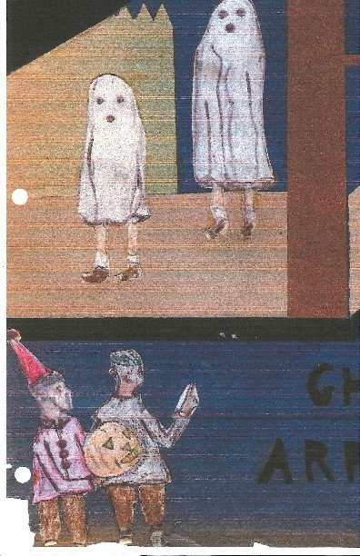
The crowd broke up and ran in fifty different directions. The colors became shadows again. The driveways and the bushes came alive, but the ghosts were fast. They had disappeared. No one knew who they were or where they had gone. The cucumber shadow said to the pumpkin shadow.
“We’ve got to get them.”
“They must have gone to the reservoir.”
“Let’s go over there. We’ll split up. You go around one way and I’ll go around the other till we meet. We can use our danger signal if we meet the ghosts.”
Now we must move over to the reservoir to see what happened there. It was one street away. Very dark and very lonesome. There weren’t any houses around. All you could hear was the ssssssissssshssssssisssssh of the water as it poured out of the fountain.
They put their jack o’lanterns down by the reservoir gate but took the flashlight. They crept along the bushes carefully, each going in his direction, watching for the slightest sign of the two ghostlike beings. The reservoir seemed deserted. The air was still. The water rushed out of the fountain with a ssssssissssshssssssisssssh. Let’s follow the first boy; the one that was carrying the cucumber. Up the embankment. Past the little tool house. Past the flagpole. Across the little wooden bridge. Then a dull light gleamed in the distance. Was it the ghosts? He would have to get closer. He rushed into the open, approaching the light. Two white figures, one small, one large. Three black spots on each. A dull soft light illuminated the larger figure from within.
Back to the bushes. Hide. Then give the danger signal. Bring Bobby back. The ghosts have been found.
“Yaaaaahhhyaaahuhhhhyahhuhhhh”
The danger signal was sounded. A pause. Then the answer from the other side of the reservoir.
“yaaaaahhhyaaahuhhhhyahhuhhhh”
Wait quietly and patiently. Bobby would arrive in a moment. They must make plans.
“Have you got them?”
“They’re up ahead walking toward the field.”
“You run through the bushes and cut them off in front. Flash the flashlight in their eyes. I’ll come from behind and pull off their sheets.”
Everything arranged, and off. The ghosts were surrounded. The flash flashed in their eyes. For a moment, the ghosts could not see. Whissst, the sheets were jerked off, and two boys were underneath.
“Ha Ha! It’s Paul and Mellie. It’s Paul and Mellie. We thought it was you all the time. Paul and Mellie are the ghosts!
The unsheeted ghosts said not a word. They shot their bean blowers and drove their discoverers back. They put on their sheets and became ghosts again. They ran down the road, and Paul shouted,
“We know you’re saving apples, and we’re going to spill them out before you can get them!”
The apples! Our friends had hardly thought of them the whole evening. They thought they were in a safe place, but the secret seemed to be out. Paul and Mellie knew about them.
The race for the apples began. Across the bridge. Past the flagpole. Past the toolhouse, Down the embankment. To the gate. Pick up the pumpkin and the cucumber. Across Ames Street. Into the O’Brian’s yard and through the hole in the grapevine. Paul and Mellie didn’t know about this shortcut. Up the Parkinson’s driveway. Across Hillside Avenue. Over behind the garage. Panting, breathless they arrived. No sign of Paul and Mellie. The apples. The apples were safe. They dragged the basket over to the fence. They were going to lift it over the fence and dump the apples on the other side. It was heavy. They tried to lift it but couldn’t. The two ghosts rushed up.
“What’re you doing?”
“We’re dumping the apples into the Sayers’ yard.”
“They’re crabs.”
“Let’s all lift it up.”
The four boys lifted the heavy basket of fruit. For a moment it rested on the spikes of the fence. It teetered and tottered, and then, PLLUURRRRPPPPSSHHHHH the load of rotten apples plunged into the next yard.
And I do not know what they would have done, but
BONG, BONG, BANG, BANG, BUNG, BONG, BONG, BONG, BONG
Nine o’clock. The group separated and walked to their houses.
One boy put a fistful of split peas in his mouth, and shot them out at the street lamp. He found an open car and put some cockleburs on the driver’s seat. He climbed up his back porch and signaled.
“Waahwaahwaahwaahwaahwaah”
Then down the street the signal was answered.
“Waahwaahwaahwaahwaahwaah”
Halloween 1932 was over.

THE TOTAL ECLIPSE

One evening in July, my father came home from work and as usual gave me the Evening Tribune he’d bought. I always liked to get down on the kitchen floor with the paper and read the funnies. I read “Salesman Sam”, and “Freckles and his Friends”. I didn’t read “Wash Tubbs” or “Boots and Her Buddies” because I didn’t like them.
After I read the funnies, I looked at the front page to see the weather and the treasury balance. There was an interesting article about a total eclipse of the sun that would be visible in many parts of New England on August 20. I had never seen a total eclipse because they do not happen very often. I asked my father whether he had ever seen one. He said, “Yes. In 1923. It got so dark that one of the clothing stores on Essex St. was robbed.” I asked my mother if she had ever seen one, and she said she didn’t think so.
I ran out the back door, climbed down the fence near the sumac bush and into Bobbie’s yard. I called him and he came out and said his family was still eating supper and that after they finished he would have to crumb the table with the silver crumber. I waited anyway, and finaly Bobby came out through the cellar door.
“We have some very important beeswax to discuss,” I said.
“What about?”
“About the total eclipse of the sun. Let’s watch it together.”
“I can’t,” said Bobby, “we’re going to New Hampshire in August. Besides, you can’t watch it in Lawrence.”
“You can so. It said so in the paper.”
“You can see most of it. But the sun won’t get completely covered up in Lawrence. You have to go away to see it get completely darl.”
“Where do you have to go?” I asked him.
“Toward Maine.”
“Well, let’s play with your steam engine,” I suggested.
“O.K.”, he answered and went up to his attic and brought it down.
We filled the steam engine with water and lit the alcohol flame from the pilot light on the gas range. Bobby’s gas range had a button, and if you pushed it, four long tongues of flame went over to the burners. After a while, the water boiled and the whistle blew. Then the piston started working and the wheel turned around.
“If we had a wooden cannon that works with a spring, we could connect it to the wheel and the engine would shoot off the cannon ten times a minute.”
“More than that,” said Bobby. “Have you got a cannon?”
“No, but they sell them in the five and dime.”
The next day, my mother gave me a dime, and I walked down town to buy a cannon. I went to the toy counter in Woolworth’s, but I didn’t see any. I asked the lady behind the counter and she said they didn’t have any cannons at all. I saw a wrist watch for 10ȼ. I asked the lady if it really worked, and she looked at me kind of funny. Then I saw a toy snake — the kind you hold on its neck joint and the whole snake wiggles back and forth. The snake cost 5ȼ, so I bought it. I also saw a special viewer for the total eclipse, a piece of very black film on a piece of cardboard with eye holes and a nose hole. This cost 5ȼ, so I bought it and went home.
When I got home, I held the snake near the canary’s cage. The canary opened his wings and beak to fight the intruder. He does this anyway when I stick my finger in his cage and pretend it’s a snake. He couldn’t tell the snake I bought was made of plaster.
The directions on the total eclipse viewer said that you should never look at the sun with your naked eyes. It also said that at the very moment of totality, Bailey’s Beads appear. These are a thin sparkling rim of like that looks like a diamond necklace. They are caused by the sunlight shining through the mountains of the moon.
That night the Evening Tribune had a map showing where the eclipse was total. The nearest place was about 18 miles from your house in Amesbury. I asked my father if we could go to Amesbury on the street car to see the total eclipse. He asked why wasn’t Lawrence good enough, and I told him about Bailey’s Beads. He said that Uncle Charley was interested in such things, and he would ask him. Uncle Charley might take us in his new Graham-Paige.
Nothing very much happened for a couple of weeks after that. Except one day I found out that if you opened the canary’s cage and he flew across the mirror and perched on the frame, he would see himself in the mirror and begin to sing.
Uncle Charlie agreed to drive to Amesbury in his new Graham-Paige. The weather turned out fine. The hour of totality was late in the afternoon. Just myself and my father and Uncle Charlie went along as everyone else was away or busy. Uncle Charlie drove up Swan Street into Pleasant Valley, and when we got to Lake Kenoza, he stopped and ate half a corned beef sandwich. He does not like to go on long trips without stopping half way.
In Amesbury, the road was jammed with more car than I’ve ever seen. We pulled over to the side and waited. The eclipse had already begun. Now the thing about an eclipse is this. It really takes a long time for the moon to cover the sun, and after it’s over, it takes a long time to uncover the sun. But the time when the sun is completely covered is quite short. We waited and waited. The viewer I had bought was very good. My father and Uncle Charlie too along a bunch of snapshot negatives to look through, but mine was better and they kept borrowing it.
Suddenly, the sun was entirely covered. The whole place got very dark. A cold breeze blew across the field. I head a robin sing the special song they sing at sunset. Bailey’s Beads appeared and lasted longer than I would have thought. We all had several turns on my viewer. I took out the snake, and it seemed to me that it was more real than usual.
When the total eclipse was over, we waited around for a while and then went back home. Uncle Charlie stopped at Lake Kenoza and ate the other half of his sandwich.
“How was it?” my mother asked us when we got back.
“Good,” I said.

THE END

