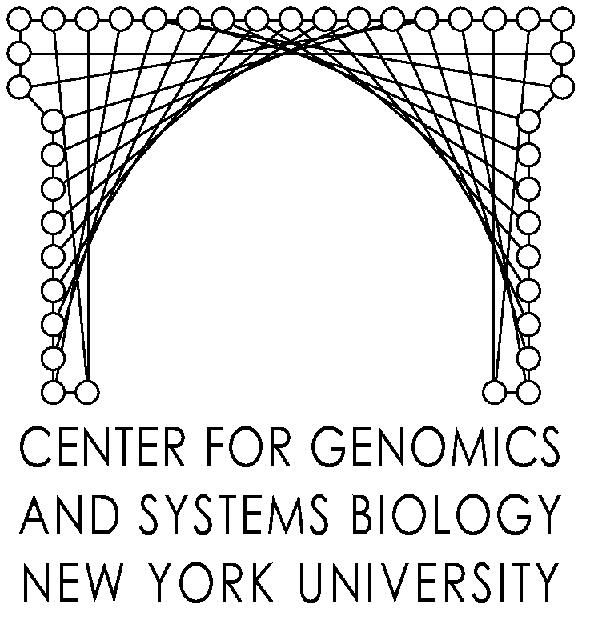
New York University

A private university in the public service
Center for Genomics and Systems Biology
12 Waverly Place
New York, NY 10003

Dec. 8, 2011

Monsanto visit to NYU Center for Genomics & Systems Biology

“Systems Biology and VirtualPlant “

AGENDA

9:00-9:30 Introductions & refreshments (Board Room, 8th floor)

9:30-10:00 Overview
“Plant systems Biology: From predictive modeling to trait evolution”
Gloria Coruzzi

10:00-10:30 VirtualPlant: A tool for systems biology.
Manpreet Katari

10:30-1:00 Hands-on VP session with lunch

1:00- 2:00 Future work
Dennis Shasha

2:00-3:00 Open discussion

Attendees:
NYU: Dennis Shasha, Professor, Courant Institute of Mathematical Sciences
Gloria Coruzzi, Carroll & Milton Petrie Professor, Center for Genomics & Systems Biology
Manpreet Katari, Clinical Assistant Professor, Center for Genomics & Systems Biology
Roberto Jimeno, Programmer
John Sabini, Programmer
Sadhana Chitale, Office of Industrial Liaison

Monsanto
Dr. David Russell, Director Technology Prospecting
Dr. Virginia Ursin, Technology Prospecting Lead

