December 6th Scribe Notes: Part 1
Going over XOR Circuit Homework:

Professor Shasha brought Julian up to go over his XOR Circuit. Julian “forgot” how he’d done it, so Professor Shasha put him on the spot to the amusement of all (You know we love ya Julian). Here’s the XOR circuit:

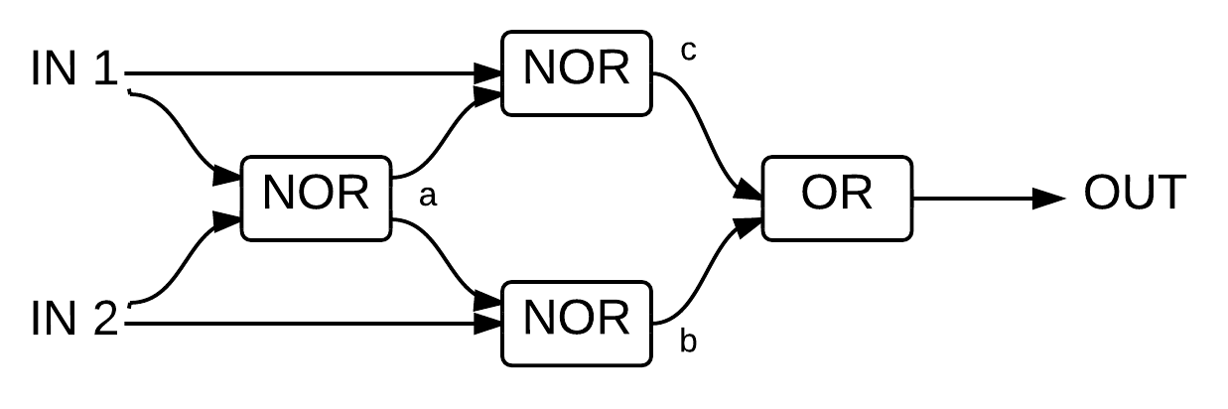

And here’s the truth table for it. I’ve included what the intermediate outputs will be at points a, b, and c. Remember, each gate (eg the boxes) can have just one output state at a time. For example, the first NOR will either output 1 or 0 to the middle 2 NORs, but will never output a 0 to the top NOR and a 1 to the bottom NOR.

IN 1 | IN 2 | a | b | c | OUT
0 | 0 | 1 | 0 | 0 | 0
1 | 0 | 0 | 1 | 0 | 1
0 | 1 | 0 | 0 | 1 | 1
1 | 1 | 0 | 0 | 0 | 0

You can think of a NOR gate as a neither gate – the output will be 1 (True) only if neither input is 1 (True). You can also think of a NOR gate as an OR gate followed by a NOT gate.
Let’s fill out the intermediate columns, working towards the final output. To fill out column a, look at the inputs to the first NOR (IN 1 and IN 2). We know that a NOR gate outputs 1 only if neither input is 1 (equivalently, if both inputs are 0). So, only the top row of column a will have a 1. To fill out column b, look at the inputs to the middle bottom NOR (IN 2 and column a, the output of the first NOR which we’ve just filled out). So, column b will be 1 only when IN 2 and a are 0, which happens only in the second row. Column c will be found in a similar way to column b except by looking at IN 1 and column a. The final output will be 1 if either point b or point c are 1, which happens in rows two and three. Looking at the final product of this circuit, we see that the output is 1 if either input is 1 but not both. This is known as an exclusive OR or XOR.

Circuit Quiz Question 1

Danna went over how she solved the first question on the quiz. The problem was to create a circuit diagram that followed the given truth table. Here’s the truth table from the quiz:

IN 1 | IN 2 | IN 3 | OUT
0 | 0 | 0 | 0
0 | 0 | 1 | 0
0 | 1 | 0 | 0
0 | 1 | 1 | 1
1 | 0 | 0 | 1
1 | 0 | 1 | 1
1 | 1 | 0 | 1
1 | 1 | 1 | 1

Danna said it helped her to draw the gate diagram (the boxes) before drawing the full circuit diagram with transistors and voltages. Her diagram is below:

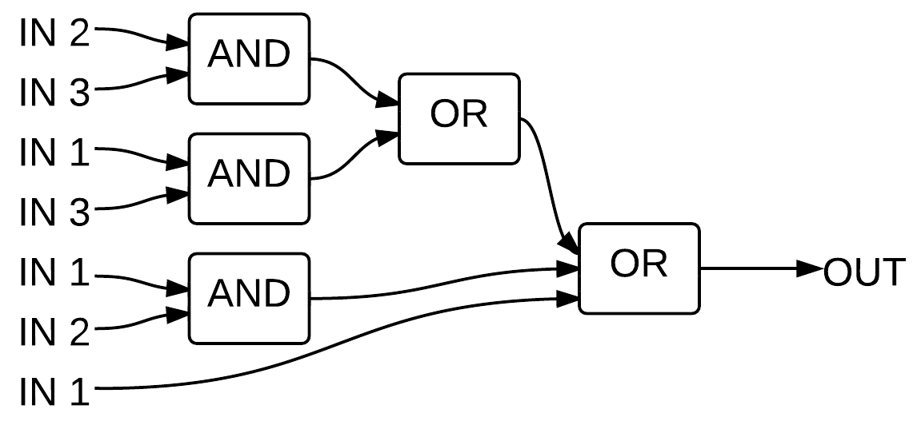

Don’t let the multiple identical inputs confuse you. Remember, we are working with electricity, so this could be drawn equivalently with just IN 1, IN 2, and IN 3 on the left with multiple wires leading to the corresponding gates.
What does this diagram actually mean? Sometimes it’s easier to start from the end (right) and then work backwards. The output will be 1 when at least one of the inputs to the final OR is 1. The bottom input to the final OR just comes from IN 1. Looking at the truth table this makes sense: whenever IN 1 is 1, OUT is 1. The middle input to the final OR comes from an AND of IN 1 and IN 2. So, when both IN 1 and IN 2 are 1, OUT should be 1. Looking again to the truth table, this checks out. The top input to the final OR comes from an OR whose inputs come from an AND of IN 2 and IN 3 and an AND of IN 1 and IN 2. In other words, that middle OR will output 1 (and in turn make the final OR output 1) when both IN 2 and IN 3 or both IN 1 and IN 3 are 1. This also works with the truth table.
This is a perfectly functional circuit, however there is a more obvious way to do it that may help you determine the full circuit diagram more easily. Notice that whenever IN 1 is 1 in the truth table, OUT is 1. This makes the middle input to the final OR redundant: yes, when both IN 1 and IN 2 are 1, OUT should be 1, but IN 1 being 1 is enough by itself to make OUT 1 (due to the bottom input to the final OR) and there is no case where IN 1 and IN 2 will be 1 without IN 1 being 1. An equivalent argument can be made for the left middle AND: IN 1 and IN 3 will both be 1 only when IN 1 is 1, which is already enough to make OUT 1 by the bottom input to the final OR. By taking out the left middle AND, we effectively make the middle OR into a wire because its bottom input will always be 0 (because there’s nothing attached to that wire), so it should output 1 only when its top input is 1 (which happens only when IN 2 and IN 3 are 1). Here’s an updated diagram with the redundant gates crossed out:

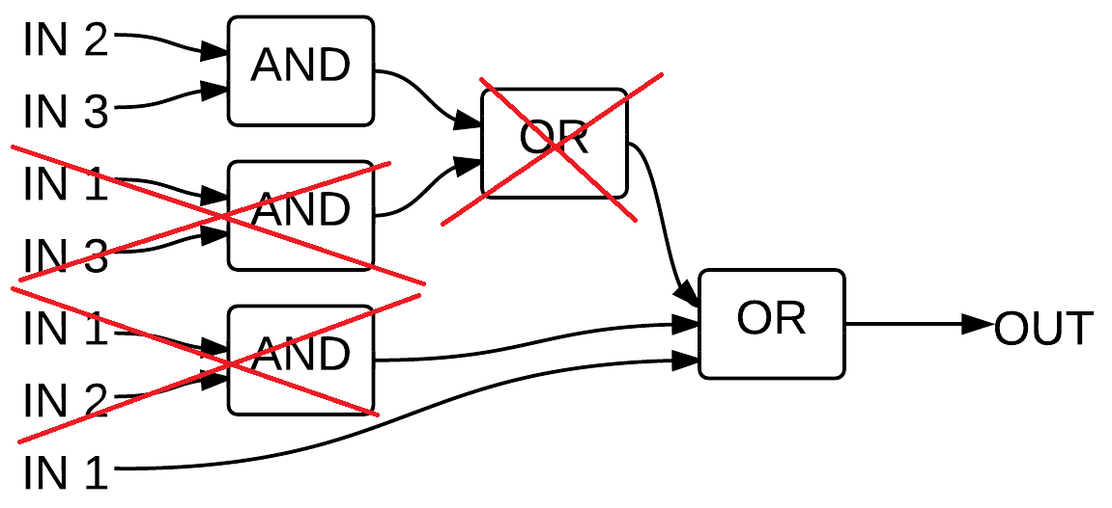

Remember that the middle OR is now just a wire. Given this diagram, it’s easier to determine the full circuit diagram. An AND is like two transistors in series: both must be on for current to flow. An OR is like transistors in parallel: if either is on, current will flow. Here’s the full circuit diagram with the AND and OR overlaid:
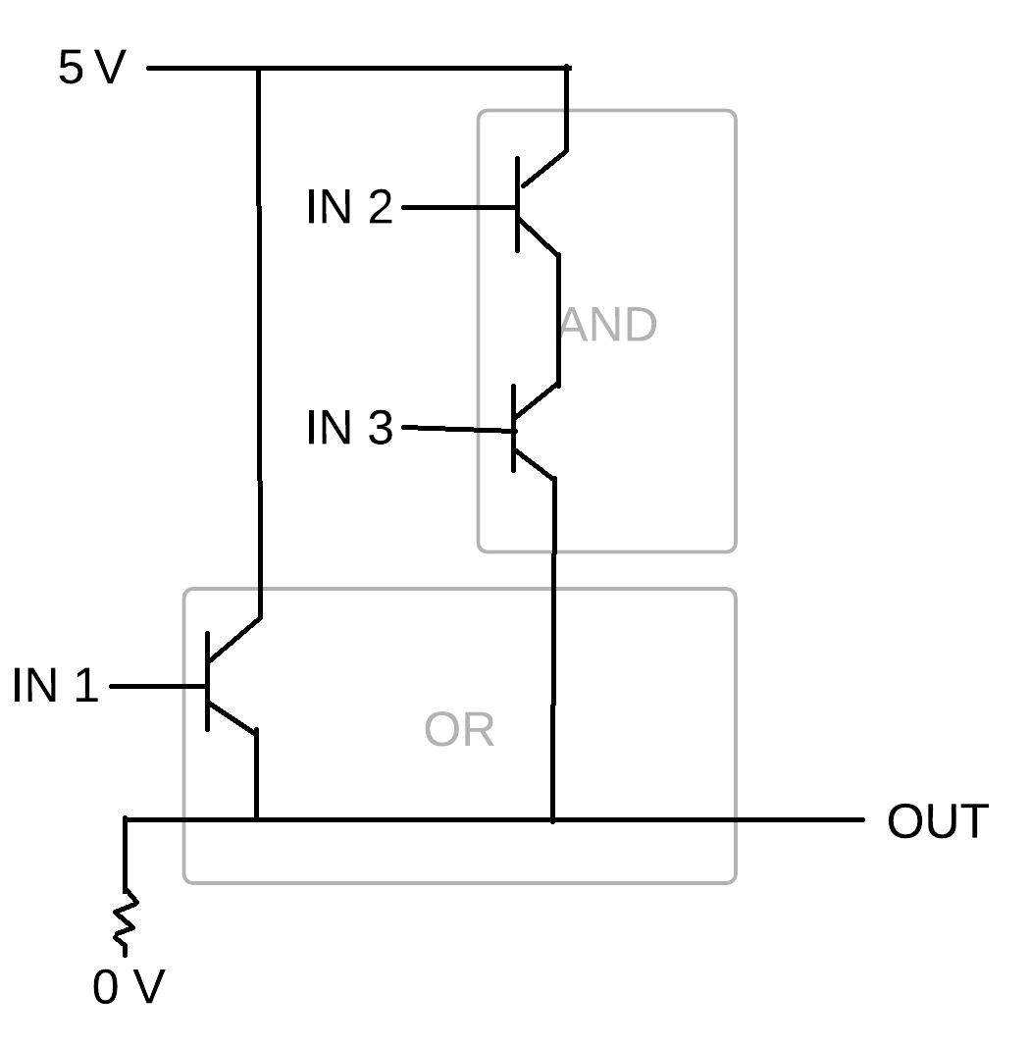
Circuit Quiz Question 2:

The task was to create a gate diagram (boxes) that will return 1 (True) when exactly 2 inputs are 1. The word ‘exactly’ means that if all three inputs are 1, it should return 0. Here’s Sareen’s attempt. We were only supposed to use AND, OR, and NOT gates, although Sareen used XOR and NOR gates as well:

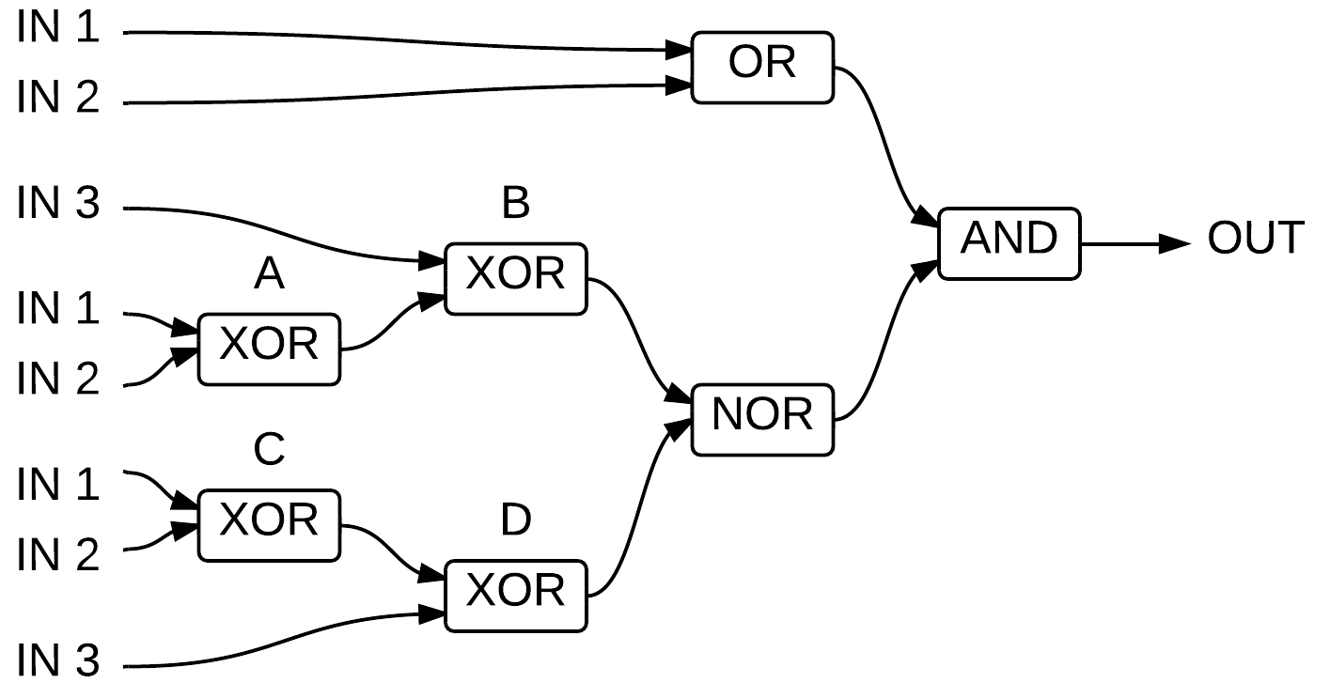

Professor Shasha commented that the circuit is asymmetrical, which is usually a bad sign if the order of the inputs doesn’t matter (In other words, it doesn’t matter which two inputs are 1, so it would seem to make sense to have all the inputs do the same thing, whereas in this circuit IN 1 is going to an OR and two XORs, while IN 3 is just going to the those two XORs). Also notice that the two inputs into the NOR will always be the same because the circuits leading up to them are identical. This means that if XOR B outputs 1 then XOR D must also output 1, so the NOR will output 0. If XOR B outputs 0 then XOR D must also output 0, so the NOR will output 1. This same outcome can be achieved by removing the bottom three inputs (IN 1, IN 2, IN 3) and XOR C and D, and replacing the NOR with a NOT receiving input just from XOR B. This is shown below:

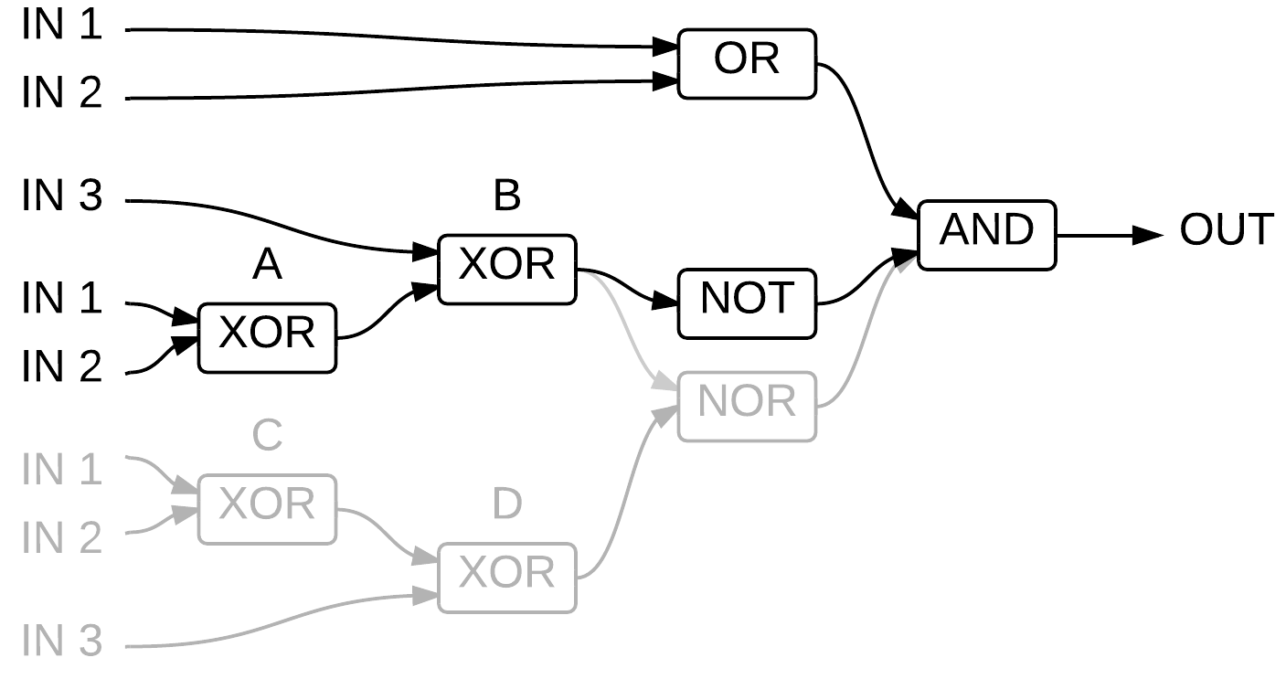
Further, notice that each XOR can be replaced by an OR and a NAND (which itself is an AND followed by a NOT) which both feed into an AND, shown below. Even verbally this should make sense. I’ve inserted parenthesis for readability, but the phrase “(IN 1 is true) or (IN 2 is true), and (IN 1 and IN 2) is not true” is grammatical and logical.

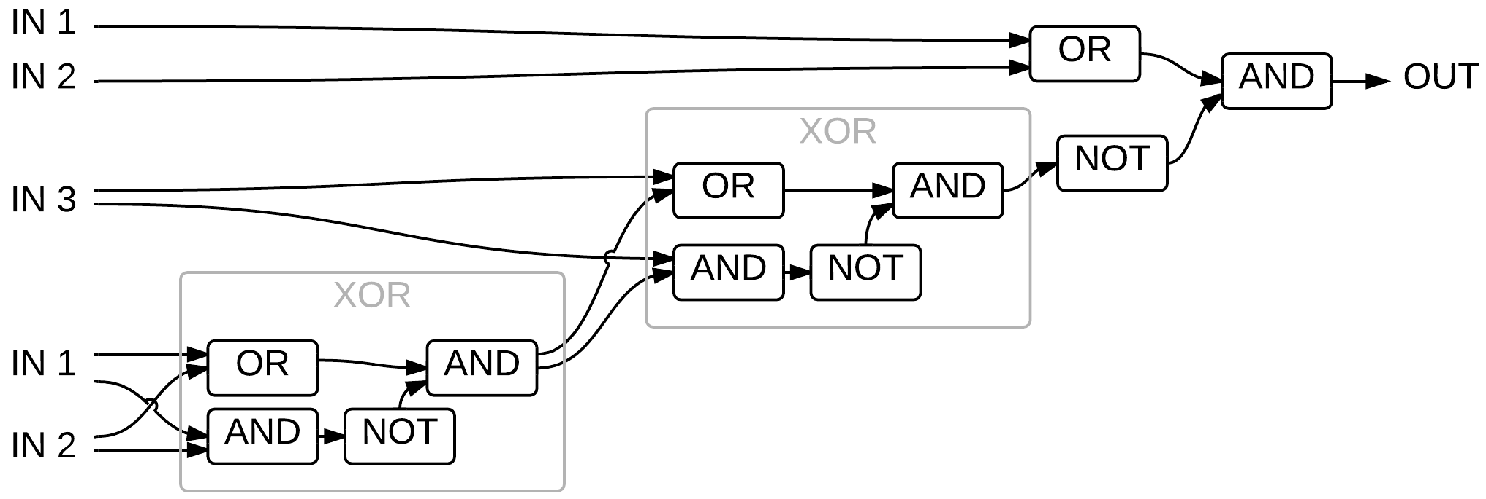

This completes the assignment, but by playing around with it you should be able to simplify it further. For example, notice that the OR in the first XOR has identical inputs to the OR right before the final AND. This means that those ORs can be combined, with the output from that single OR going to where the individual ORs used to go.
Here’s a solution using 7 gates (This isn’t directly derived from Sareen’s version, but I wonder if you could get between any two working circuits using arguments similar to those I’ve made above?):

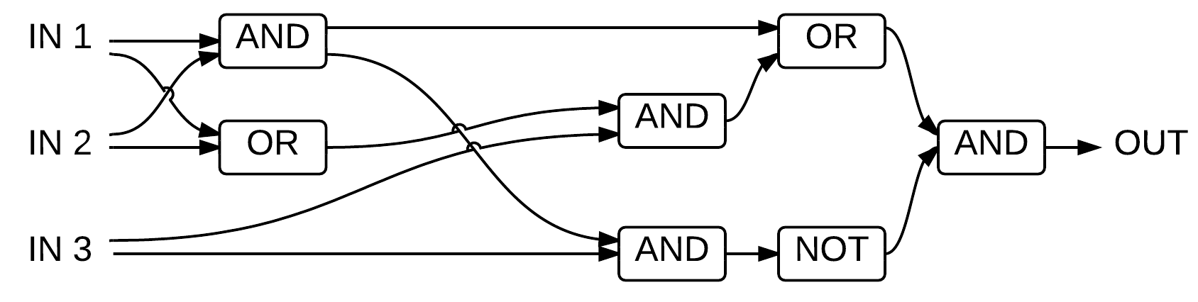

Circuit Checking Circuits Problem:

We held off going over the Circuit Checking Circuit puzzle until next week, but Professor Shasha gave us some hints.
When making a calculation, the computer actually does all possible operations simultaneously, but only the required result is used. For example, if you wanted to add 5 and 2, the computer will compute 5+2, 5-2, 5x2, 5/2, 5^2, etc. Which output is used is determined by a device called a Decoder. A Decoder accepts a few bits as instructions and has as many outputs as the number of operations the computer is capable of doing. Outputting a 1 on the multiply wire will tell the computer to use the result of the multiplier, a 1 on the add wire will tell the computer to use the result of the adder, and so on. This is diagrammed below:

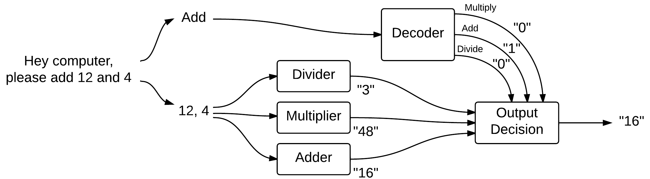

The above isn’t super important so don’t worry if you don’t understand. The important part is the following: if the decoder outputs more than one 1, then the computer will crash because it won’t know which result was actually intended to be used. In order to prevent this, there is circuitry which checks all the outputs of the decoder, and if more than one output is 1 the computer is instructed to shut down in a safe way, or somehow recover from the error. Professor Shasha worked on making one such decoder checker after college. This problem is actually analogous to the Circuits Checking Circuits problem. Here’s a checker for a six output Decoder that works in some cases:

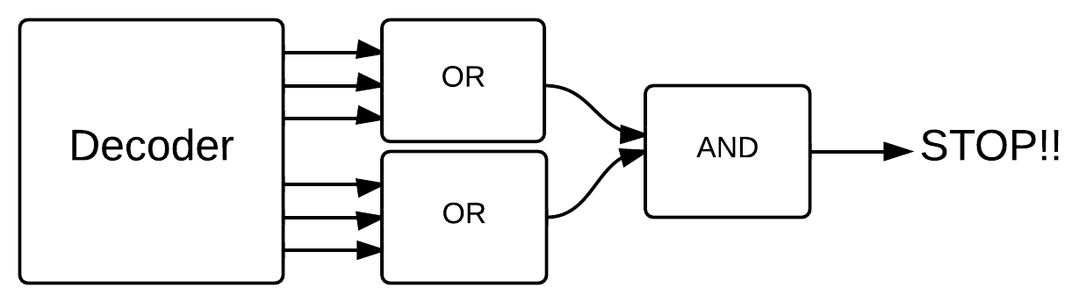

If one 1 comes from the bottom 3 outputs and one 1 from the top 3 outputs, then both ORs will output 1 to the AND which will in turn output a 1, causing the computer to stop. However, if both 1s come from the bottom 3 outputs, or even if all 3 of the bottom outputs are 1, then the checker will not output a 1 (which means it fails to detect the error). To solve the Circuits Checking Circuits problem, any two outputs being 1 must result in a stop command.

