Remove your logo – will only be from nyu wireless and nyu

NYU Wireless Docket 14-177 NOI Comments Outline

Introduction:

Who is NYU Wireless, why is it qualified, and what are it interests
Bibliography of reports that are related

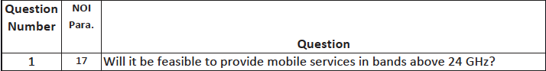
Yes. Research at NYU Wireless and elsewhere show that the propagation channel is appropriate if cell sizes are in the 100-200m range and MIMO-like technology is used in base stations and mobiles. With beam combining, where receivers are able to couple energy from multiple beams simultaneously from more than one directional antenna, distances can be increased to 300-400m. While rain and atmospheric attenuation are factors on larger distances, these effects will be less deleterious over shorter coverage distances. Foliage and shadowing by people and objects will play a role in blocking signals, but early work indicates reflections and scattering paths from other directons may be quickly formed using electrical beamsteering, thus allowing a mobile link to be maintained at high speedsSummarize NYU papers

>24 GHz will not soon replace lower bands that allow for much larger cell sizes due to more benign propagation. 5G planning generally considers >24 GHz as a supplement to lower bands, not a replacement. However, for unlicensed access or for enterprise mobility, stand-alone mmWave bands will llikely be viable. Over time, as adaptive antenna technology and low power millimeter wave circuits and systems are perfected for performance and low cost, it is possible that the lower bands will become less important for future mobile systems, just as 150 MHz and 400 MHZ systems of the 1950’s-1970’s are not used widely today in mobile communications.

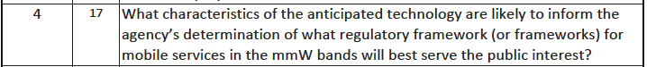

We believe that FCC regulation should be enabling, and not prescriptive. One can never be certain when technology in band X will be economical, but one can be certain that if FCC forbids mobile in a band that there will be major disincentives to capital formation for R&D due to regulatory uncertainty and regulatory risk. Thus , we would advocate for the FCC tocreate mobile service rules for some or all of the bands discussed in a way that does not preclude other uses now authorized, and to enable new uses of existing spectrum held by incumbent license holders, as long as the new uses do not cause harmful interference to others. Where there are incumbents, incum,bents should be honored and given flexibility and time to form capitalization and business partnerships that would allow for the transition of spectrum use for the highest and best value as deemed proper by the license holder. Marketplace forces should be relied upon to either facilitate the transition at the time it is economically practical or to encourage the development of appropriate sharing techniques. We would encourage the FCC to find multipole-GHz of spectrum bands suitable for mobility above 24 GHz, and consider nationwide auctions with very light regulations for the winning bidders.

Thus the focus should be on enabling mobile access in specified bands subject to reasonable stated interference limits to adjacent bands and adjacent cochannel licensees such as satellite users and federal government systems.

While FCC did have detailed technical interoperability standards for 1G cellular in the early 1980s, since 1987 FCC has not specified CMRS technologies for new systems ()Citation please. This flexibility is what allowed CDMA to be developed in the US while it was shunned by prescriptive overseas regulators as being immature. All 3G technologies incorporate CDMA subsystems, and this generation of mobile technologies all over the world would not have been possible if the US had not been the testbed for proving the effectiveness of this innovative technology.

Give a similar example of how unlicensed bands in ISM allowed for the proliferation of today’s WIFI, and how in the future, capacity and coverage may require future license holders to collaborate and cooperate with network operators of unlicensed spectrum. There should be sufficient flexilbity that today’s mmWave spectrum holders should be allowed to implement Wi-Fi like service if they felt the business demand or unmet need was there, and similarly, the FCC should encourage the development of mmWave equipment through more spectrum licenses and more unlicensed spectrum blocks (5 to 10 GHz for each ) in the near future.

Where there are incumbent fixed service area licensees, we believe the path for timely implementation is to give them the rights for mobile transmissions as well as Wi-Fi like coverage, in addition to backhaul or fixed point-to-point, in their service area, subject to a buildout requirement. While this raises the possibility of “unjust enrichment”, it can result in more rational planning than the alternative of having separate mobile and fixed licensees in the same service area and same spectrum who must coordinate over time. The resulting marketplace forces will facilitate licensee decision making to determine the appropriate sharing details much faster than detailed FCC rulemaking would.

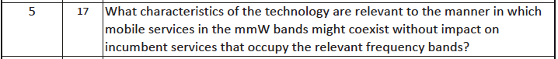

The small wavelengths involved encourages the use of directional transmission, because antenna sizes have to be smaller at higher frequencies/smaller wavelengths.. This implies that transmissions will tend to be noise limited rather than interference limited – a major departure from today’s CMR services. The ability to electrically steer beams with great accuracy is a powerful technological capability that previous mobile and WiFi networks have not been able to exploit due to much larger wavelengths and thus much smaller gain (broader radiation pattern) antennas.

In addition, atmospheric absorption and poor diffraction over obstacles limits undesired power received at other users, much more so than at lower frequencies

It is likely that the same bands can be used for both mobile and fixed/backhaul in the same area, but it is uncertain when this will become economically feasible. FCC rules should allow this but not require it. Thus. when the technology becomes mature for commercial use, it can be implemented in a timely way without further FCC rulemaking or waivers. We believe that simultaneous use for mobility and backhaul will be supported in the same spectrum, provided that spectrum allocations are sufficiently wide to justify the capital investments to bring such equipment to market. Channel bandwidths of 2.5 GHz or more will be necessary for such efficient use and rapid development of the spectrum, as this represents about an order of magnitude increase in spectrum compared to most incumbent 4G cellular operators [5G it will work].

One way to share spectrum between fixed and mobile is to use TDD and place mobile and fixed use in different time slots. The smaller cells of future mmWave networks will readily lend themselves to time division duplexing, due to the relatively small time delays between close-in mobiles and mobiles at the edge of the cell. CDMA with interference cancellation could be used in many mobile and fixed channels, due to the relatively benign multipath spread (lending to simple receivers) and very wide channel bandwidths that appear flat when highly directional antennas are used (Sun IEEE Comm Mag Dec 2014). Another way to efficiently share spectrum is to use CDMA for the fixed signals to separate the two signals. Finally it will likely be possible to place a mobile base station with a MIMO-like antenna at one height on a monopole support and place a fixed antenna high on the same monopole. Adequate separation between the two systems could be implemented through a trade off between vertical separation of the two antenna systems and separation of the beam patterns of the two systems. In general the lower mobile antenna would have downtilt that would increase the separation of powers.
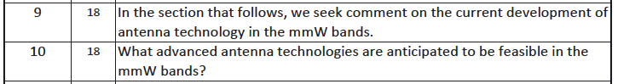
MIMO-like technology in both the base station and the mobile antennas appears to be possible and a key way to deal with the difficult propagation paths encountered in mobile use >24 GHz. MIMO in 4G is implemented by simply orthogonolizing (nulling out interference) without true beamforming where energy is directed with low sidelobes (e.g. today’s cellular does not implement classic beamforming for high directivity (Liberti 99). As shown recently, urban measurements in New York City show that mmWave systems could implement true beamforming, single user MIMO where multiple beams carry indepdnent data streams, or massive MIMO when the channel coherence degrades among many users (Sun IEEE CommMag Dec 14). The potential for Massive MIMO is very strong in mmWave systems, where antenna manifolds can be electrically large but relatively small in physical size compared to today’s cellular antennaas, and the rich scattering supports diversity (Caire June 14).

However, we believe FCC should not require any specific antenna technology or design techniques but should instead focus on interference limits in the new regime of directional antennas. Allowing flexible licensing that enables engineering solutions that exploit interference cancellation, beamforming, MIMO, and new spatial processing should be allowed and encouraged for the US wireless industry to develop and expand rapidly.

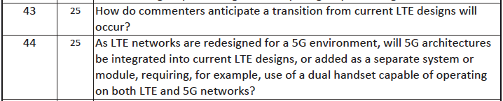

5G at >24 GHz will supplement LTE, not replace it, at least for the next decade. 5G will not be one monolithic technology in a specific band, but rather is likely to be a package of technologies in various bands that match the characteristics of the bands to the services required. The standardization of 5G is likely to be evolutionary through the 3GPP standards bodies for the cellular/mobile industry, and through IEEE standardization for the unlicensed WiFi bands. For various possible modes of development, see Chapter 8 of (Rappaport, et. Al. Milimeter Wave Wireless Communicatoins, c.2015, Prentice Hall)

With most of the US geographic territory covered already by lower frequency CMRS signals, 5G will not expand coverage in the early deployment stages, because base stations covering several kilometers are unlikely to be feasible in suburban or highly dense forested areas. Thus areas with low user density will likely be served primarily with low band services for the first 5 to 8 years of mmWave rollout. As costs decline and components perfected in a mass market, it is likely that mmWave could be used to cover vast geographies using relays and backhaul modes, much like electrical power is now carried to rural areas. The speed of the buildout of very broadband connectivity depends on the speed at which the FCC enables broad swaths (many 10s of GHz) of mmWAve spectrum to be used by license holders (both incumbents and new auction winners) to provide the grid of coverage that could connect even the most remote mobile or fixed users.

Global harmonization yield real benefits with economies of scale in R&D and production. However, harmonization goals have been elusive in the past and probably will continue to be elusive, unless the FCC leads in unlicensed spectrum allocation as part of its millimeter wave strategy. Federal users have legitimate needs for spectrum in the bands under consideration for CMRS use. But in general, federal spectrum use and CMRS spectrum use are orthogonal in space and time with the San Diego area being a notable exception.

Sharing at >24 GHz frequencies is very different than VHF due to the high directionality and the natural losses that occur due to obstructions, so G/NG sharing should be easier and allow new approaches such as the existing novel 70/80 GHz sharing. EXPLAIN WHAT THIS IS – LIGHT LICENSIG? BUT THIS IS NOLY FOR FORZEN ROPES?

The US has the largest most technically advanced military in the world that depends greatly on IT for its advantage. It may not be reasonable to expect that US spectrum use >24 GHz will be the same as countries with lesser national security problems. However, creative sharing approaches could minimize such differences, and freeing up unused or extremely lightly used military or astronomical spectrum for mobile wireless should be done to spur American competitiveness and, eventually, to bridge the digital divide.

While this is an appropriate number for fixed services, we also believe it is a useful value for base stations that support mobile devices, Wi-Fi hotspots, or backhaul. However, this value is too high for mobile terminals, indicating that Cooperative Multiple Receivers (ComP) will likely be an important architecture for future mmW systems.
We believe the focus of regulation should not be eirp limits, but rather RF safety limits and pfd limits that protect co-channel and adjacent channel users. The small antenna sizes feasible with small wavelengths allow antenna pattern shaping in much more detail than at lower bands. Current regulations for safety focus on a metric that is not the best used for mmW, where the skin depth is much less than at frequencies below 6 GHz. We propose a temperate gradient safety limit, rather than today’s SAR or Power Density safety limits, as described in the APPENDIX.

Should be controlled solely by RF safety issues such as now being resolved in Docket 13-84. Mike, I need to know more about this.WE have our own views on safety and have done a lot of work on this and have an invited magazine article coming out in March 2015 Microwave MAgazine

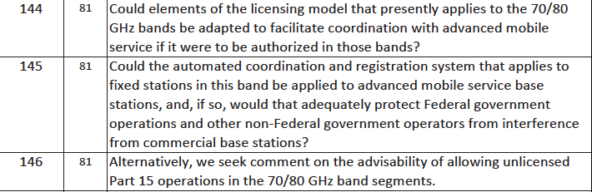

The 70/80 GHz licensing model was designed for fixed service systems with point-to-point coverage only. CMRS services are area based. The 70/80 GHz model is basically first come/first served and the high concentration of links declared in the data base in Northern NJ near data processing centers of the stock exchanges shows the problems with “land rush” effects.

Since the coverage of a mmW cell is likely to be 100-200m, and perhaps more with ComP and multibeam combining, many base station are needed to cover an area. Recent work shows that the density is likely to be 4 to 5 times today’s 4G base stations (Sept 2014 Comm Mag). Traditional licensing using MSA or RSAs, as was done for the LMDS spectrum auctions of YEAR?, is thus more appropriate in this case. However, automated coordination with NTIA will be a useful tool HOW/WHAT in MID? and should also minimize NTIA resources.

The issue of unlicensed use in 70/80 GHz was considered in Docket 02-146 and rejected at that time. We see no reason here to reopen that issue and create regulatory uncertainty for the existing licensees in the bands. However, the FCC would do well to offer new wide bandwidth allocations, in excess of 5 GHZ, for unlicensed use, at frequencies well above 100 GHZ, in order to provide a complement to the 60 GHZ band that suffers an extra 20 dB/decade oxygen absorption compared to 70/80 GHZ bands.

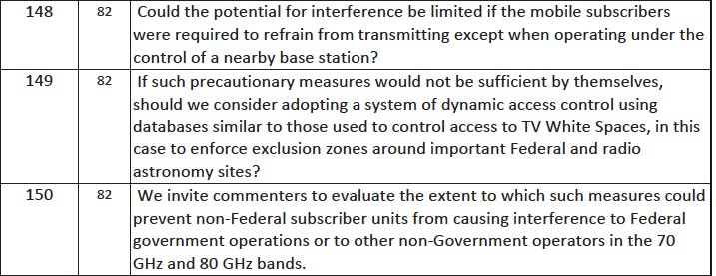

In general CMRS mobiles receive their frequency and power information from base stations. In bands where there are special interference issues, such as satellite systems or federal systems, it may be necessary to have initial contact between the mobile and the base station to be on an “order wire” channel in a band that is exclusively CMRS in order to verify if spectrum in the higher band is available at that location and only use the higher band in the mobile unit when interference free access is verified by the base station that has knowledge of the mobile’s location as well as the non CMRS users that might be affected. However, such approaches would be awkward and would make investments difficult. A better approach would be to institute spectrum masks and simple guard band requirements that are more cautious in locations where interference is possible. By having flexible guard bands, spectrum holders could simply determine alternate coverage/deployment strategies using smaller, albeit still much larger than today, swaths of spectrum in sensitive locations.

