Aquery- Getting Started

Download q from this website : https://kx.com/download/
Select your OS and fill in other details.

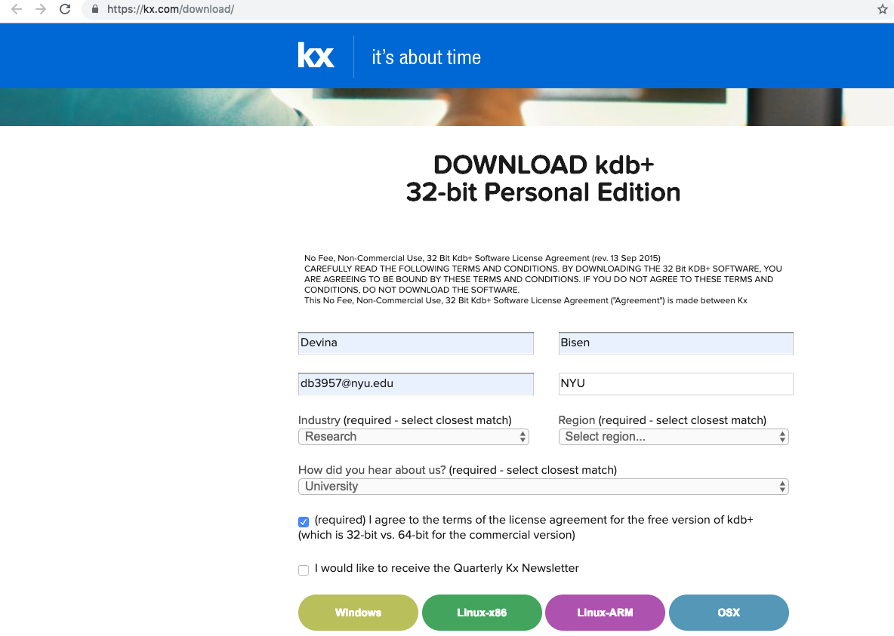

Untar /Unzip the downloaded file.

Add the installation path of q to your bash profile.

You may use the following steps to edit profile.bash on mac:
ls -la
vi ~/.bash_profile
// add the following line
/Users/username/foldername/q/m32/q
// to exit
Esc+; wq

Check if the path has been added successfully by calling :

which q

This should echo the path.

Type q in your home directory to start q, you should see:
Welcome to kdb+ 32bit edition msg.

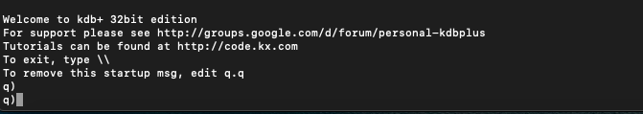

Now, to use aquery, we fist need to download sbt (scala build tool).

Download sbt from https://www.scala-sbt.org/
Untar/ Unzip it

You also need to have java in the system.

Add path of sbt & java to the existing q path as follows:

PATH=$PATH:/home/sbt bin installation path
PATH=$PATH:/home/java_home bin installation path

Check the path with which sbt and type sbt in home directory to launch scala build tool (just to make sure it all has installed correctly).

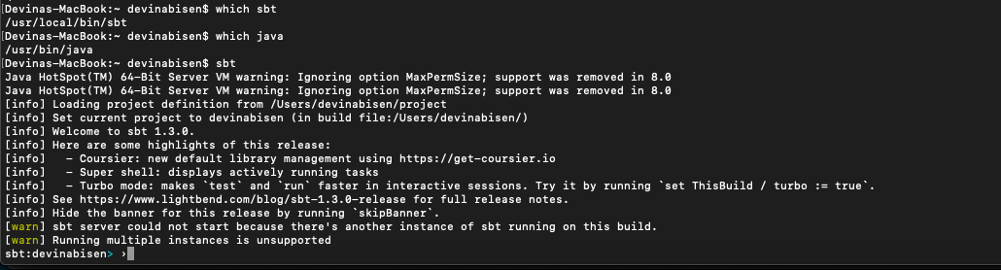

Next step is to clone the github repository for aquery:

git clone https://github.com/josepablocam/aquery.git

Download the aquery’s jar from:

https://drive.google.com/file/d/0B9IR8VjNetPYbWRIX0x2SEdoUGc/view

Keep aquery & q in the same directory for simplicity, run the following command.

Java – jar aquery.jar -h

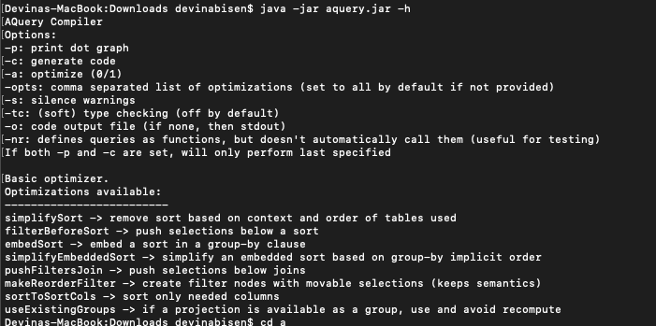

Run the following commands for executing the q files.

q -q inputfile.q

wrap the call to java and add it to your path
./a2q
java -jar target/scala-2.11/aquery.jar

run

./a2q filename.q -q

File extension is not strict you can also check by using:

./a2q Test.txt -q

Or

./q/m32/q Test.q -q;

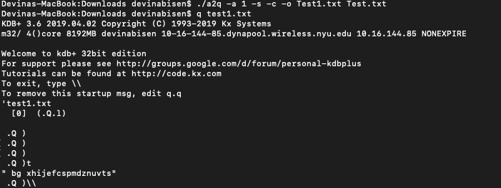

./a2q -a 1 -s -c -o Outputfile.txt Inuputfile.txt

This will convert the aquery code to q, which executes on kdb.

You can further test your aquery code by putting it into input file and using q commands.

