SPEAK , TEA KETTLE :

MY YEARS IN LAWRENCE MASSACHUSETTS 1923 - 1939

PP

Pafnuty Press

Providence, Rhode Island

2005

To

Leon and Miranda and Ruth

Preface

The stimulus for these reminiscences came from reading a publication of the Massachusetts Humanities Resource Center, Spring, 2005, sent to me by Clara and David Park. This article described certain difficulties currently experienced in the City of Lawrence, Massachusetts.

What I am about to write is paradoxically both very personal: a definite place, time, and persons, and yet in some ways it is absolutely typical because none of us live isolated in time and space. The particular and the universal live contiguously.

I thank the Internet for jogging my memory at a few places and for supplying most of the pictures.

Speak, Tea Kettle

I remember your song from those days when you were always on the stove. I remember butter sold from the tub, pickles and crackers sold from the barrel. I remember when delicatessens, bakeries and even drug stores had distinctive smells. Your nose would tell you where you were. I remember cap makers and cigar makers down town. They sat near the windows of their shops and I would watch them from the street ply their craft.
I remember when men wore spats, when boys wore knickers until they went to high school ;when girls wore middies. I remember when cheese cloth was used to drain clotted milk over the sink, when houses had root cellars. I remember ink wells and penwipers in grammar school. I remember when we used to collect horse buns off the street and spread them on flower beds. I remember when the back door was the door for daily use and the front door was only for funerals. And tell me: where now are the spittoons of yesteryear ?

My father had a ditty which he used to recite in Yiddish:

Amol iz g'ven
Un heynt iz nitoo
Un az Gott vet geb'n
Vet veiter zayn.

Rendered into English,

There used to be things
That are no longer here
But if God so wishes
They will return.

Do we really want them to return?
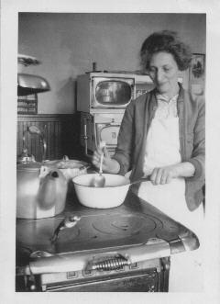

My Mother. The Kerosene Stove. The Tea Kettle

April,1937

But all these old things and old ways that I've just mentioned were universal. What was special to Lawrence? That's hard to say. When the snow melted in the spring, we kids built "dams" in the street gutters; when we called our playmates out to play, we called in a special sing-song used only for that purpose. Perhaps we had a regional accent. But I think it was pretty much the same as a "Boston Accent": Thus, for example, the famous shibboleth or test sentence: Park the car in Harvard Yard comes out as Pahk the cah in Hahvahd Yahd. Shorts came out as shots.

We kids had a special game called "Ten-twenty." We bounced a tennis ball against some tall and steep outdoor staircase. If we caught the ball when it touched the ground once after it bounced back, that scored ten points. If it didn't touch the ground, theta was twenty points. Very occasionally, the ball would be thrown against the sharp edge of a step and then the ball would fly high up into the air in an arc that was beautiful to behold. If we caught the ball , that would be a hundred points. Was this game special to Lawrence ?

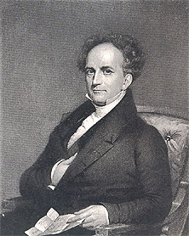
But let me back up a bit and write a few words about how the Lawrence of my childhood came to be. The City of Lawrence was founded c. 1845 by a Boston group headed by the congressman, financier and industrialist Abbott Lawrence. It was carved out of two much older towns, Andover and Methuen, both of which were settled in the 1640's. The history of Lawrence and particularly its labor and ethnic troubles, has been written up endlessly by many historians and social anthropologists. As I write these few pages, I will ignore this voluminous information.

Abbott Lawrence
1792 - 1855

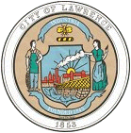

The Great Seal of The City of Lawrence

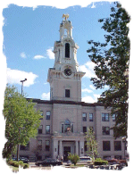

The City Hall, Lawrence

The City of Lawrence is located about 25 miles north of Boston and about four miles from the New Hampshire state line. The Merrimack River runs through it. In my childhood, Lawrence was connected to Boston by Route 28 and by the Boston & Maine Railroad which ran frequent commuter trains.
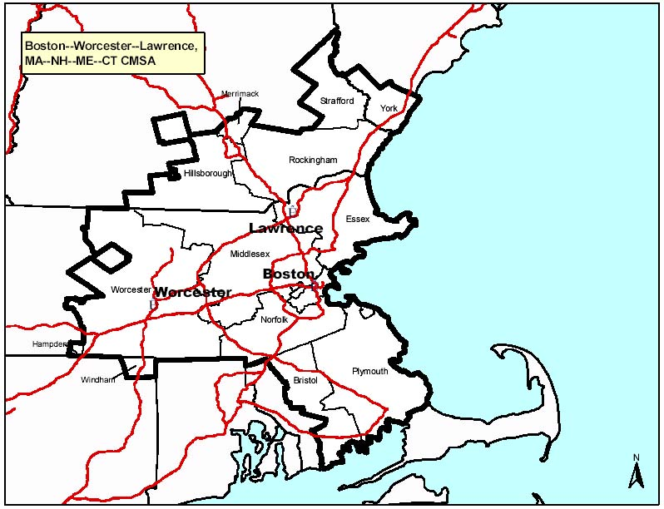

Situating Lawrence, Mass.

I write about the years 1923 - 1939. Why these dates? Well, I was born in Lawrence in 1923 and in 1939 both my family and I left the city; my family went to New York where my brother and sister were already living and I went to college. Except for visits which over the years became less and less frequent, I essentially never returned. My knowledge of the city after 1939 therefore is very spotty. My Cousin H. who remained in Lawrence or in the adjacent town of Methuen all his life used to visit us in Providence and tell us stories of the city.

One of my first recollections is of bells and whistles. The whistles were those of the mills, particularly of the Arlington Mills, calling thousands of mill hands to work at 7:00 A.M. The bells were school bells, particularly of the Bruce Grammar School, calling the children to their studies. There were also church bells and fire bells that announced which fire alarm box. had been activated.

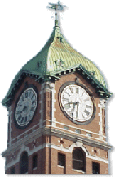

The Clock Tower of the Ayer Mill, often used as a logo for the City.

My Lawrence was a mill town with a troubled labor history. The famous Lawrence Textile Strike of 1912 has been written up in many books. The militia was called in. When my grandfather died in 1934, a pistol was found in one of his bureau drawers. Why ? An older relative recalled: "Oh, yes. A good many shopkeepers were deputized and issued arms so as to preserve law and order. But he never had to use it."

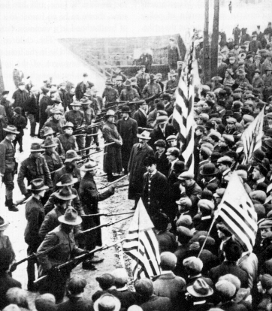

Soldiers confront the strikers, Lawrence, Mass.,1912

But all this was in the past, long before I was born. As a child, a good deal of the past as experienced by my parents was hidden from me and still remains unknown to me. The traumas that hit my parents during my childhood were known to me only in incomplete detail, and as much as I knew I either ignored or repressed and never really tried fill in by inquiring of those who knew. The past is simultaneously a tragic mistake and a comedy from which we try to reason out and locate our own existence.

When I burst onto the Lawrence and the World Scene, delivered at home by a Dr. Bannon and three years later inoculated by him, my immediate family consisted of father, mother, two older brothers and one older sister. My extended family consisted of three uncles, three aunts and eight cousins. One generation older: one grandfather, one grandmother and one step-grandmother. All these relatives lived in Lawrence and most are buried there. There was a time , perhaps around 1915, when there were even more relatives in Lawrence. But they resettled in Dorchester Mass, Louisville Kentucky, Philadelphia Pa, and St. Louis, Mo.

My father's father, Israel Davis, had come to Boston in the early 1890's from the small Ukrainian town of Stavische. I have the certificate of his citizenship granted in Boston in 1898. My father, Frank Davis, was born in Stavische and I think that he came to America as a boy and that his Bar Mitzvah was in Boston. For three years, he went to the Phillips Grammar School on the back side of Beacon Hill. This grammar school had a distinguished career starting in the early 1800's as an elite school for the privileged. By the time my father was a pupil, it was a public school open to all classes of children. In those days, three years of grammar school were considered quite adequate for a boy before he got a job.

My father used to tell me that when he was a boy, he sold newspapers on the streets of Boston around Charles Street and the Boston Common and also peddled "Dewey Medals" that were struck to celebrate Admiral Dewey's victory in the Battle of Manila Bay, (May, 1898) in the Spanish-American War. I assume my father was selling a commercial version of the medal depicted here. My father was then fourteen.
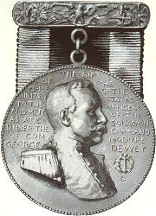 Dewey Medal

In those days, and probably all the way to WW II, there was a thriving garment industry in Boston. A bit later, my father had a job as a bundle maker for a clothing manufacturer. It was always a pleasure for me to watch him -- a professional -- make up a bundle.

My mother, Annie Shrager Davis, also came from the Ukraine, but I don't know from where. She arrived in America, unschooled, and at a somewhat later age than my father. She told stories of having been denied admission to a school in her village when she was a young girl. There is a picture of her as a young woman of about twenty posed with her female co-workers in a clothing factory in Chelsea, Mass.

I do not know the story of how my mother and father met. I suppose it was through the good offices of a matchmaker, which in those days and in their circles was a pretty standard procedure. How and why and exactly when my mother and father and their families came to Lawrence, I never knew. Immigrants frequently came initially to where relatives or friends had already settled. Frank Davis and Annie Shrager were married in Lawrence on Labor Day, Monday, September 7, 1908 in the "Russishe Shul" on Concord Street which was adjacent to the tenement where they were to live.

My parents rarely spoke to me of the "old country." To their generation of immigrants, America was the "Goldene Medina" -- the Golden Land -- and it presented every reason to be Americanized as rapidly as possible, to look forward, and not back. Consequently my own interest in their Ukranian background and experiences has been very slight. I have a book put out a bout twenty years ago by the Stavische Landsmanschaft of the USA. There is a website -- would you believe -- for the current town of Stavische in the Ukraine. These really don't interest me. It suffices that over the years, I've heard of the devastation and atrocities caused in Stavische by the two world wars.

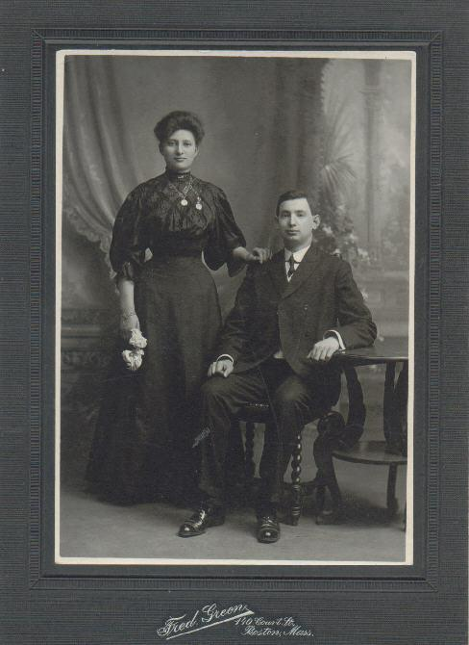

Engagement Picture of Annie Shrager and Frank Davis

Boston, c. 1907

My Grandfather, Israel Davis, was quite a guy. I wish I had known him better; he died when I was eleven. He was quite educated by the criteria of the shtetl. He was imaginative, always dreaming up ways to earn a living or more than a living. I know that he had sold tobacco and ice-cream, had a tonic factory (i.e., carbonated drinks,) had a soap factory. He founded, invested and lost money in the Granite State Distillery. The Eighteenth Amendment killed the start-up. He was a strong Zionist. His brother had immigrated to Palestine when that country was part of the Ottoman Empire. My grandfather bought land in Rishon-le-Zion, Palestine, and hoped to retire there and raise oranges. Alas, he died before he could pluck a single orange.

My grandfather rolled his own cigarettes and collected the tobacco coupons.
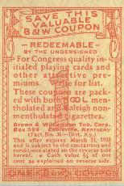

Brown & Williamson tobacco coupon

One of the premiums he got with coupons was a small compass/magnifying glass combination that he kept dangling from his pocket watch chain. I once asked him what he used the glass for and he told me that when it was sunny, he would focusing the sun's rays on the cigarette tip and light it. But I never saw him do it.

My grandfather was an Orthodox Jew; he had his Sabbath meals out of a fireless cooker. He was a "pillar" of the Anshe Sfard synagogue; he had bought a permanent seat and placed in it a prayer desk in which he locked his prayer books, commentaries, his tallis and his tephillin. I admired this greatly: in my eyes it lifted him above the other desk-less congregants. He owned a four door Star automobile with roll up glass windows (wow !) and an oval shaped hood. He pitched horseshoes, he raised pigeons, he bought me a Willys-Knight children's' pedal automobile. Returning from a trip to Palestine in the late 1920's he brought back for me a straw writing table (my size,) an inkwell in the shape of a camel, and an ivory hilted scratch pen.

In my childhood, my father owned and operated a men's clothing store at 410 Common Street. Most of his customers were immigrants, factory workers, farmers, and my father's knowledge of several languages was vital. The language of my family was English and Yiddish. But my parents were polyglot; in addition to English and Yiddish , they also spoke Russian, Ukranian (which is a bit different,) and Polish. (Ukraine at one time in the past was part of the Polish Kingdom.) They used these Slavic languages as their "private language" when they didn't want their children to know what they were saying. My mother also told me that she could speak what she called "Court Russian ", the fancy form of address that one used when talking to social superiors or aristocrats.

I understood Yiddish perfectly and could read Yiddish, but except for a few phrases now and then I never spoke it either with my parents, grandparents or others. As regards Russian, I knew the Cyrillic alphabet early. I pumped my mother for a few Russian words and phrases: subaka, dog; chas idyot, time flies; eets tu domu spatz (if I have it correctly: go home fast, i.e., beat it.) But it was only when I was a graduate student that I learned enough Russian, mathematical Russian, to be able to read and review articles.

At one time, my father combined his men's clothing store with an agency for remitting immigrants' money back to Europe. The 1930 Report of the Commissioner of Banks for the Commonwealth of Massachusetts, listed Frank Davis, Inc., as capitalized for $100,000. In those days, when a plain soda cost 2¢ and a movie cost 5¢ or 10¢, depending on the time of day, this was fair amount of money.

But let me get back to Lawrence. Lawrence, in my childhood, was a city of about 80,000 people. It was multi-ethnic; a city largely of immigrants attracted by jobs in the huge woolen mills and the promise of a better life.

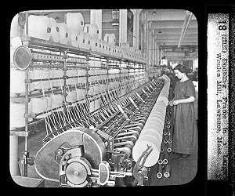

Interior of Woolen Mill, Lawrence

Besides the native New Englanders of many generations, I recall the Irish, Scots, French-Canadians, Italians, Russians, Lithuanians, Polish, Germans, Greeks, Syrians, Armenians, Chinese, and of course, the Jews. The Lawrence Street Directory of about 1930 which I used to read as a child listed about 35 African-Americans.

All these ethnic groups had their separate religious and social institutions. I suppose that at the time of the original immigration of these groups, they huddled together in distinct parts of Lawrence. The Italians originally clustered around their church near Union Street and the Everett Mill. I remember their street fairs celebrating a religious holiday in the Fall. But in my day, the diffusion process was fairly well along. Thus, on Hillside Avenue, the street where I spent my first ten years, there were Yankee, Irish, French Canadian, and Jewish families. The children in the grammar school I attended were of even more diverse backgrounds and included two Afro-Americans. Strangely, I do not remember any Chinese children either in my grammar or high school.

The Jewish population was sufficiently large to support three orthodox synagogues and one conservative (i.e., modern) synagogue. I would estimate the numbers to be around 5,000. The Jews of Lawrence were mostly small business men, shopkeepers, peddlers, drummers (i.e., traveling salesmen), automobile salesmen, craftsmen, (I recall a printer, a shoe repairer, a tailor, a glazier, a window dresser for stores .) There were rent collectors (yes, rent was often paid weekly and with many defaults.) I recall Luftmenschen (impractical, contemplative persons with no definite business or income but always with idealistic plans) and I recall schnorrers (beggars, spongers) who would turn up for a free meal at every bar-mitzvah, wedding, or funeral.

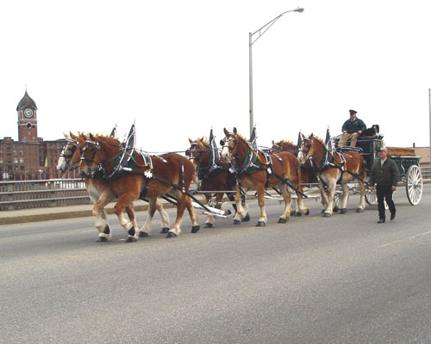

Recent nostalgia. I recall two horses, but not four or six

Among the Jews were one doctor, a few lawyers, and insurance men. Some few worked in the mills, and a few had farms in the nearby countryside. Then there were the occupations within the Jewish community and religious life: rabbis, teachers, ritual slaughterers, matchmakers, etc. The Jewish social life was often organized into Landsmannschaften which reflected the various areas of European origin.

I would estimate that the Jewish immigration into Lawrence began around 1880 and continued until shortly after WW I when Washington placed restrictions on all immigration. In the mid '30's a few refugees from Nazi Germany found their way to the city. (In 1939 when I was in college there were numerous college freshmen who were either refugees from the Nazis or whose parents in England, France, etc., had sent them to America so as to be out of harm's way from bombings and a possible invasion.)

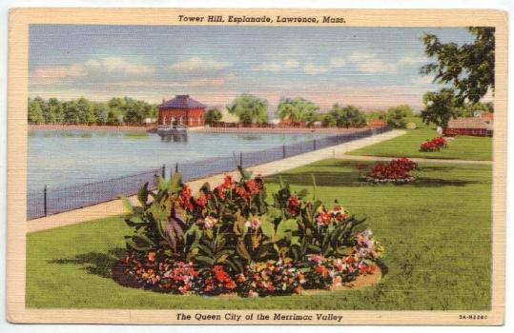

The "Res"(ervoir). We lived two streets away.

Our house at 38 Hillside Avenue was a two story brick built c. 1922 jointly by my father and his brother-in-law Charlie Young. We lived downstairs and the Youngs lived upstairs. My very early playmates were of Irish or Scottish extraction. The Minahan girl who lived two houses up the street was a year older than me and she taught me about Adam and Eve, the angels and the Virgin Mary. The O'Brien boy once asked me where I went to Mass.

I was hardly aware of undercurrents of ethnic strife in Lawrence and I personally never experienced any unpleasant episodes. But I used to hear things like "When the Irish and the Italians intermarry, then count on it, there's trouble ahead." And when a Jew married a Christian, this was a disgrace or worse; a matter to be kept quiet; in some instances it resulted in excommunication from the family and prayers for the dead.

I was much the youngest child in my family, separated by thirteen years from my brother Hy, eleven from my brother Barney, and nine from my sister Tilly. In 1928, when I entered the Alexander B. Bruce Grammar School (the school having been named after a mayor of the city) Hy was already in college. My brothers and sister graduated from the Lawrence High School and then went on to college. Hy went to MIT and got a D.Sc. in Chemical Engineering in 1933. Barney went to Dartmouth with a B.A. in chemistry in 1933. Tilly went to Radcliffe earning a B.A., in 1936. The depression that set in 1929 hit the family heavily, but somehow, all of us managed to get bachelor's degrees and higher.

My teachers in grammar school were the Misses Knapton, Fleming, Comber, Brown, Morse, Barlow, and Mrs.Weiss. (At the time, married women were not allowed to teach, the reason being, I suppose, that married women were supported by their husbands. But widows were allowed to teach

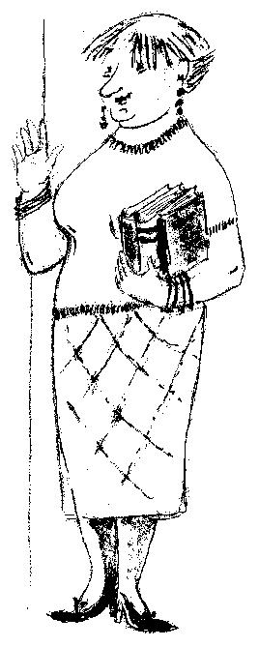

Miss Comber

Most married women in Lawrence did, in fact, work ; in the mills, in shops, in offices, etc. My mother put in her time in my father's store. "Papa-Mama" stores were everywhere.

In grammar school, we had to stand up and read out loud to the class. What a painful experience this was when one of the students who was a poor reader was called on. What were some of the books we read in grammar school ? Only a few stick in my mind. Parts of Hiawatha in the 4th Grade. Parts of Evangeline in the 8th Grade. Also: The Man Without a Country by Edward Everett Hale (1822–1909,) the story of Lieutenant Philip Hale.
We also read The Story of a Bad Boy by Thomas Bailey Aldrich, who as a child moved from the North to New Orleans. Aldrich was an author and magazine editor from Portsmouth, New Hampshire.

In seventh grade arithmetic, we did double discounts; now figure that one out ! By the eighth grade, we had been taught some English grammar. We learned the parts of speech and how to parse sentences. We also had to commit poems to memory: "Breathes there a man with soul so dead / Who never to himself hath said ...." A patriotic poem, the Civil War was still within memory of the living. I recall the last Lawrence Civil War veteran marching in the Fourth of July Parade around 1934.

In addition to the "Three R's", we had singing (four part by the time of the Eighth Grade; I sang "tenor-alto".) What songs? Way down upon the Swanee River; The Arkansaw Traveller; America; America the Beautiful (O beautiful for spacious skies / For amber waves of grain,..) Annie Laurie; etc.

We had painting (awful ; what a mess I made with my water colors ! ) The boys had woodworking (good !) while the girls had cooking and sewing. We had gym ( ugh !) We had historic movies: Columbus, Washington at Valley Forge (great !) We had Thanksgiving and Christmas Plays. We had geography (real good ! ) Our geography book, authored by Frank Carpenter ( Carpenter's Geographic Readers,) began: "Man is in need of three things: food, clothing, and shelter." Only three, Frank ?

My eighth grade class (1934-35) was the last class that my eighth grade teacher, Sarah Barlow, taught before retiring. She used to talk about the pollution of the Merrimack River. The pollution, she said, came principally from the dye works that dumped their chemicals into the river. When she was a girl, she said, (c. 1870) there were salmon in the Merrimack.
I entered Lawrence High School in September, 1935. By 1935, we were living at 89 Tower Hill Street , a two family tenement, and I would walk down the hill to high school about a mile and a half away. Lawrence High School had about four thousand students, separated into four different courses: college, commercial, general, and industrial. The students were separated by classroom and by course; we hardly mixed with students in other courses .In our home room at the beginning of the school day, we recited the Pledge of Allegiance and a piece known as the American's Creed:
"I believe in the United States of America as a Government of the People, by the People, for the People; whose just powers are derived from the consent of the governed; A democracy in a republic, a sovereign Nation of many Sovereign States; a perfect Union, one and inseparable; established upon those principles of Freedom, Equality, Justice, and Humanity for which American Patriots sacrificed their Lives and Fortunes.
I therefore believe it is my duty to my country to Love it; to Support its Constitution; to obey its laws; to Respect its Flag; and to defend it against all enemies."
We did not, as we had done in grammar school, bow our heads and recite the Lord's Prayer and the 23rd Psalm.

What did I learn at Lawrence High School ? English, Latin, French, German, U.S. History, Civics, Algebra, Geometry, Trigonometry, Physics, and Chemistry.

What books did we read in English? My memory there is quite strong, so here goes.

Freshman year: Tom Brown' s Schooldays; The Midsummer's Night's Dream.

Sophomore year: Scott's Quentin Durward, Twelfth Night. George Elliot's Silas Marner. The Virginian,( the first and perhaps best of all out western stories, written by Owen Wister, Philadelphia lawyer and friend of Pres. Theodore Roosevelt.)

Junior year: The House of Seven Gables, Julius Caesar, an anthology of poetry: (The king sits in Dumfermline town and all that.) Lord Charnwood's biography of Abraham Lincoln; Macaulay's Biography of Samuel Johnson. An easy, romantic novel by Henry Sydnor Harrison (now largely forgotten) Queed, which essentially tried to patch up the lingering post Civil War hostility between North and South by arranging a marriage: The hero, a northern newspaper man; the heroine : a southern gal. I learned two new words from this novel: eleemosynary and behemothian.

Senior Year: Macbeth, Eugene O'Neill's Emperor Jones, Thackeray's Henry Esmond. John Steinbeck's Of Mice and Men.

More poetry : I recall When lilacs last in the courtyard bloom'd / And the great star early droop'd... Vachel Lindsay's "Boomlay boomlay, boomlay, boom." xxxxx
In retrospect, this list was not too bad for the times. What were our writing assignments in English? Not very many. Short parodies came easily; plot summaries came easily, but I doubt if I was able to write a critique of any book longer than three sentences. When I got to Harvard, I was seriously disadvantaged until the spring semester of my freshman year when I was able "to find my own voice."

Civics: this was a one year course that was largely a waste of time, I recall only two things. The first: Morris Dorgan's History of Lawrence, Massachusetts (1924) was distributed as a text and I absorbed it. The second: We were asked to make a scrap book and paste in newspaper items of interest. I remember pasting in a picture from the Boston Herald of German soldiers marching into Austria during the so called Anschluss. The date: (I just found it on the Web) March 13, 1938.

In Mathematics, I had two fine teachers, the first, Ernest Jewell, a graduate of Harvard and the second, Edward Praetz, a graduate of MIT. Mathematics posed no problems for me. I went ahead and learned calculus and determinants on my own.

By my own lights, and knowing also some of the graduates of my siblings' generation, Lawrence High School was a good school. There were two Ph.D's from Radcliffe on the faculty. The college course turned out students who became professors: I knew Daniel Hindman who became professor of obstetrics at the Harvard Medical School; Jack Millman, professor of electronic engineering at Columbia; Phil Levine, professor of paleography at UCLA; John Kelleher, professor of Irish Literature at Harvard, and of course myself. I'm sure there must have been numerous others in earlier and later classes. The school also boasted that the poet Robert Frost had been Valedictorian and his wife-to-be had been Salutatorian in 1892.

In a charming little book of reminiscences, One Boy's Boston, 1887-1901, the historian Samuel Elliot Morison, who as a boy lived on Brimmer Street in the Back Bay area of Boston, describes the tradesmen that came around to his house and the street noises he heard. I'll follow his lead.

Who came around to 38 Hillside Avenue? The bread man. The fish man. The vegetable man. The ash man. The swill man. (I considered the word "garbage" to be hoity-toity. Lots of words struck me as hoity-toity: "veranda" instead of "piazza"; "luncheon" instead of "lunch" "dinner" instead of "supper"; "soda" instead of "tonic", "scallions" instead of "scunions") American instances of Nancy Mitford's "u and non u" language ?

But to return to the periodic visitors. The laundry man, the spring water man all came. The milk man's and the ice man' s horses knew at which houses to stop. The paper boy; the postman came twice a day and rang the front door bell. On Saturdays he came only once. The coal man, the woodman, the oil and kerosene man. The junk man. The knife grinder and the umbrella repair man. The accordion man came around four times a year always playing the same tune which I can still hear in my mind's ear. My mother would throw him a few coins out the window to. And there were still others. At Sukkoth time in the Fall, a man came around carrying a lulab and an ethrog, and for five or ten cents, my mother would fulfill the mitzvah of saying the appropriate blessings.

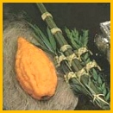

Ethrog and Lulab

Which of these men had a characteristic sing-song? The junk man. The knife grinder, the umbrella repair and the accordion man. But there were other sounds. The sound of the street cars running periodically on Haverhill Street down the hill from our house was always comforting to me, especially at night. I'm not sure why, but to me street cars were always friendlier things than busses. The sound of an airplane was rare. If we kids heard it, we'd rush outdoors, look up, wave, and shout: "Hi, Lindy."

Every place in the world likes to brag that in some respect it has the biggest, the best, the most notable this or that. It usually takes numerous qualifications to make the claim stick. What were the notable places in Lawrence? The great stone dam across the Merrimack: at the time, the largest of its kind.

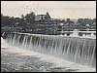

Merrimack River Dam and Falls , Lawrence

The Wood Mill, built around 1905 by William Wood. At the time it was the largest woolen mill in the world.

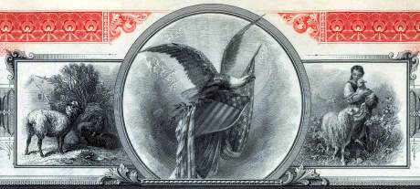

American Woolen Company's Scrip

Lawrence had four movie houses located contiguously on Broadway; the Palace, the Broadway, the Modern and the Strand. What other city had four contiguous movie houses? And besides these there were four other movie houses in the city !
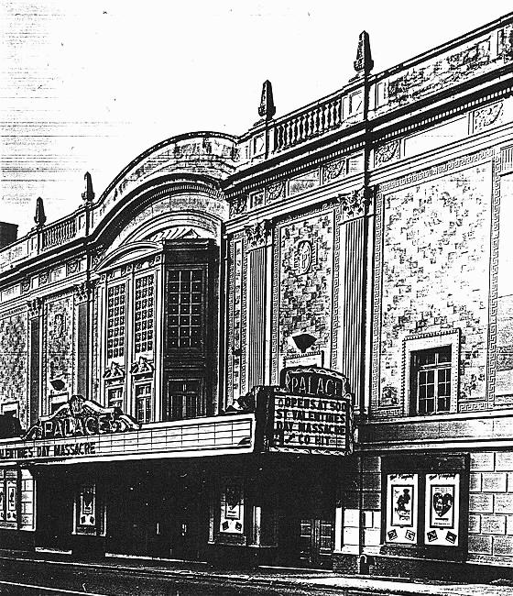

The Palace Theatre, Lawrence, Mass. c. 1967

While in grammar school, I went to the movies frequently, usually on Saturday afternoons and often with a friend. The movies then consisted of a "double bill"; a main feature and a grade B film that was often a Western, a Police Story, etc. There was also included the News of the Week, a Mickey Mouse and the Coming Attractions : all this for 10¢. The movies were run continuously and so it made no difference to us at what point in the afternoon we'd got to the theatre and come into the story. We'd see the beginning when it came around. Once in high school, my movie going slacked off noticeably. The following list omits probably around 50 Westerns that I saw over these years. I will assign critical stars according to my feelings of the time.

A Few Notable Movies seen by PJD in Lawrence and with his Ratings

1930 Whoopie with Eddie Cantor. ****

1930 and later, all the Marx Brothers movies, Animal Crackers, Horse Feathers, Duck Soup, A Night at the Opera, A Day at the Races. *****

1930 All Quiet on The Western Front. *

1930 The Vagabond King, a musical with Dennis King and Jeanette MacDonald. *

1930 The Cohens and Kellys in Africa (and later: in other places.) *****

1933 Cavalcade, based on a play by Noel Coward. *

1933 King Kong, with Fay Wray on top of the Empire State Building. ****

1934 The Return of Chandu, with Bela Lugosi. A serial in ten parts. *****
1934 The Little Minister, with Katherine Hepburn. **

1935 Becky Sharpe with Miriam Hopkins as Becky. *

1935 Midsummer's Night Dream with Mickey Rooney, Joe E Brown, and James Cagney. **

1936 The Great Ziegfeld, with Louise Rainer as Anna Held. **

1936 Modern Times, with Charlie Chaplin and Paulette Goddard. ***

1936 Klondike Annie with Mae West. **

1936 Escape Me Never, with Elisabeth Bergner. * (I give it only one star, but I had a crush on Elisabeth.)

1938 Broadway Melody of 1938. with Eleanor Powell. ***
But Lawrence had other connections to the movies. In the early 1900's, Louis B. Mayer, who later became the famous Hollywood mogul managed one of the movie houses in Lawrence and in nearby Haverhill.

Thelma Todd (now largely forgotten) was a Lawrence girl. Thelma was a talented and popular blonde movie star in the 20's and '30's who played comic roles. She acted in 121 movies spanned the transformation from the silents to the talkies. She played with the Marx Brothers in Horse Feathers and Monkey Business. She was born in Lawrence in 1906. She died mysteriously in 1935 under scandalous circumstances. Suicide? Murder? The question is still unresolved. I remember the older people talking about it in hush-hush tones. Her ashes were buried in Bellevue Cemetery, near where we lived.
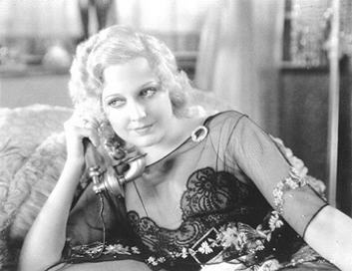

Thelma Todd

The Water Tower at the top of Tower Hill was a distinguishing landmark feature of Lawrence. Until 1933, we lived one block away from it. What other city in New England had a water tower built in the form of a castle on the Rhine ? During the summer, the Tower was open on weekends. After a tough climb to the top on a iron spiral staircase, the view was wonderful. To the west, one could see Mount Monadnock near Keene, New Hampshire. To the east and south, the whole City of Lawrence spread out.
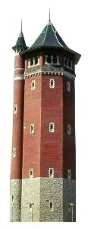

The Water Tower, Lawrence, Massachusetts

Lawrence had its mills, its ball parks, its street cars, its ice houses along the Merrimack River and adjacent ponds. In the winter, the streets were ploughed by a team of horses. In the summer, we sat on the front piazzas and sweated it out. I used to sleep on this unscreened piazza, despite the mosquitoes. That's how I learned the constellations of the Northern Hemisphere.

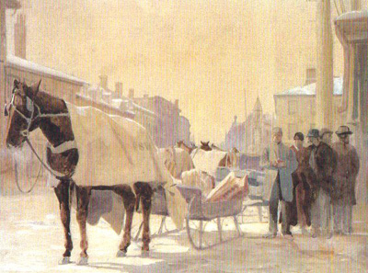

I don't remember such a scene in Lawrence, but I remember it in nearby New Hampshire.

In grammar school, I used to go with friends to the Lawrence High School football games. A season ticket cost 25¢. The stadium was rather far away in South Lawrence. and we used to walk there and then take the trolley back. When Lawrence High won, we stood up in the back of the trolley car and rang the trolley bell all the way into town. This was allowed.

The Stock Market Crash in October 1929 affected the Davis family only after several years. The '20's had been very good for my father's clothing store. His clothing store, downtown, at 410 Common Street, was in an old building beginning to fall apart, and my father made plans to replace it with a modern structure. By 1931, his new store complete and was opened with a flourish. But 1931, was a very bad year, the Lawrence Trust Company collapsed and with it a good deal of my father's resources. From there on my father's financial picture went downhill slowly; he never essentially regained his financial independence.

The following years were times of great distress in the city. More strikes, layoffs, reductions in pay, business failures. There were suicides of Lawrence business men. I recall bread lines and soup kitchens.

In 1933, President Franklin D. Roosevelt was inaugurated President and brought in the New Deal. The NRA (National Recovery Act) was one of the first of the Rooseveltian measures. Most all stores displayed its symbol, a "Blue Eagle" that carried the slogan "We do our part." The NRA lifted spirits somewhat but was declared unconstitutional in 1935 by the U.S. Supreme Court in a case that involved the sale of chickens in New Jersey ! I never knew at the time, and I still don't know what the NRA was suppose to accomplish.

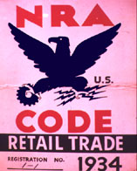

The Blue Eagle

Nonetheless, New Deal agencies such as The CWA, the WPA, the PWA, the CCC, the NYA (National Youth Act,) government projects for writers, artists, and even mathematicians ( the latter in New York City) survived the judgment of the courts. Social Security was enacted in 1935. This was not a new idea for governments. Bismark put it through in 1889 in Germany. Federal Deposit Insurance Corporation (FDIC) came in. All these Rooseveltian laws and projects were helpful. But they were only band-aids. The country didn't recover fully until war was declared on December 8, 1941. "Yesterday, December 7, 1941 - a date which will live in infamy ..." How strange can life be ? And having left Lawrence in September, 1939, I did not witness whatever economic recovery occurred in the city in later years.

In 1934, my father had to give up his store. We had already moved out of 38 Hillside Avenue to a rented two tenement flat at 89 Tower Hill Street. The rent: $9.00 a week, which I used to take every week to our landlord who lived a few doors from us.

My father's pride would not allow him to declare himself bankrupt and our family was never "on relief." I don't know how the family managed during this period. Certainly with the aid of my brother Hy who had a good and steady job as a chemical engineer first in New Jersey and later in New York City. But there may have been other sources (relatives ?) that I know nothing about. Yet, during this period of great hardship, I never wanted for a single meal. I never wanted for decent clothes or for a decent home, or the care of a father and mother. Our home was always in a nice part of town. The rent was low, but it was not the lowest rent paid by other Lawrence families that I knew.

How was our house heated in the winter ? Well, in the years 1934-39 (approx.,) we had a coal furnace, primed by logs delivered from a local farm which I used to split with an axe. In very cold weather and on special occasions (guests, relatives) the furnace was lit. But generally, two or three rooms were heated from a kerosene stove in the kitchen. It was my job to go down to the cellar where the kerosene storage tank was, draw off a pail of oil, bring it upstairs and pour it into the tank of the stove. One pail might last the day, and in those days, kerosene sold for 7 ¢ a gallon. In cold weather, the kitchen became the center of family life. I slept under quilts and on top of a woolen khaki "horse blanket" of WW I issue. Nor, during this period, did I ever think of myself as poor. I knew from direct experience that there were kids in my classes who really were poor.

Lawrence had three newspapers: the Eagle, the Tribune and the Telegram. During my days, the first two consolidated while the second went out of business. As a child, when my father brought home the Tribune. I would spread it on the kitchen floor and read the funnies. Gasoline Alley, Wash Tubbs, Freckles and His Friends. Winnie Winkle. Was I the only child who read the funnies on the floor?

Every day the Tribune would carry the "Treasury Balance" from Washington. Numbers such as $2,367,800,849. I think that every now and then my father would buy a chance based on the last three numbers. He also bet on the Irish Sweepstakes (strictly illegal in the USA in those days) and once won £ 5.

The Lawrence Common, in the center of town between Common and Haverhill Street, seventeen acres, sported a typical Civil War Monument, complete with four surrounding pyramids of cannon balls. It had a band stand, from which in 1937 or 1938 John L. Lewis, head of the CIO (Committee [later:Congress] for Industrial Organization and a forceful speaker, harangued the crowd . I was in the crowd, but at this remove in time, I can only imagine what his message was.

In later years, I used to hear the quip "If after 1929, a person was not a communist, he had no heart; and if, after the Hitler-Stalin Pact of 1939, he was still a communist, he had no brains." I've described in my book The Education of a Mathermatician, how around 1934 my brother Barney, then a graduate student at Dartmouth in Hanover, New Hampshire, became a communist; and how around that time he participated in a strike of granite workers in Barre, Vermont, and got beaten. I also wrote of my own mixed sympathy and skepticism about this social doctrine and movement, and so I'll say nothing more here.

The Merrimack River which flows through Lawrence deserves special mention for the historic role played in the city and in my own life. The river rises in the White Mountains of New Hampshire. It flows south into Massachusetts, then turns northeast and empties into the Atlantic Ocean near Newburyport after a total run of 110 miles. The main cities along the river include Concord, Manchester, and Nashua, N.H., and Lowell, Lawrence, and Haverhill, Mass. In the 19th century, the textile mills used water power from the river derived through a system of canals. In my day, the power was steam and electricity with the huge mill chimneys rising high in the sky and belching forth black and gray smoke. In the graphics of the 1870's and later, smoke in the chimneys was a symbol of prosperity. On the other hand , no smoke, no jobs, no money.

When I lived at 89 Tower Hill Street, the Merrimack was just a few blocks down a steep hill. The road that went along the river was high up from the river bank and between the road and the river bank there was perhaps 500 feet of wild vegetation. There was a footpath through this wilderness and we used to say that it had been an Indian path all the up to the White Mountains. At any rate, I used to go there frequently with my dog Pneumo. As we approached, Pneumo would tug powerfully on his leash in anticipation. One on the Indian path, I would unleash him and let him run freely.

In the Spring, skunk cabbage grew in profuse quantities along the river banks. Its leaves were beautiful but they put out a powerful fetid odor.
In my senior high school year, I wrote a four page "theme" on this for my English class and drew some sort of moralistic conclusion. This was the pinnacle of my high school writing career. My theme was never returned to me graded -- just as well.

My Lawrence comprised all the small towns and villages immediately surrounding it. With the exception, perhaps, of Andover, all these places were rural: many farms. Call this complex Greater Lawrence. My father and mother used to visit their friends and customers in these places. They would barter shirts and overalls and underdrawers for fruit and vegetables, milk, eggs, and (live) chickens. I would go along. Often, we drove around just for pleasure. When I think of these villages, one or two events stand out clearly to identify them.

Methuen: I took my junior year College Board Exams in the Edward Searles
High School. Methuen also has the great Aeolian-Skinner Baroque Organ. (Made in Germany in the 1860's)

Andover: Very suburban. I took my senior year College Board Exams in Philips Academy. Also the place where Samuel F. Smith wrote America.

North Andover: Where we used to get sweet corn from Mr. Whitman who had a farm near Lake Cochickewick. A few years later, Mr. Whitman sold his property, and the exclusive Brooks Prep School was built there.

West Andover: Where we picked elderberries at the Fetzko's Farm and turned them into elderberry wine.

Ballardvale: Where I caught five fish in a pond and brought them home for my mother to fry.

Billerica: Where my father walked a cow about a mile from one farm to
another, and arranged for a three - way barter. As a result of this walk, my mother ended up with a Hoover vacuum cleaner.
The complexity of the deal would have baffled the head of the Federal Reserve Bank.

Reading: Where, around 1925, my father got a ticket for driving through town at 15 m.p.h.
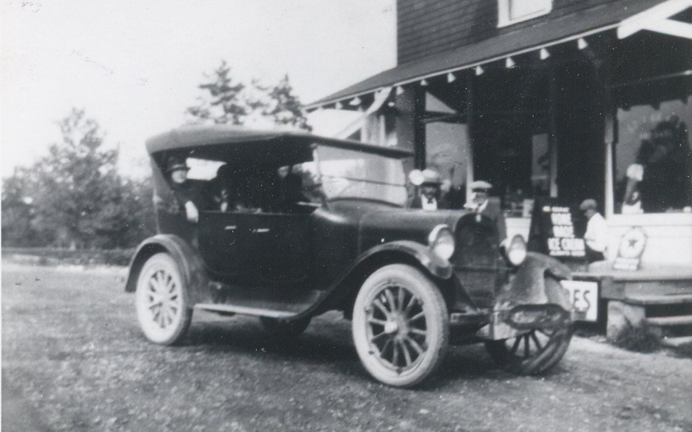

Our First Car: 1923 Dodge

Boxford: Where the Budniks' had a slaughter house and I saw a calf slaughtered.

Salem, N.H. Canobie Lake Amusement Park. Where I first went on a merry-go-round. Also where in 1920 my grandfather and some partners had a well dug: water for the ill-timed Granite State Distillery. The 18th Amendment to the U.S. Constitution ruined that investment.

Pelham, N.H. Where my family lived on a farm during the influenza epidemic of 1918. Where the Kooperofskis' had a dairy farm and we used to pick blueberries in their pastures.

Windham, N.H. Where, in the summer of 1938, we rented a lakeside cottage on Cobbett's Pond and I learned to row.

But New Hampshire was more to me than these few towns, and that came about because my brother Barney who was athletic spent about six or seven years at Dartmouth in Hanover, N.H and was a considerable mountain climber. I got to know Hanover, Orford, Mt. Moosilauke, Mt. Cube. I got to know some of his classmates, including Richard Lauterbach, who reported WWII for Time-Life from within the USSR, and Bud Schulberg who grew up in Hollywood and became a well known novelist.

Despite the difficulties of the years 1931-1939, I never thought badly of my city. I knew it like the back of my hand. It was perfectly safe to walk all over, and I did; to the high school, to the public library, to the movies, to the football field in South Lawrence, way across the city to take clarinet lessons. In later years, I never thought of myself as having "escaped" from a difficult place. It's also true that over the years I've hardly ever gone back to Lawrence.
I still have warm feelings toward the city and some of its characters. One local character was our family doctor John Sheedy. Dr. Sheedy was a tall, portly man, always dressed impeccably and expensively; in the summer he wore a panama hat. He walked unhurriedly through the streets of the city a bit like a battleship. At the time I knew him, he was retired, but used to give out medical advice freely. He treated me when I had the whooping cough and the German measles.

My father's store was the assembly point of many men who had time on their hands. Fellow shopkeepers, drummers, marriage brokers, sat around and talked. Though the store didn't have the classic pot-bellied stove around which to warm hands and spirits, it was as though it did.

Dr. Sheedy was one of the regulars. A graduate of Johns Hopkins Medical School, he ran a clinic in Lawrence for many years. He was a bachelor. He had a brother who was a priest and a sister who was a nun and he spoke of the clergy with considerable irreverence. I doubt if he went to Mass. His parents were Irish immigrants, and he knew some Gaelic, which he was delighted to teach me (now, alas, forgotten.) He was the first to inform me that Jesus was a Jew. I was incredulous.

I was one of his favorites. I would come around to the store on Saturday afternoons, before or after going to the movies, and with high probability, Dr. Sheedy would be there. He taught me the names of the bones in the body (now alas, forgotten.) He would say the name of one of the bones, then have me run out the door onto the street and then come back and repeat the name. Why bones? I suspect it had something to do with this: part of his medical practice was with industrial accidents. He told me that he had a boneyard behind the house where his office was and where he buried his amputations. He invited me to his office to see his "museum". I shuddered and never took up this invitation. Dr. Sheedy wrote a recommendation for me for Harvard, It worked. He was present at my father's funeral.

World Chronology According to PJD in Lawrence

January 2, 1923 Birth of PJD during the presidency of Warren G. Harding.

March 4, 1925, Calvin Coolidge inaugurated President.

May 20-21, 1927 Lindy's Flight across the Atlantic. New York - Paris.

September, 1928 PJD enters Alexander B. Bruce Grammar School

March 4, 1929, Herbert Hoover inaugurated President

October 24, 1929, Thursday, Stock Market Crash. Beginning of the Great Depression.

October, 1931 PJD enters after-school Hebrew classes at Temple Emanuel.

November, 1932. National election: Hoover vs. Roosevelt. PJD wears a "Repeal Tie" displaying a foaming mug of beer.

March 4, 1933, Franklin Roosevelt inaugurated President. All banks in country closed. The Twenty First Amendment to the Constitution ratified repealing the 18th Amendment that prohibited the sale of alcoholics beverages. Beer, wines, spirits, bars, package stores, saloons, restored little by little. I had my first sip of "3.2 Beer." Didn't like it.

1933, Hitler seized control of Germany. Beginning of Nazi persecutions.

June, 1933. Barney Davis graduates from Dartmouth. PJD present.

June, 1933, Hy Davis awarded D. Sc. from MIT in Symphony Hall, Boston.
PJD and Joseph B. Ely, a Williams graduate, a Democrat and Governor of the Commonwealth of Massachusetts, were both present. Governor Ely wore a top hat. (A black cylinder.)

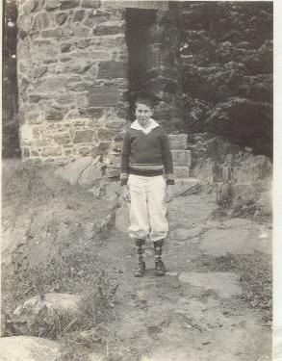

PJD wears his brother's academic cap, Hanover, N.H. 1933

June, 1935, PJD graduates from Grammar School. Ceremony at the Empire Theatre. We sang a four part piece adapted from Haydn's Oratorio The Creation.

September, 1935, PJD enters Lawrence High School.

1935 Mussolini invades Abyssinia. Pastor of the Holy Rosary Church (Italian) collects parishioners' golden wedding rings to add to Mussolini's war chest.

January, 1936 PJD Bar Mitzvah at Temple Emanuel.

March 1936 Merrimack Flood. We got out of school for a week. My uncle who lived in the flooded downtown region went shopping in a row boat.

June, 1936 Tilly Davis graduates from Radcliffe College.

March 4, 1937 Roosevelt inaugurated for his second term.

Summer 1937, Hy Davis and Rosalie Gallert's wedding in Boston/Newton.
Champagne over a block of orange sherbet served in Dr. Ehrenfried's (Rosalie's uncle) garden.

1938 September 21, The Great Hurricane. Large nearby elm trees blown down, etc. Few personal injuries in Lawrence, though many deaths elsewhere.

1938 Christmas Vacation. PJD visits New York City for the first time. Stays with brother and roommates in their digs on West 103rd Street. Views the construction of the 6th Avenue Subway. Heard talk about the Spanish Civil War and the Abraham Lincoln Brigade. Went to Radio City Musical Hall to see the Rockettes.
June 1939, PJD graduates from Lawrence High School. Ceremony at the Lawrence High School Football Field . We sang Henley's Invictus::

"Out of the night that covers me
Black as the Pit from pole to pole
I thank whatever gods may be
For my unconquerable soul. "

PJD awarded a couple of medals.

July 1 - September 2, 1939. PJD lives with Hy and Rosalie in their apartment on West 20th Street and Seventh Avenue. Gets social security card in downtown NYC on Broadway. Sells Coca Cola at New York World's Fair of 1939. Wears a green uniform with red piping. Earned approximately $17.50 per week.

July, 1939, Wedding of Barney Davis and Frances Kronstadt. In NYC.

August 23, 1939, The "Hitler-Stalin Pact."

September 2, 1939, Germany marches into Poland. Beginning of WWII.

September 2, 1939, Barney Davis dies in Mexico.

September 1939, PJD matriculates at Harvard. Listens to poet Archibald McLeish tell Freshman Class: "The lights are going out all over Europe."

October, 1939. Family moves from Lawrence to 720 Fort Washington Avenue, NYC.

***

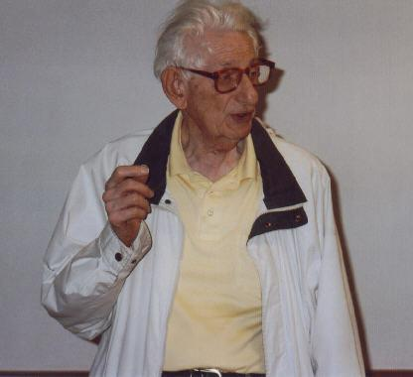

PJD May, 2004

Bibliography

When I Was a Boy, c. 1955. This book exists only in one copy.

The Education of a Mathematician, AK Peters, 2000.

See my book "When I Was A Boy" for additional stories of this type.

