ΤΌ ΤΑΞΕΙΔΙ ΜΟΥ ΣΤΗΝ ΚΡΗΤΗ

My Trip to Crete

Philip J. Davis

Trip to Crete, October, 1999

With Ben (B) and Teddy (T) Birnberg.

From: My Diary
With a few explanatory notes added in brackets [ ]

© Pafnuty Press,
Providence, R.I. USA , 2011
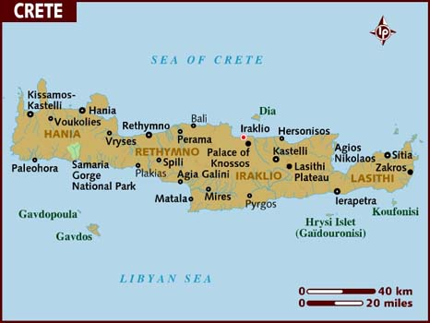

Dramatis Personae

Benedict Birnberg (B) and Theodore Birnberg (T) are Hadassah's British cousins. B is a prominent civil rights attorney in London, now retired. T, sadly deceased, was a teacher of French literature.

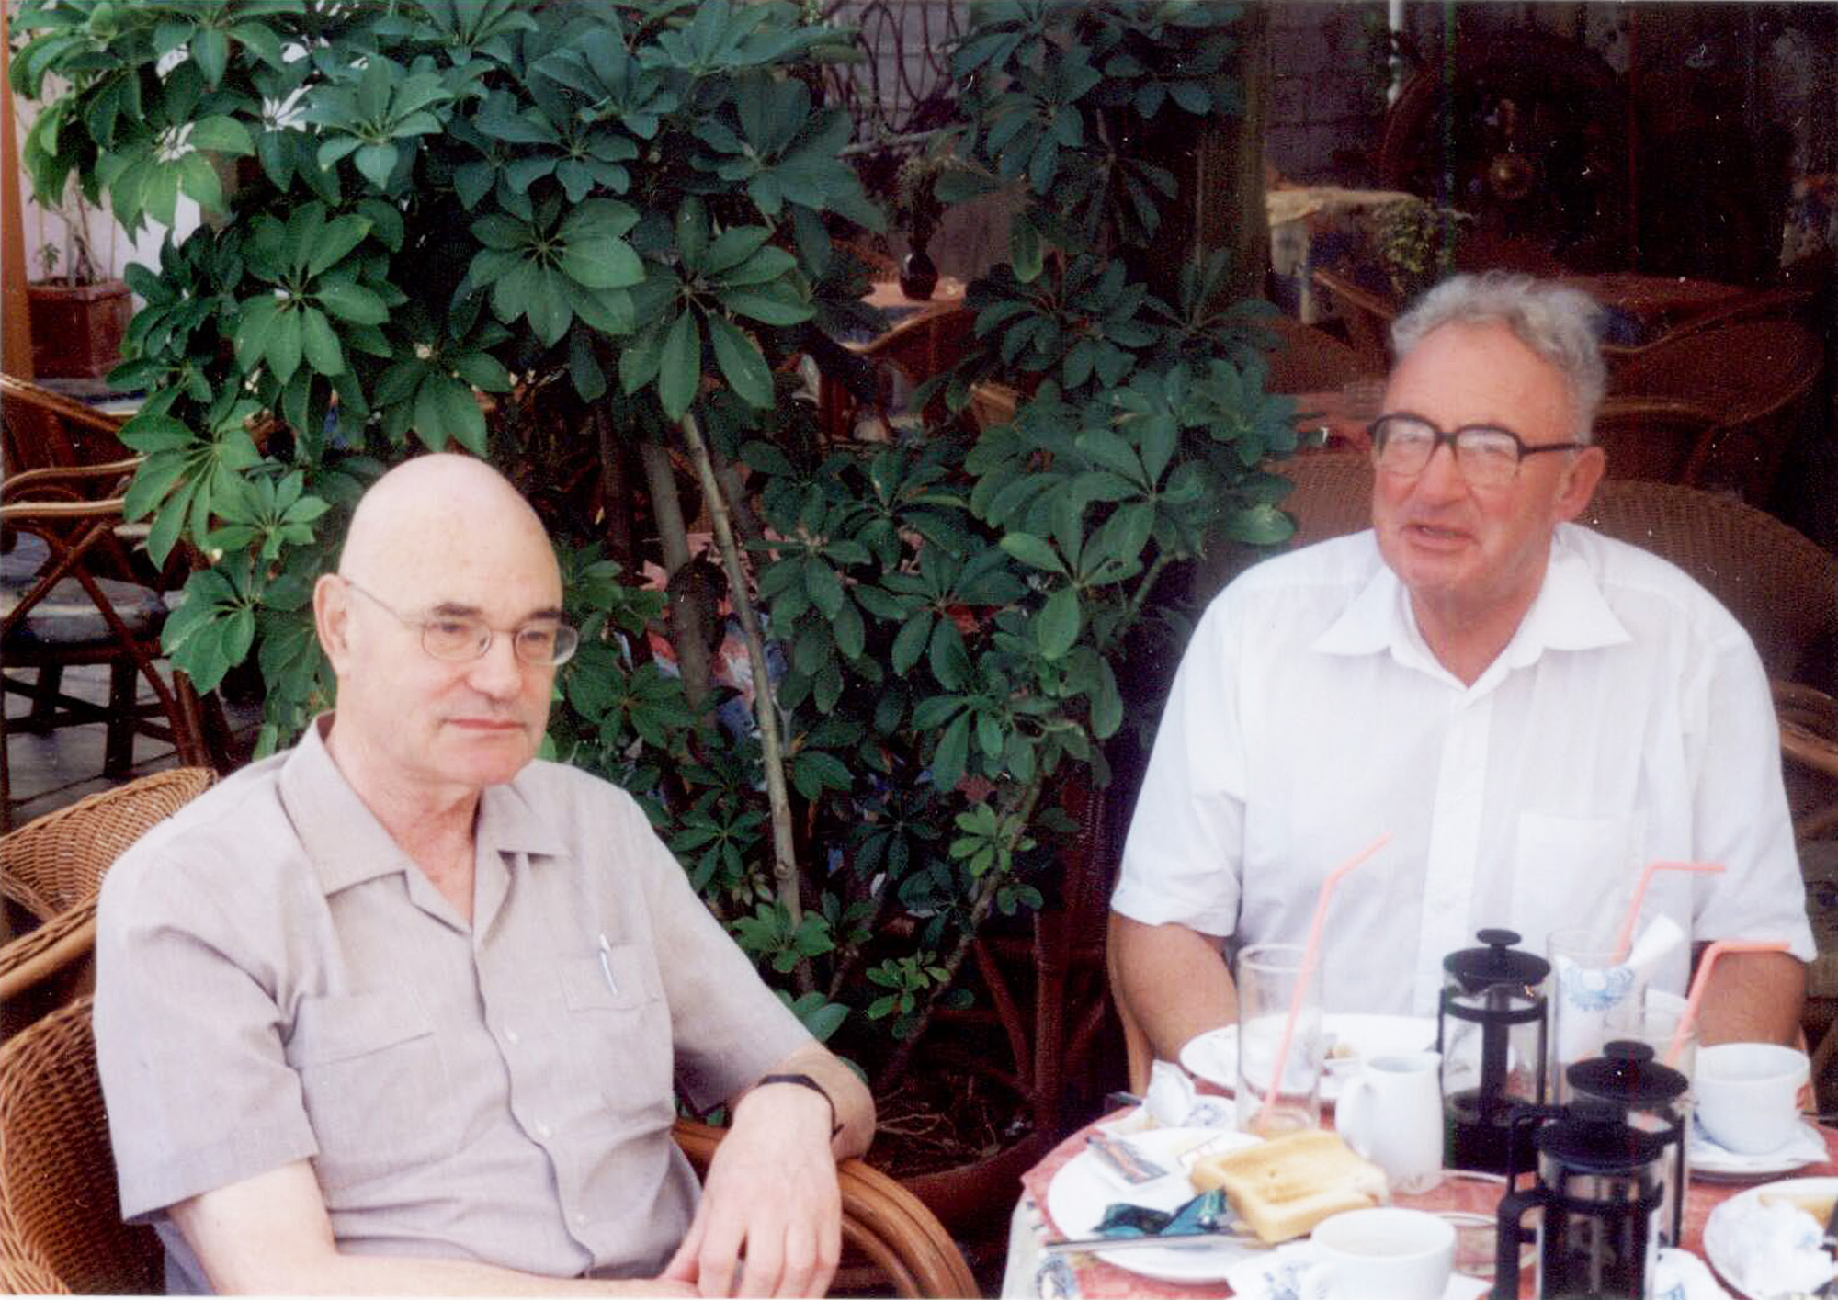

Ben and Teddy

B is married to Felitsa whose relatives in Crete include her sister, Mary and Mary's husband Manolis Gazis. B, a resident of Blackheath, London, owns a second house in Chania to which he and his wife often go. Nikos Stavro(u)lakis is a jack-of-all trades: an organizer and promoter, an artist, a writer or a whatever-you want. We will meet them all in what follows.

Reason for the trip

At an international meeting of mathematicians, I had been buttonholed by a Greek mathematician who invited me to come to Crete and lecture. Happily, I was able to combine forces with B and T
so that my trip was part touristic and part professional.

From My Diary

Tues. Oct. 5
London. Hotel Imperial. British Museum. Van Dyke prints. Slept. Bought cheese baguette and OJ.

Wed. Oct. 6
To Heathrow #2. Plane on time. Had tuna sandwich @ airport. On plane T's "vegetarian" meal contained chicken. T irate. Arrived Athens. Plane to Heraklion (Iraklion) delayed. [Waiting outside I thought I could see the Acropolis in the distance.] Arrived Heraklion 11:30 P.M. local time. Mix up with rental car. Big fuss. T irate. Got to B's place. (B's address: Chania, (Χανια) Lithinon, 42 ).
Ate supper at 1:00 AM. Went to sleep.

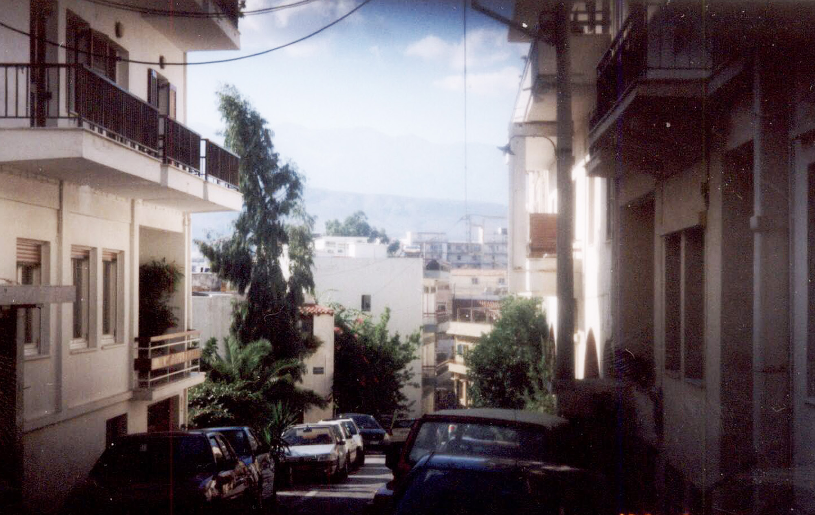

The view down Lithinon toward the harbor

Thurs. Oct. 7.
Woke at 9:30. Went to sea side café for breakfast. Had "German Style" breakfast. [juice, fruit, eggs, sliced meats and cheeses, pastries] T and B's eggs came with bacon. T irate. [ T and B are vegetarians. ] Send back eggs. Soft boiled eggs came semi-hard. Walked around old city. Turkish and Venetian residue; some restored. Hotels and restaurants galore. Big tourism from Scandinavia. [ Picture books of Chania available in numerous languages including Russian.]

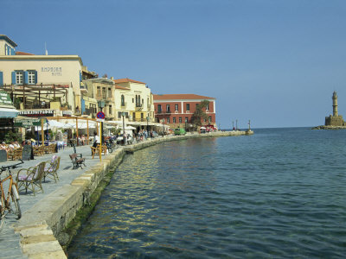

Waterfront Scene: Chania

Saw Etz Hayyim [Tree of Life] synagogue. Being restored. Very beautiful inside. Very small. Saw built in ritual bath (Mikva). Restoration supervised by Stavroulakis; a character. Raised much money .[Plaque: Victor, Lord Rothschild, among the numerous donors.]

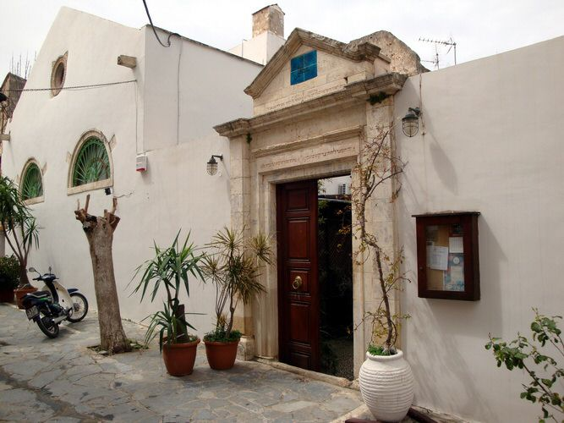

Façade Etz Hayyim

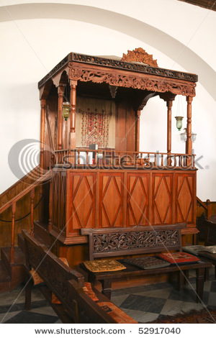

Reader's Platform: Etz Hayyim , Chania

Local priests or politicians raising a fuss that services were being held without a proper congregation ! Worries: the Head of the District writes to the local paper an anti-ceremonial opinion. Saw town. Needed sun glasses. Changed $50. Got about 300 drachmas.
[ Drachmas now obsolete: Greece is on the Euro] Back home = B's house. = Lithinon, 42. Locked out. T irate.

4.00 P.M. Drove up to a mountain gorge. After a few miles the people look picture book primitive. Many, many sheep and goats.

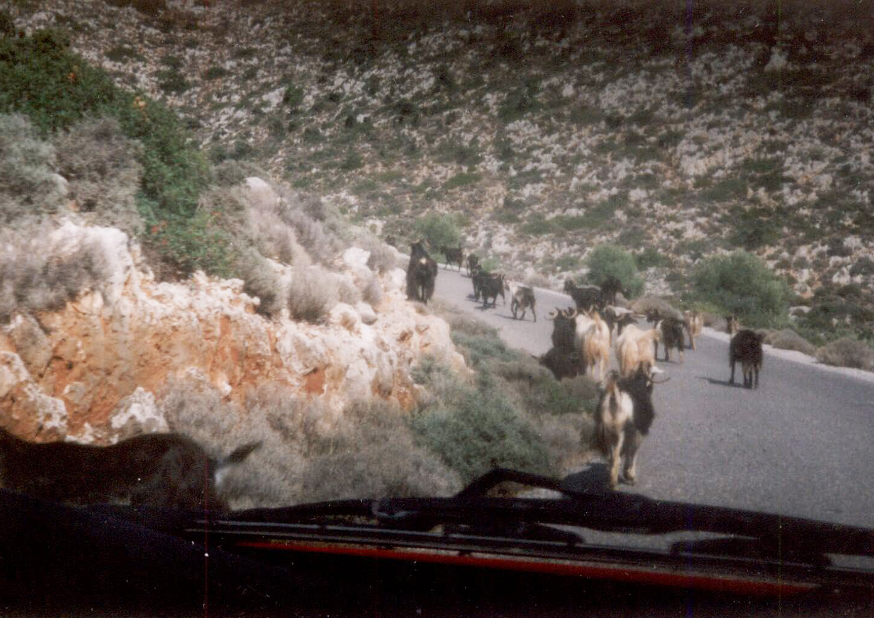

Cretan Goats

9:00 P.M. Went for supper. Beer. avocado salad, green salad, F.F. potatoes, Stewed green beans. Rather cheap.

Fri. Oct. 9
Breakfast continental style. Not so interesting. Made contact with Hadjidemos [ Mathematician from Cyprus] . Item: No business or institution is opened or inaugurated without a priest coming around and sprinkling holy water and basil. B's Irish neighbor told me that.

Fri. P.M. Drove to the far West Coast. View spectacular. Many "new" half finished houses and buildings. B. explained why, but I didn't understand. Had lunch: Meat Balls. [Keftedes]. Fanta.
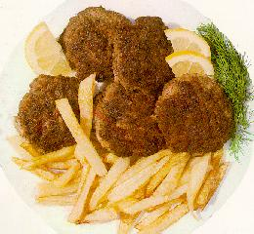

Keftedes and the omnipresent French Fries

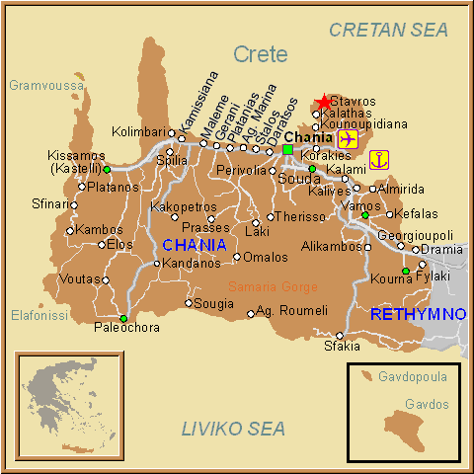

Map of Western Crete.

6:00 P.M. At Etz Hayyim . Tremendous transformation from yesterday. Very beautiful. Overflowing crowd. Large delegation from Athens and Salonika. Three services: Rededication. Minha and Ma'ariv. Extremely long. The mad , strange , genius or (eccentric) Nikos Stavro(u)lakis. Father Jewish, mother Moslem. They divorced. Boy went with the father. Taught in America (what ?) Taught in Israel (what ?) Unmarried. Knows Hebrew. Not religious. Driven. [Re: Stavrolakis. Strangely, we had heard of him in Providence because someone gave us a cookbook he wrote: The Cookbook of the Jews of Greece. Apparently, Stavroulakis can and does do anything and everything !] House of Glory. No mechitza. Women sit in the back rows. Various local non-Jews present. Put up a mezuzah. Outside: a young man describing in an oil painting the Seven Days of Creation.

Afterwards: restaurant @ waterfront with B, T, Manolis Gazis , Mary and Ariadne. Mary = Felitsa's sister. Manolis = Mary's husband. Ariadne their daughter. Had kotopolo grilled [ κοτόπονλο : chicken] ,greens, garlic & oil, tomato salad, French fries, beer, bread.

Plan of B's house in Chania . Four stories

4 2nd Kitchen Bathroom Roof Garden

3 Living Room Bedroom

2 Bedroom Bedroom

1 Bathroom Kitchen

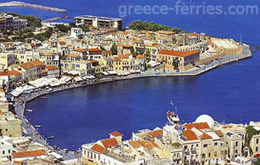
View from B's roof garden

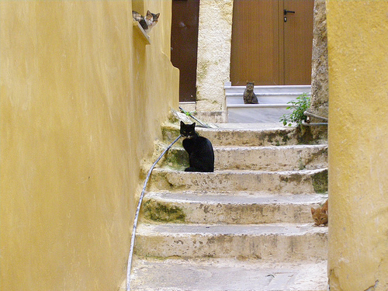

Near B's House : Cats galore.

Sat. Oct. 9
Breakfast "German Style." To Etz Hayyim @ 10:30 A.M. Came in for Kriyat ha Torah. Crowded. Afterwards. Kiddush. Lots to eat. Greek style hors d'oeuvres. [ Mezé platter : stuffed grape leaves, spanakopita [σπανακόπιτα , spinach pie ] , hummus, olives, et alii. ]
Met ???, the local MP [to Athens] . Friend of Manolis. Same political party.

Later: walked and walked. Hundreds of shops. [ Strangely in one street there are numerous shops, side by side, selling all kinds of knives. Knives appear to be an important symbol in Cretan culture. Why ? ]

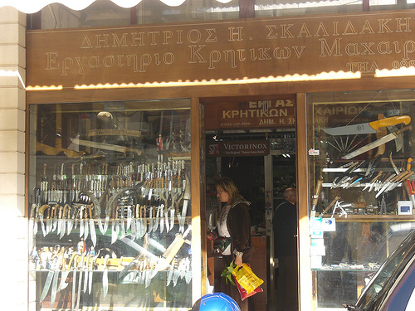

Knife Store in Chania

Venetian and Turkish Ruins. Ruins from German shelling [in WWII] Glass bottom boats for rent. To see what ? The remains of sunken boats.

Saturday Night. 8:00 P.M. Gala dinner thrown by Municipality [ to celebrate restoration of Etz Hayyim.] Took over the narrow street in front of the synagogue. Initially unorganized chaos. Then: seating assigned. Many appetizers, Then lamb boiled & lemon sauce for main course. Small orchestra of lute and lyre. A traditional mixed dancing group of four. Sat opposite a lovely lady; wife of Rector of Technical Univ. Crete [ Πολυτεχνείο Κρήτης ]. She, Jewish. Born in Poland of Jewish parents. Been in the USA. for ten years. Boston University. Met her scientist husband at UCLA. Then to Chania. Also sat opposite German diplomatic representative. Why is he here ? Germany gave some money for restoration. Reparations. [ I had no idea that in planning my trip to Crete it would coincide with the restoration ceremony for Etz Hayyim.]

Sunday Oct. 10

Secular service at Etz Hayyim. One hour. Not too bad. Overflow in the courtyard and out to the street.

Lunch at the farmhouse of the grand(?) parents of the "other" Ariadne. Her boy friend is Vasilios. Orange groves, olive groves. Wandering chickens cats and flies. Meal: Walnuts, Aqua Vitae, boiled greens, potatoes, grilled green pepper, grilled red pepper, broiled lamb [ on an outdoor spit] , salad, wine, apples, grapes, phyllo dough with custard, Cretan halvah. [Wow !]

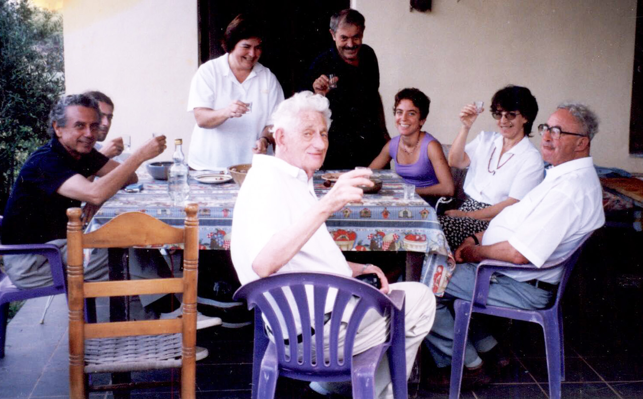

The perpetual bottle of Akavit

Afterwards trip the top of a hill where one sees excavations of a Roman camp. T and B arguing horribly. Supper at the waterfront: pizza, salad, beer.

Monday, Oct. 11.

Breakfast at waterfront. Continental and fresh fruit.

Call Prof. Hadjidemos 081-393-865

Call Prof. Nikos Stylianopoulos 393-841, [Math Prof. Univ. Cyprus, Nicosia]

Notes: Hotel Lato [in Heraklion] Very close to the old Venetian harbor and fort. Univ.on Knossos Ave. about 5 km. from city center. Knossos antiquities, 1 km. before the Univ.

At the Bank; (τραπεζα; trapeza = table= bank ) Met a man at the teller's window, Jewish. Born in Vienna. Went to London by train (pre-WWII) . Then to Melbourne. Fifty years there. Then: retire to Chania. Why Chania ? I didn't understand his reasons.

11 AM- 4 PM. Went to big mountain along the coast. Where there are two monasteries. En route :swim for B and T. Goats galore. Visited one monastery. B is afficionado of Greek icons.

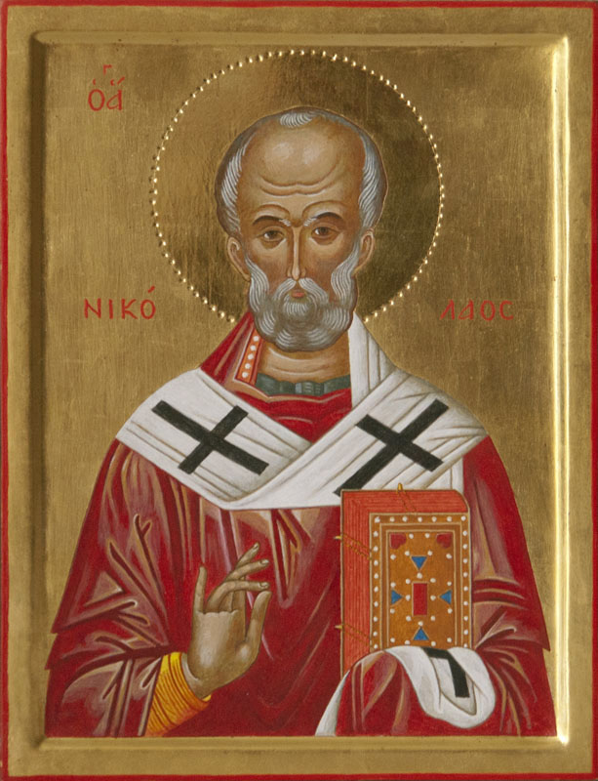

Example of Cretan Icon

Lunch at "Irene's." Pastitsio = lasagna. Fanta. Φάντά .
Evening. Taken out by B's architect friend. [ Costas Mavrakakis. His wife is Maria Vasilaki, the Byzantinologist with an international reputation.] To some obscure (?) restaurant east of Chania. Steak, French fries, salad, beets, white wine (better, not ouzo) halvah Turkish style = semolina, almonds, sugar and olive oil. And the perpetual bottle of akvavit (gratis !).

From a historical brochure (in English, French and German)
Cretan Eras

Neolithic 6000 - 2600 BC
Pre Palace 2600 - 1900 BC
First Palace 1900 -1700 BC
2nd Palace 1700 - 1380 BC
Post Palace 1380 - 1100 BC
Protogeometric 1100 - 900 BC
Geometric 900 - 600 BC
Archaic 650 - 500 BC
Classical 500 - 330 BC
Hellenistic 330 - 69 BC
Graeco-Roman 69 BC - 330 AD
Byzantine 330 AD - 824 AD
Arab Conquest 824 - 961
2nd Byzantine 961 - 1212
Venetian 1212 -1669
Turkish 1669 -1898
Union with Greece 1898 -1941
German Occupation 1941 -1944
Current 1944-

[How many spots on earth can display so many recorded historical
eras ? Jerusalem ? ]

Reflections on Personalities radiating from the Vienna Circle of Philosophy . [B must have mentioned his mother Naomi Bentwich.] Naomi: student of Philosopher G.E. Moore at Cambridge. Rebelled against his assertion that there are no absolute standards. Hated Alfred Ayer's material [logical positivism] with a great hatred.

Tues. Oct. 12

Breakfast as usual (German style) . Left Chania around 11:00 AM. Stopped en route to Heraklion @ small village. Had a pizza and a fanta. Arrived @ Hotel Lato around 2:00 PM. Tremendous chaos in town. Embrouillement, noise, motorcycles, one way streets, blockages. Had a nap and a shower. [No point to go to the actual site of archaeological dig at Knossos. ] (Instead ) went to the famous nearby archaeological museum. [Saw the famous Minoan lady and many other Minoan artifacts.]

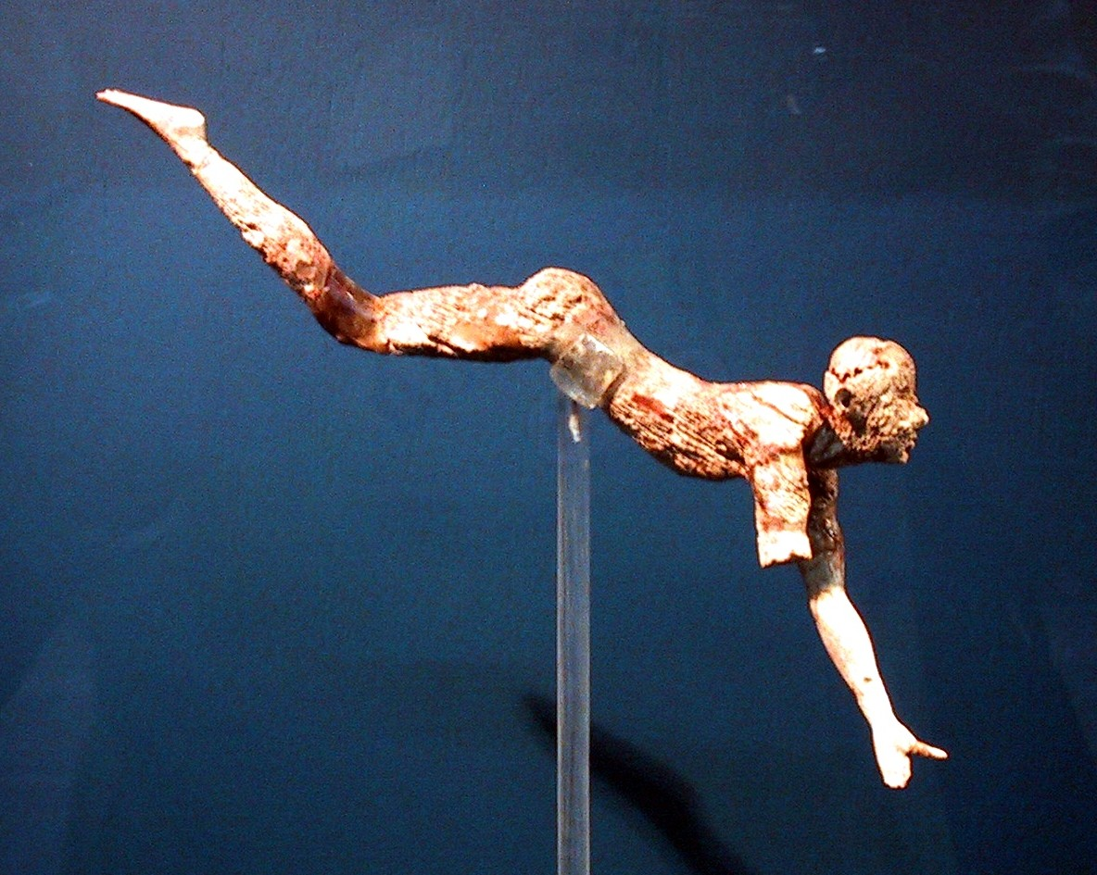

The "Bull Leaper" c. 1500 B.C.

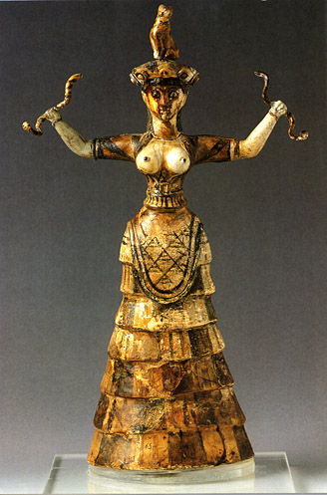

The Minoan Snake Goddess

Had tea and bouraka =cream puff, but cream = starch filling, but good. ) [ Bouraka= wrapped blintz leaf. Could be filled with anything.] Prof. Hadjidemos comes for supper at 8:30 P.M..

Had supper @ Central Square @ 4 lions fountain with Hadjidemos and Nikos Stylianopolous from Cyprus. Spaghetti bolognese and mushroom soup.

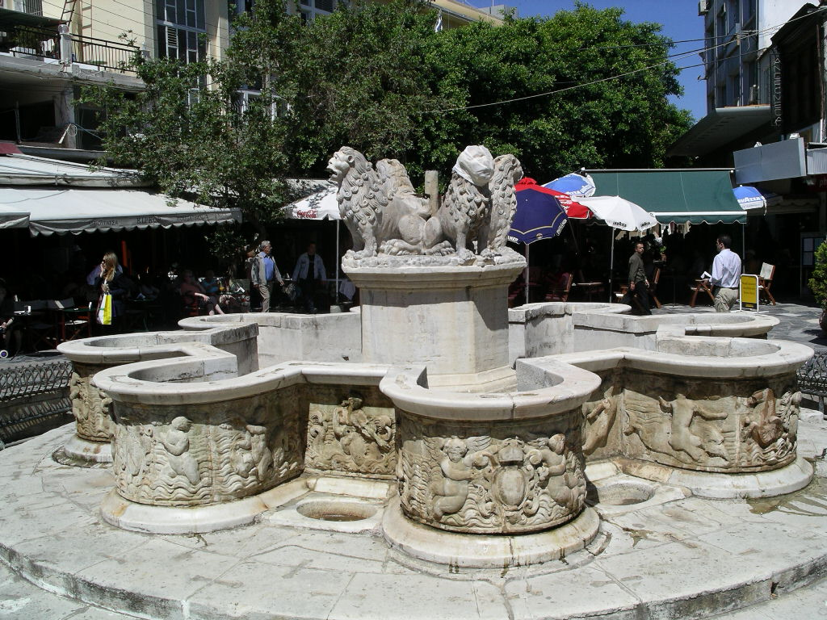

Heraklion: Four lions , center, raised

Wed. Oct. 13

Excellent buffet breakfast at Hotel Lato. Vavalis [ who he ?] picked me up at 9:00 AM. To University. Met many people. Dept. in physical repair. Talk @ 11:00 AM. Good talk. Great success. [ I don't remember what I talked about. Perhaps Spiral of Theodorus.] Warm reception. New friends. Received 65,000 drachmas. [Seems very generous.] Complaints by university people. Low pay = that of bank clerk. No Government support. But augmented by some project support (from EUC ?) Hostility between staff and "help" = janitors, etc. The latter have a union. Two types of students A and B. A = good. B= stay on for five or six years. Much parental pressure for college. Crammers employed to get kids into college. Hostility between pure and applied mathematicians. [ Nothing new there ! ] An exit sign that amused me: Εχοδοσ (Exodus) [ Like 2nd book of the Bible]

Back at Hotel Lato @ 1:30 PM. Checked out : 15,000 drachmas.
Stopped at ?? en route back to Chania. Had a plate of broad beans (φασίολ; fasiol ) and tomato sauce, Back in Chania by 4:45 PM. Supper in a "traditional restaurant" on a side street. [Traditional meaning not targeted fro the tourist trade.] Side streets full of motorcycles. Had Greek soup = veggies, rice and lemon. Salad. Beer. Later: boureka in a pastry shop.

Rumor: Stavroulakis is proposing to hold a Seder in Etz Hayyim in the Romaniote tradition. Not in the Sephardic tradition.
[ The Romaniotes or Romaniots (Greek: Ρωμανιῶτες, Rōmaniōtes) are a Jewish population who have lived in the territory of today's Greece and neighboring areas with large Greek populations for more than 2,000 years. Their languages were Yevanic, a Greek dialect, and Greek. They derived their name from the old name for the people of the Byzantine Empire, Romaioi. Large communities were located in Thebes, Ioannina, Chalcis, Corfu, Arta, Corinth and on the islands of Lesbos, Chios, Samos, Rhodes and Cyprus, among others. The Romaniotes are historically distinct from the Sephardim, who settled in Greece after the 1492 expulsion of the Jews from Spain. There is a Romaniote Synagogue in New York. Courtesy : Google. ]

Thursday, Oct. 14.

Breakfast at home. Bread, cheese, juice, scrambled eggs, tomatoes. To the Polytechnic. Yannis Phillis, Rector of Polytechnic will send car to pick me up 10:00 A.M. in front of the Agora. Blue Mercedes, red plates. Met the Rector & five mathematicians. Warm reception. Heard many grievances (again !). They are anti-centralization. Students go on strike at least demand which are infinite in number. Invited to lecture at any time with flight from Athens paid for. Back home. Lunch @ traditional place at the Agora. Beans, spaghetti, fanta.
Supper at 8:00 P.M. at "The Ruin" [ a restaurant built among Venetian ruins in downtown] with Mary and Manolis. Dolmades, i.e., stuffed grape leaves & tomato sauce, pastitsio (lasagna), beer, apples and pears.

Friday, Oct. 15.
To airport in Chania. Flight to Athens. Short wait. Flight to London. T made fuss over lack of butter. Flight went over Bolzano and the Austrian Tyrol. Into LHR. Wait for large keg of olive oil we were carrying for Felitsa. [Years ago in Cambridge, Mass., H & I lived above a Mrs. Velagrakis who asserted that olive oil was a sovereign remedy for all that ails a human being, but particularly after an appendectomy. ]

Ride to Security Car Park. Stopped at Tescos outside LHR for a tea break. Traffic terrible. (Friday P.M.) Time from landing to Blackheath: 3:30 PM -7:00 P.M. [ B & Felitsa's house ; 6 Eliot Place] Supper great. Salmon poached in a bit of wine, olive oil, lemon juice and orange slices on a bed of cardamom leaves. Went to bed about 8:30 P.M.

Saturday, Oct. 16
Breakfast: Yoghurt & honey mixed with fruit & dry breakfast cereal. Very good. Called Trevor Stuart. No answer. Called Sue Wesley. Called Susanna Ortiz. Tea tomorrow with the Ortiz @ Hotel Imperial.

