UPDATE to NSF Plant Genome IOS, Proposal #: 1238085 Date: June 5, 2012

Title: “X-Net: Integrating-omic data across species to infer networks and enhance model-to-crop gene discovery.

PI: Gloria Coruzzi (NYU Biology); Co-PIs: Dennis Shasha (NYU Courant), Manpreet Katari (NYU)
Senior Personnel: Stephen Moose (U. Illinois); Kranthi Varala (NYU), Rob Martienssen (CSHL);

This update relates to Aim 2, our combined computational-experimental approach which exploits genomic data from crops to derive “weighted” gene networks in Arabidopsis. These weighted networks will identify TF hubs and network modules associated with traits of agronomic interest (Aim 2A) that will be experimentally validated (Aim 2B). In the grant, we propose to use a rapid and reliable transient assay system to validate network targets genome-wide. In this update, we show that our results for TFtargets in this transient protoplast system, recapitulate findings from 35S:TF expression in transgenic plants.

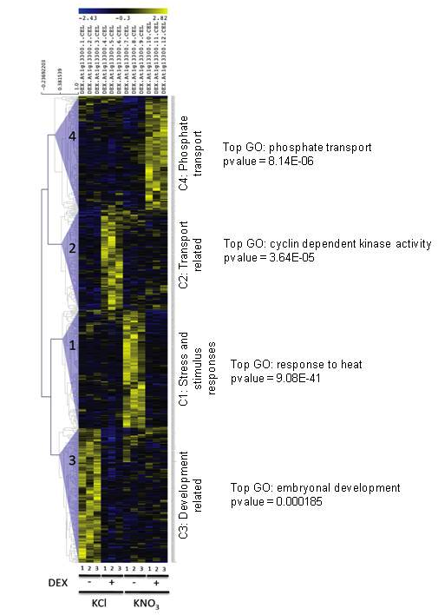
Aim 2B. Experimental Validation Strategy: Transient “Network Walking”. In Aim 2B, we proposed to use a medium throughput protoplast expression system to validate TF->target genes predicted by networks identified using the weighted network approach in Aim 2A. The results below demonstrate that the TFtarget connections uncovered in this inducible transient protoplast assay, uncover networks that are biologically relevant to whole plants.
As review, this TF-expression system employs transient transformation of Arabidopsis protoplasts with TF-GR fusions, and inducible nuclear re-localization of TFs by dexamethasone (DEX) treatment. Transcriptomic analysis then enables us to investigate the network targets of a given TF genome wide. When performed in the presence of cycloheximide, only primary targets of the TF are identified. This system is rapid, and this allows the discovery of network targets any given TF in less than 2 weeks.
In a proof-of-principle study, we expressed a myb transcription factor (35S::HRS1-GR) in protoplasts using this transient DEX- expression system, followed by ATH1 chip analysis. Transcriptome analysis revealed four clusters of genes that are influenced by Dex-treatment (e.g. HRS1 activation) (Fig. 1). Cluster 4 genes, which are induced by HRS1 activation under +DEX/+N conditions, show a significant overrepresentation of genes involved in “phosphate transport” (p-val = 8.14 E-06). Remarkably, in an independent study transgenic plants stably transformed with 35S::HRS1, exhibit defects in phosphate signaling [Liu et al 2009, Journal of Integrative Plant Biology 2009, 51 (4): 382–392. “Overexpressing HRS1 Confers Hypersensitivity to Low Phosphate-Elicited Inhibition of Primary Root Growth in Arabidopsis thaliana”].

These results demonstrate that the transient protoplast system we propose to use as an initial screen for TF function in Aim 2B, uncovers TFtarget networks that have in vivo relevance. Importantly, these results also support the notion that we can this transient protoplast system to rapidly validation TFtarget predictions of the “weighted” networks. The beauty of this protoplast system, is that we can use it to test cross-species conservation of TF function (e.g. expressing maize TFs in Arabidopsis protoplasts) or vice-versa (as described in Aim 2). The above results also show that our findings in protoplast system will have relevance to whole plants, and that the rapid protoplast system can help us priortize the more laborious testing of TFs in transgenic plants.

