INRIA International Chair Proposal

Research Program

Data Science in a Dynamic World

Professor Dennis Shasha

Courant Institute of Mathematics

New York University



INRIA – Sophia-Antipolis Méditerranée

Montpellier

30 september 2014

1. Executive Summary
Many fundamental problems in natural science from astronomy to microbiology require big data from heterogeneous sources, hence giving rise to a new “data science”. The basic workflow is to collect that data, form some kind of similarity metric between objects based on each data source, and then weight those different similarity metrics for some data analysis task. The goal is to gain actionable insight such as the cause of some symptoms, the function of some protein, or the likely source of some epidemic.
Most often this is conceived of as “do-it-once” exercise. However, as data acquisition techniques improve, data may evolve continuously. When that happens the question is whether new revised insights can be obtained in a close to real time manner. Whether this is possible depends on the qualities of the new data, the weighting of the data sources, and the machine learning algorithms used. This project addresses data science in a dynamic world, aiming to find fast and minimalist methods to update insights as new data appears. This will result in new data management algorithms that will be implemented in tools and validated in the context of real data, in particular biology data.
2. Short CV of Dennis Shasha
Dennis Shasha (http://cs.nyu.edu/shasha) is a professor of Computer Science at the Courant Institute of New York University. He works with biologists on pattern discovery for network inference; with computational chemists on algorithms for protein design; with radiologists on fast algorithms for image reconstruction from magnetic resonance imagery; on clocked computation for DNA computing; and on computational reproducibility. Other areas of interest include database tuning as well as tree and graph matching. He has written six books of puzzles about a mathematical detective named Dr. Ecco, a biography about great computer scientists, and a book about the future of computing. He has also written five technical books about database tuning, biological pattern recognition, time series, DNA computing, resampling statistics, and causal inference in molecular networks. He has co-authored over seventy journal papers, seventy conference papers, and twenty patents. Shasha is co-editor in chief of Information Systems. He has been on the program committees of numerous conferences and has been the program chair of the principal research database conference SIGMOD. He has written the puzzle column for various publications including Scientific American, Dr. Dobb’s Journal, and starting in the fall of 2014 the Communications of the ACM. He is a fellow of the ACM.
3. Environment for the Program
The research program deals with scientific data management, which is the main focus of the Zenith Inria team (headed by P. Valduriez) in Montpellier. Shasha has already visited the Zenith team in Montpellier in January 2013, in the context of the Computational Biology Institute (http://www.ibc-montpellier.fr) where he gave a series of talks and proposed several interesting themes of collaboration of interest to the Zenith team. Shasha has a long experience of collaboration with Inria research teams. He spent his first sabbatical in the Rodin project (headed by P. Valduriez) in 1992, a second one in the Caravel project (headed by E. Simon) in 2001, and the last one in the Smis team (headed by P. Pucheral) in 2007. This collaboration produced excellent results and publications in top venues [Anciaux et al. 2007, Fabret et al. 2001, Shasha et al. 1992, Shasha et al. 1995].
Recently, Shasha has also been working with biologists at INRA Montpellier on data analysis to infer gene or module functions [Lejay et al. 2004, Krouk et al. 2010, Ruffel et al. 2011, Krouk et al. 2013]. On the other hand, there have been already some discussions between the INRA group (L. Lejay) and the Zenith team to collaborate on the design of a database on plant roots. Thus, Shasha will be in a perfect position to foster this collaboration. And since Shasha’s interests are interdisciplinary, his talks will be of interest to biologists, medical researchers as well as computer scientists in Montpellier.
4. Research Program
This project is about data science in a dynamic world, a fascinating new research direction. For the sake of concreteness, let us review the scientific workflow of an area in which Shasha has been working recently [Drew et al. 2001, Youngs et al. 2013]: protein function prediction. The rate of new protein discovery has, in recent years, outpaced our ability to annotate and characterize new proteins and proteomes. In order to combat this functional annotation deficit, many groups have successfully turned to computational techniques, attempting to predict the function of proteins in order to guide experimental verification. Specifically, there has been a surge of interest in applying machine learning methods to the problem of protein function prediction in order to take advantage of the wealth of biological data including computationally-predicted tertiary structure [Drew et al. 2011].
While traditional approaches to function prediction mainly involve either homology (with limitations of accuracy) or manual curation [Bairoch and Apweiler 1997] (dependent on rare expertise), these new methods integrate many different sources of data. In such a method, genes are represented by nodes in a network and edges are defined by a similarity metric obtained from raw data (e.g., the Pearson Correlation Coefficient of feature vectors) based on various data types (notably, expression, sequence, three dimensional structure, and phylogeny). Functions are predicted by propagating information from genes known to have a function, through the network to unlabeled genes based on guilt-by-association [Kim et al. 2008, Leone et al. 2005, Qi et al. 2008, Zhang et al., 2008, Bhardwadj et al. 2010]. Many techniques have been used. For example, Marcotte et al. (1999) used linkage graphs while Troyanskaya et al. (2003) used Bayesian approaches to predict function. Machine learning methods include Support Vector Machines, Random Forests, Decision Trees, and several composite methods [Guan et al. 2008, Lee et al. 2006, Obozinski et al. 2008, Tasan et al. 2008]. The following figure gives a schematic of the approach, showing the different data types and the weighted similarity graph.
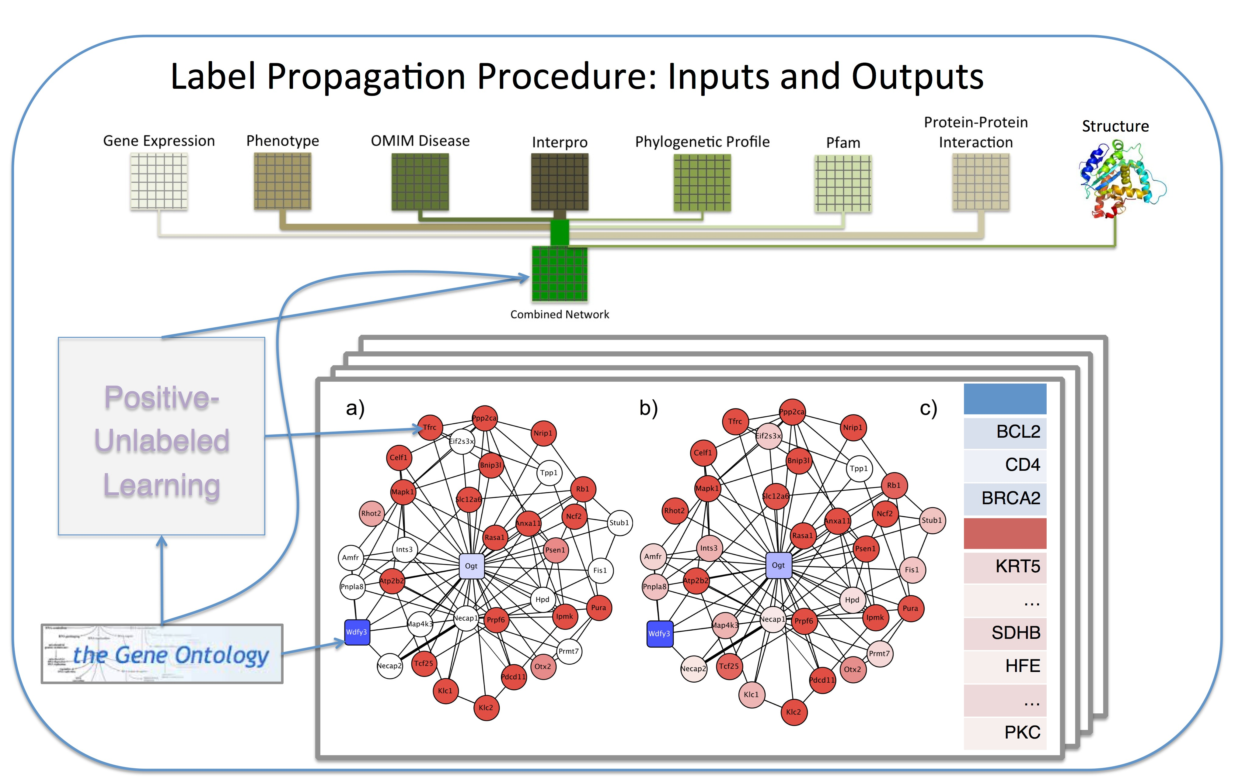

Figure 1. A graphical depiction of the label propagation protein function prediction process. Different datatypes are processed as similarity matrices (where each data type has a different weight) and combined utilizing existing Gene Ontology [Ashburner et al. 2000] annotations, as well as negative examples obtained via Positive-Unlabeled learning. This combined affinity matrix represents a network, different for each function being predicted, where positive and negative labels, as well as prior biases for unlabeled nodes can propagate.
This example illustrates the need, within data science, to integrate multiple data types, to incorporate disparate notions of similarity, and to use multiple machine learning methods operating over networks. As normally conceived, such a workflow is rerun infrequently because data changes are assumed to be slow. But new laboratory techniques may completely change that situation. For example, sequencing an individual human can be done in a few days for a few thousand Euros. Given a model that could predict the variations in function of particular mutations of a protein and given that mutations of different proteins might have a coordinated effect on phenotypes, new data may result in different conclusions.
The basic question then is: how can we minimize the time and effort needed to arrive at new insights given changes in the data? This is an experimental as well as theoretical question. One approach will be to look at the data itself to see whether any of the new data items are “very different” from existing values. This could entail clustering the data based on coefficient weights that an existing regression-like machine learning method has determined. If new data points fall within the clusters of existing data points, then conclusions are unlikely to change. A second approach will be to run the existing rules generated by the machine learning algorithm already in use to see if the conclusions of the algorithm are consistent with the values in the new data. If so, then the new data won’t change the final insights much. When the first two approaches suggest that changes to insights are possible, then we seek efficient incremental uses of machine learning algorithm to take into account the new data and come to possibly new conclusions. How to do this depends, in the current state of research, on the specifics of the algorithm. Gradient descent and neural network methods are naturally incremental, because they are trained incrementally. The situation is a more subtle one for support vector machines: [Cauwenberghs and Poggio 2001] and for decision/regression tree learning [He 2008]. We consider the situation unresolved for Bayesian networks. It is a deep research question to know whether there is a universal incremental approach to machine learning, a question of great interest to us.
An important additional issue is what to do with very old data. As Shasha has found from his interactions with Wall Street traders [Whitney and Shasha 2001], they have the memory capacity of fruit flies. Surprisingly, this makes them better at their jobs: old information is far less useful than current information when it comes to markets. Even in biology, this can be the case: old techniques for RNA expression measurement will soon be superseded by direct counting methods, rendering old data less and less useful. Fortunately, the effect of removing old data is analogous to adding in new data. If the removed old data lies within the clusters of the other data, then conclusions need not be recomputed.
Realizing the vision of dynamic evolution of insights as data changes will require engineering advances as well. For example, as new data arrives, a dynamic system must support both incremental clustering and the ability to indicate when differences have become so great that incremental machine learning must begin. There might even be a mechanism whereby idle time can be used to perform incremental machine learning even before triggering conditions have been reached.
Data science in a dynamic world is an ambitious project that will have a strong impact on the way scientists do science, making scientists more efficient and overall: science better. It is a challenging project that will require the combined talents of Shasha in data analysis and machine learning and those of Valduriez and his team in data integration [Özsu and Valduriez 2011, Ayat et al. 2013] and data streaming [Gulisano et al. 2012]. The project will lead to new data management algorithms and methods that will be implemented in tools and validated in the context of real data, in particular biology data from our partners at INRA Montpellier.
Specific advances [Patrick, please feel free to edit]
Algorithmic: Find incremental variants of existing machine learning algorithms in the quest for a general theory of incremental updates in data analysis.
Tool: Given a data analysis pipeline (as in the figure), determine when new data in a single data type might trigger changes in conclusions based on the similarity metric for that data type, the weight of that data type, and the machine learning method used. When required, invoke an incremental algorithm on the machine learning algorithms being used.
References
Anciaux N., Benzine M., Bouganim L., Pucheral P., Shasha D. (2007) GhostDB: querying visible and hidden data without leaks. ACM SIGMOD Int. Conf. 677-688.
Ashburner M, Ball CA, Blake JA, Botstein D, Butler H, et al. (2000) Gene ontology: tool for the unification of biology. The Gene Ontology Consortium. Nat Genet 25: 25-29.
N. Ayat N., Akbarinia R., Afsarmanesh H., Valduriez P. (2013) Entity Resolution for Distributed Probabilistic Data. Distributed and Parallel Databases, 31(4):509-542.
Bairoch, Amos, and Rolf Apweiler (1997). "The SWISS-PROT protein sequence data bank and its supplement TrEMBL." Nucleic acids research 25.1: 31-36
Bhardwaj N, Gerstein M, Lu H (2010) Genome-wide sequence-based prediction of peripheral proteins using a novel semi-supervised learning technique. BMC Bioinformatics 11 Suppl 1: S6.
Cauwenberghs G. and T. Poggio (2010), “Incremental and decremental support vector machine learning,” in Advances in Neural Information Processing Systems (T. K. Leen, T. G. Dietterich, and V. Tresp, eds.), vol. 13, (Cambridge, Massachussetts), pp. 409–415, The MIT Press, 2001
Drew, K., et al. (2011) The Proteome Folding Project: proteome-scale prediction of structure and function. Genome Res., 21: 1981-1994.
Fabret F., Jacobsen A., Llirbat F., Pereira J., Ross K., Shasha D. (2001) Filtering Algorithms and Implementation for Very Fast Publish/Subscribe Systems. ACM SIGMOD Int. Conf. 115-126.
Guan Y, Myers CL, Hess DC, Barutcuoglu Z, Caudy AA, et al. (2008) Predicting gene function in a hierarchical context with an ensemble of classifiers. Genome Biol 9 Suppl 1: S3.
Gulisano V., Jimenez-Peris R., Patiño-Martinez M., Soriente C., Valduriez P. (2012) StreamCloud: An Elastic and Scalable Data Streaming System. IEEE Trans. On Parallel and Distributed Systems, 23(12): 2351 – 2365.
He, Zheng (2008) Batch and Incremental Learning of Decision Trees, Diplomarbeit (thesis) October 2008. http://alexandria.tue.nl/extra1/afstversl/wsk-i/he2008.pdf
Kim, W. K et al. (2008) Inferring mouse gene functions from genomic-scale data using a combined functional network/classification strategy. Genome Biol 9 (Suppl. 1), S5.

Krouk et al. (2013) Gene regulatory networks in plants: learning causality from time and perturbation. Genome Biology, June 2013
Krouk et al (2010) Predictive network modeling of the high-resolution dynamic plant transcriptome in response to nitrate. Genome Biology 2010, 11:R123 doi:10.1186/gb-2010-11-12-r123 Published: 23 December 2010
Lee, H., et al. (2006) Diffusion Kernel-Based Logistic Regression Models for Protein Function Prediction. OMICS, 13, 896-904.
Lejay et al. (2004) Adaptive Combinatorial Design to explore Large Experimental Spaces: approach and validation. Systems Biology 1(2), 206-212.
Leone, M., and Pagnani, A. (2005) Predicting protein functions with message passing algorithms. Bioinformatics, 21(2), 239-247. doi:10.1093/bioinformatics/bth491.
Marcotte, E. M., et al. (1999) A combined algorithm for genome-wide prediction of protein function. Nature, 402, 83-86.
Obozinski, G., et al. (2008) Consistent probabilistic outputs for protein function prediction. Genome Biol., 9 (Suppl 1.), S6.
Özsu T., Valduriez P. (2011) Principles of Distributed Database Systems – Third Edition. Springer, 850 pages.
Qi, Y., et al. (2008) Random forest similarity for protein-protein interaction prediction from multiple sources. Pac. Symp. Biocomputing, 531-542.

Ruffel et al. (2011) Nitrogen economics of root foraging: Transitive closure of the nitrate-cytokinin relay and distinct systemic signaling for N supply vs. demand. Proc U.S. National Academy of Science November 8, 2011
Shasha D., Llirbat F., Simon E., Valduriez (1992) Simple Rational Guidance for Chopping Up Transactions. ACM SIGMOD Int. Conf., San Diego, 298-307.
Shasha D., Llirbat F., Simon E., Valduriez (1995) Transaction Chopping: Algorithms and Performance Studies. ACM Transactions on Database Systems, 20(3):325-363.
Tasan, M., et al. (2008) An en masse phenotype and function prediction system for Mus musculus. Genome Biol., 9(Suppl. 1), S8.
Troyanskaya, O.G., et al. (2003) A Bayesian framework for combining heterogeneous data sources for gene function prediction (in Saccharomyces cerevisiae). Proc. Natl. Acad. Sci., 100, 8348-8353.
Youngs N, Penfold-Brown D, Drew K, Shasha D, Bonneau R (2013) Parametric Bayesian priors and better choice of negative examples improve protein function prediction. Bioinformatics 29: 1190-1198.
Whitney A, Shasha D (2001). Lots o' Ticks: real-time high performance time series queries on billions of trades and quotes. ACM Sigmod 2001.
Zhang, C., et al. (2008) An integrated probabilistic approach for gene function prediction using multiple sources of high-throughput data. Int. Journal of Comp. Biology and Drug Design, 1(3), 254-274.
Zhang Y, Thiele I, Weekes D, Li Z, Jaroszewski L, Ginalski K, Deacon AM, Wooley J, Lesley SA, Wilson IA, et al. (2009). Three-dimensional structural view of the central metabolic network of Thermotoga maritima. Science 325: 1544–1549.
Zhao XM, Wang Y, Chen L, Aihara K (2008) Gene function prediction using labeled and unlabeled data. BMC Bioinformatics 9: 57.
Zhou, D., et al. (2004) Learning with local and global consistency. Adv. Neural Inf. Process. Syst., 16, 321-328.
Zhu, X., et al . (2003) Semi-supervised learning using Gaussian fields and harmonic functions. In Proceedings of the Twentieth International Conference on Machine Learning,

