Penguins

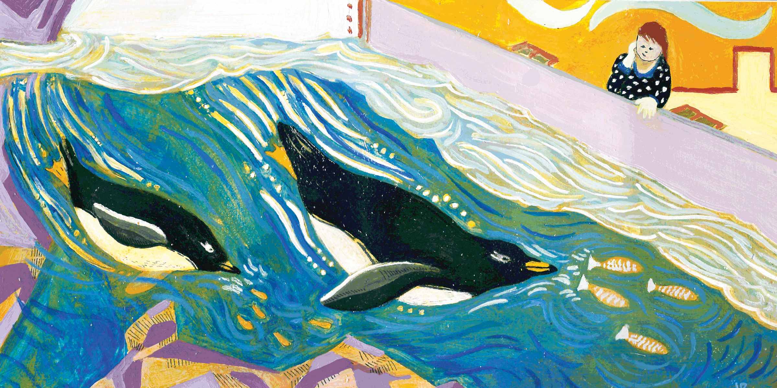

Level 1:

Either Fred or Judy is a penguin but no more than one of them.
Either Judy or Alice is a penguin but no more than one of them.

If we know there are two penguins, then what are their names?

Level 2:

Either Fred or Judy is a penguin but no more than one.
Either Judy or Alice is a penguin but no more than one.
Either Fred or Alice or Tom is a penguin but no more than one.

If there are exactly two penguins, what are their names?

Level 3:

Either Fred or Judy is a penguin but no more than one.
Either Judy or Alice is a penguin but no more than one.

Exactly two of Fred, Alice, and Tom are penguins.

- If there are exactly two penguins, what are their names?

Penguins: Solutions

Solution Level 1:
Must be Fred and Alice, because if Judy is a penguin, then neither Alice nor Fred can be.

Solution Level 2:
Fred and Alice can't both be penguins by the third rule,
so Judy must be a penguin and Fred and Alice must not be.
Therefore Tom is another penguin.

Solution Level 3:
It must be Fred and Alice.
It cannot be, say, Fred and Tom, because if so, then Judy is not a penguin and therefore neither Judy nor Alice is a penguin, which is impossible.
Similarly for Alice and Tom.

