Constructing stored instruction silos

Introduction

In order to explore the experimental realities of the stored instruction silo, we decided to first attempt creating silos of various lengths. The method of construction for the silos employed was very similar to the deconstruction method of alternately pouring an annealing tick and tock strands. In this case, however, we would start with the “base” strand, and alternately pour anti-tick and instruction strands. This method, though time consuming, proved to be the most reliable for making silos of a determined length, and unlike many one-step methods, would allow for construction of the color-changing silos described earlier.

Time is not a large concern in construction of these silos since they can be prepared far in advance of their use and stored stably at low temperatures. In addition, this construction could easily be automated, which would make it even more convenient.

Our findings indicate that this method of construction should be a viable method for making silos of an approximate length, as stoichiometric balancing of input strands was able to curb expected chain reactions wherein excess anti-tick and instruction strands continue to anneal and create longer silos than intended. This is also promising for the deconstruction step, where we anticipate that the similarly expected chain reactions – a possible source of inaccuracy – could be mitigated by controlling stoichiometry. Besides controlling stoichiometry, is there a cost in time at deconstruction to avoid chain reactions, e.g. extra time to wait for reactions to happen completely.

Overview of methods

Our original approach was a one-step method, which combined base strands, instructions strands, and anti-tick strands in a 1:4:4 ratio to see if we could create silos containing approximately four instructions. In this stage, we combined all the strands at 40˚C to disrupt any unwanted base pairing (these pairings usually occur over small ranges (2-3 nucleotides) between strands during storage at low temperatures, when it becomes favorable for any sort of interaction to form between strands). We then cooled the combined strands slowly, as slow cooling favors correct annealing between the longest matching sequences.

When we ran the resulting construct on a native gel (one that allows DNA to exist in a double stranded state, thus not disrupting our constructs unlike a denaturing gel), the results showed a wide range of sizes, indicating that this one-pot method yielded many chain reaction constructions, as shown below.

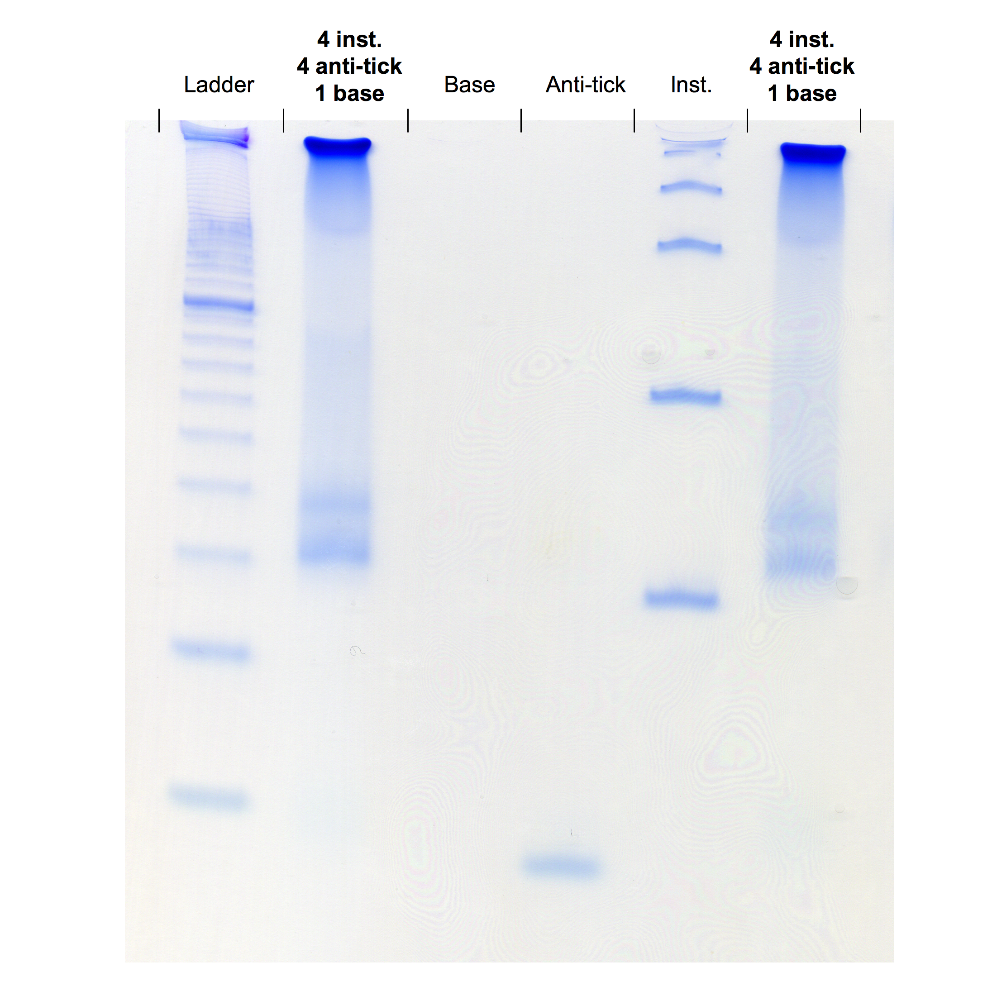

For this construct, we used a small (8 bp), single-stranded base strand. The anti-tick strand was a 16bp single strand of DNA, and the instruction was a 56bp hairpin. Each of these components was run in an independent lane on the gel as a reference for size. The base strand was too small to appear on the gel, and in addition would dissociate from the silo fairly easily due to its small region of complementarity. The multiple bands present in the lane consisting only of instruction strands will be explained shortly.

The silo appeared as a large smear in both of the lanes we ran it in, indicating the presence of many different sized constructs, containing anywhere between one and four instructions. This supported pursuing a sequential construction, where we would alternately pour and anneal balanced amounts of anti-tick and instruction strands in order to have more control over the length of the silo.

Because a sequential approach would require multiple rounds of heating and slow cooling (one for each strand to anneal), we had to design a larger base strand. The single-stranded 8bp fragment would not complement a large range, and would denature from the bottom of the silo at relatively low temperatures. Thus, we designed a new base as a composite of two strands – SB (small base) and LB (large base) – with an overhang that bound to the first instruction of the silo. This increased size also allowed us to visualize the base on a gel.

Because we were performing a sequential construction, we developed a naming system to categorize all intermediates we would hope to observe on the gel:
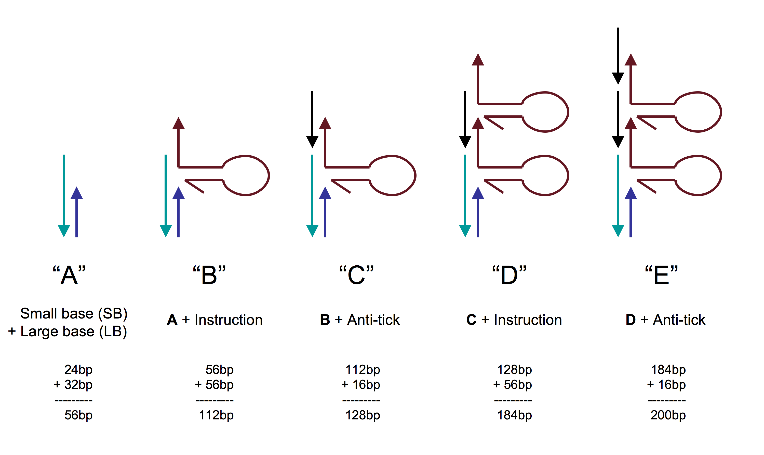
The sequential addition method proceeded as follows: equal molar amounts of the two base strands would be heated to a high temperature then cooled slowly to allow annealing. For each subsequent step, the current intermediate would be heated to a temperature high enough to disrupt unwanted base pairings, but not high enough to denature the construct. For example, when forming intermediate C, an equal molar amount of anti-tick and B would be combined in a vessel and heated to just below the temperature when the top instruction strand of B would dissociate. These temperatures were determined by the length of complementarity between the strands, which in this case was 8 base pairs. (Doesn’t it also matter whether the complementarity is AT vs. BC?) The resulting mixture would then be slowly cooled to allow desired annealing.

Following this method, we constructed A through C and ran the results on a native gel:

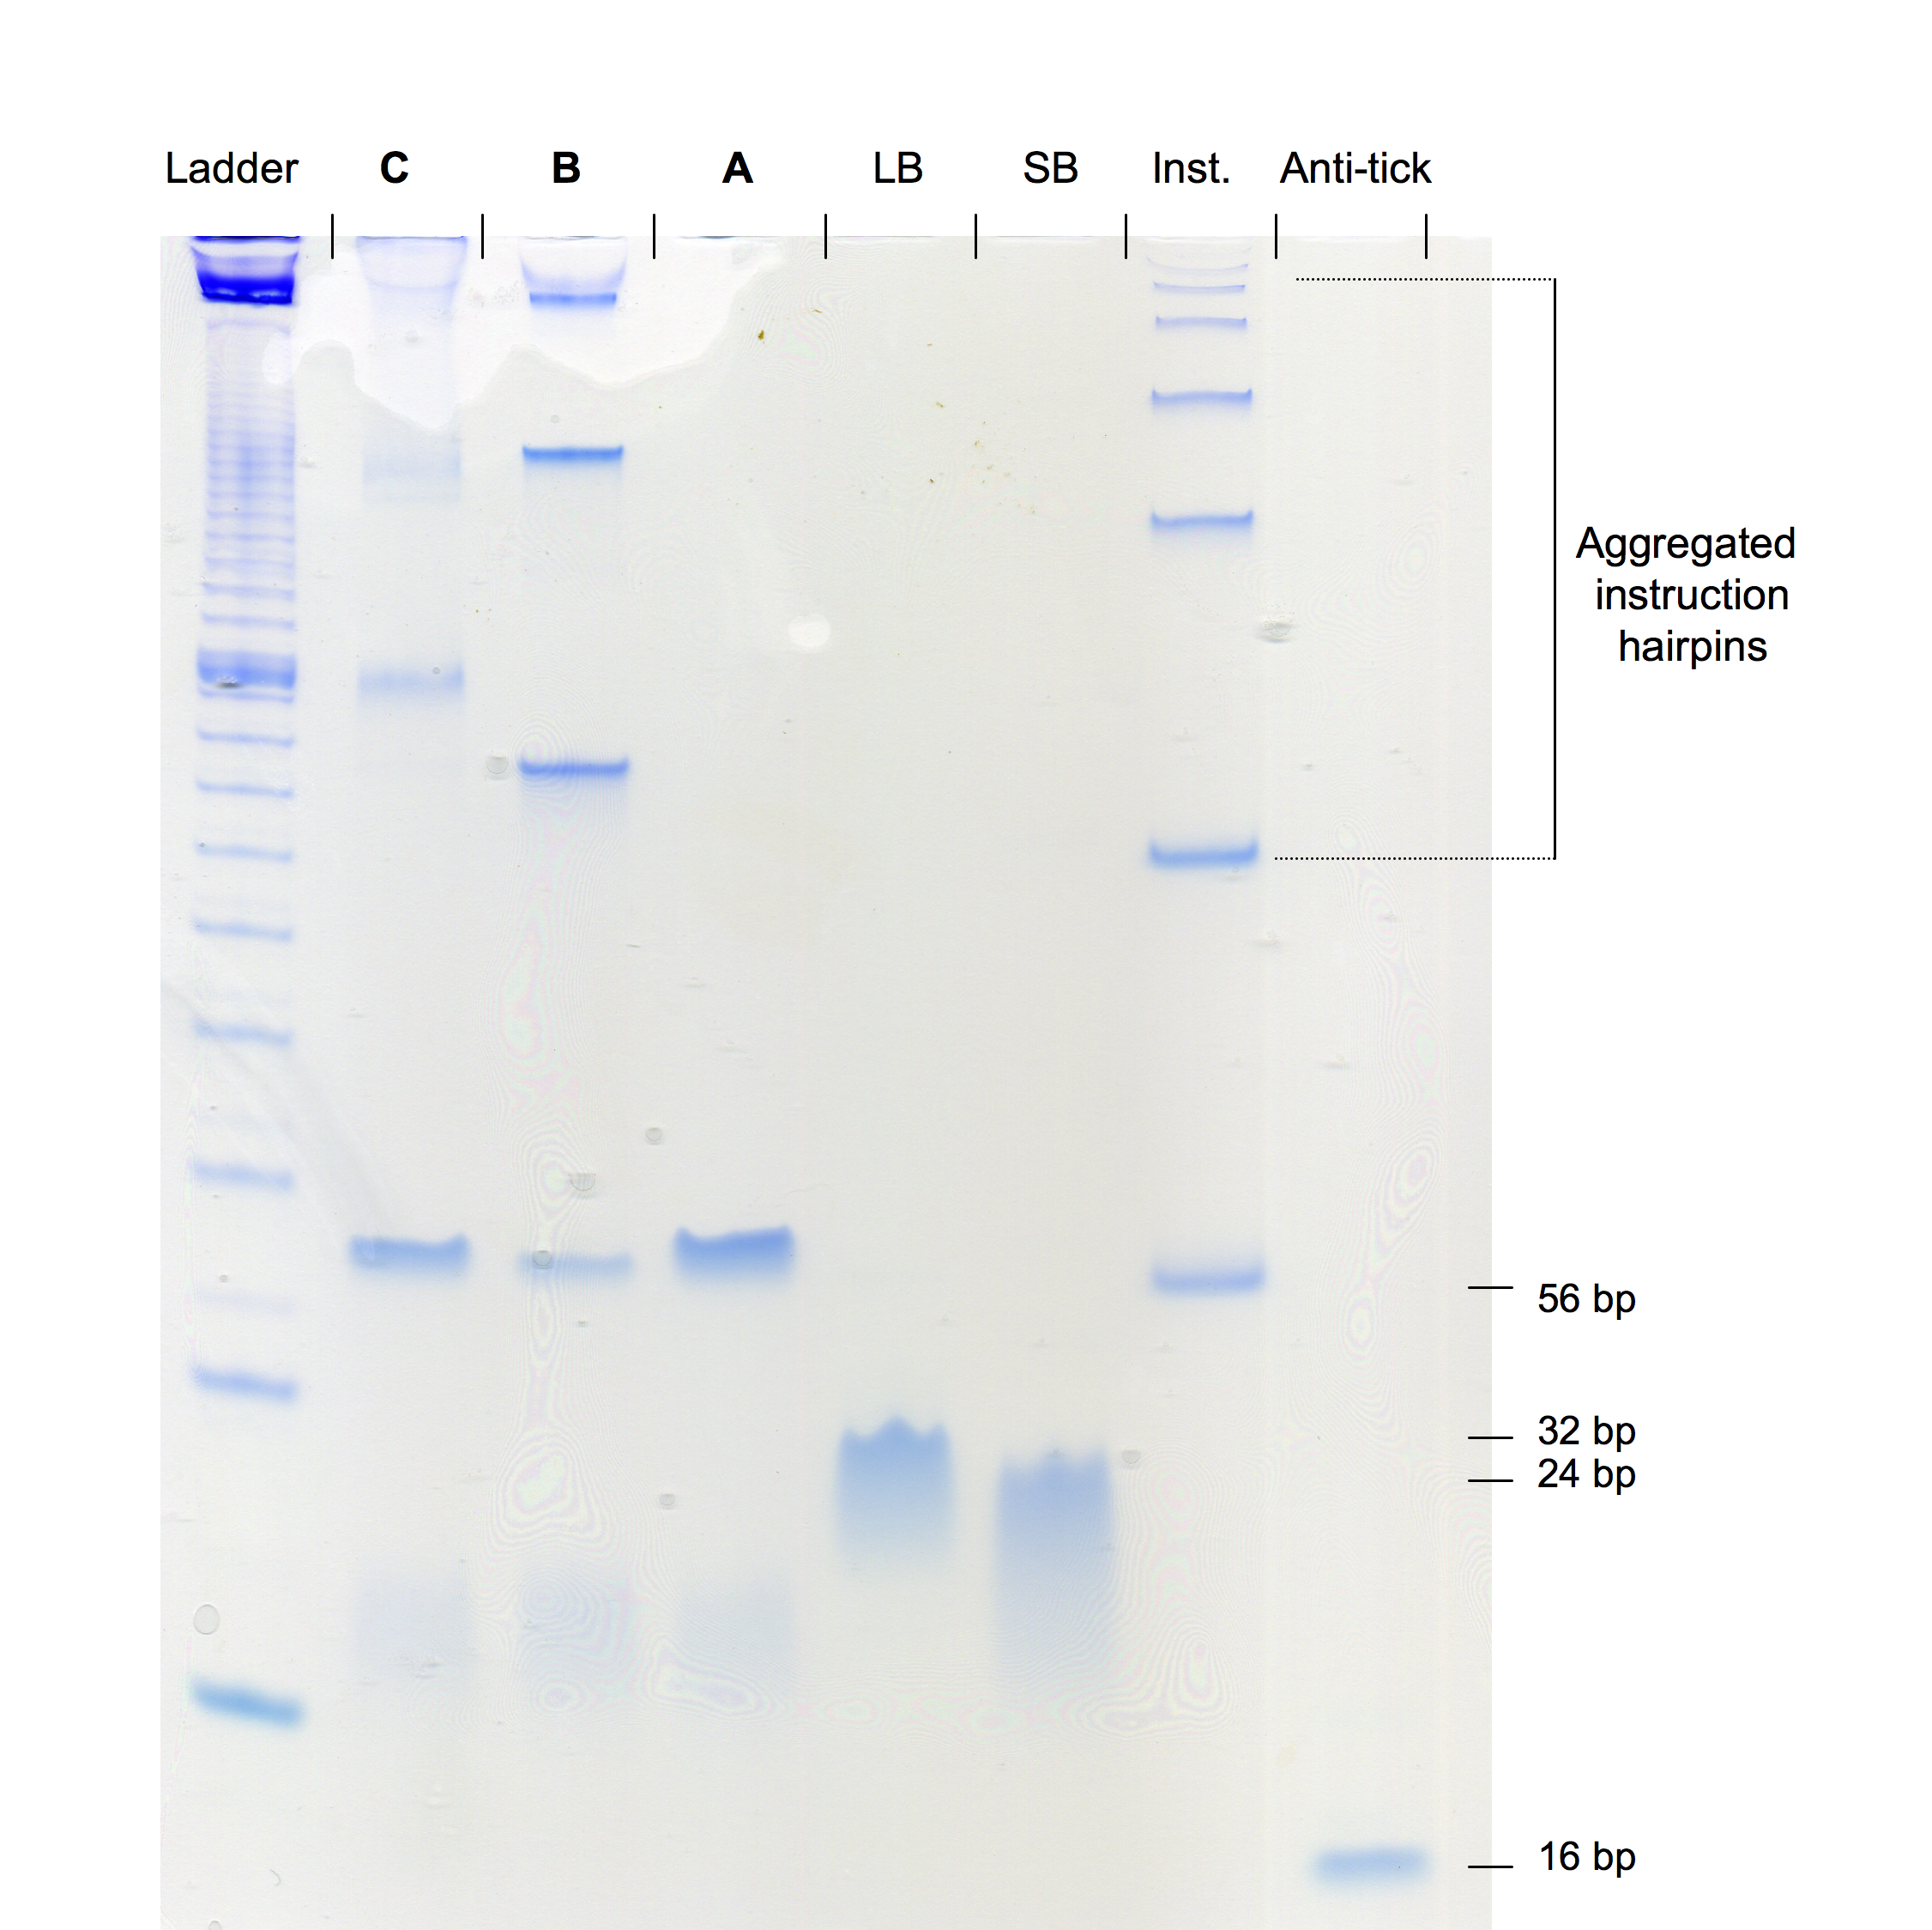

The anti-tick, SB, LB, and construct A lanes all show clear bands, but once again, the lane containing the instruction strand shows multiple discrete bands. This is due to the formation of aggregate hairpins – multiple hairpins bound together. This occurs when the hairpin stem melts, then, rather than re-annealing intramolecularly, binds to the melted stem domain of another hairpin, forming a double instruction, as illustrated below. This can occur multiple times, and on the gel we see aggregates of up to six instructions forming in appreciable amounts.

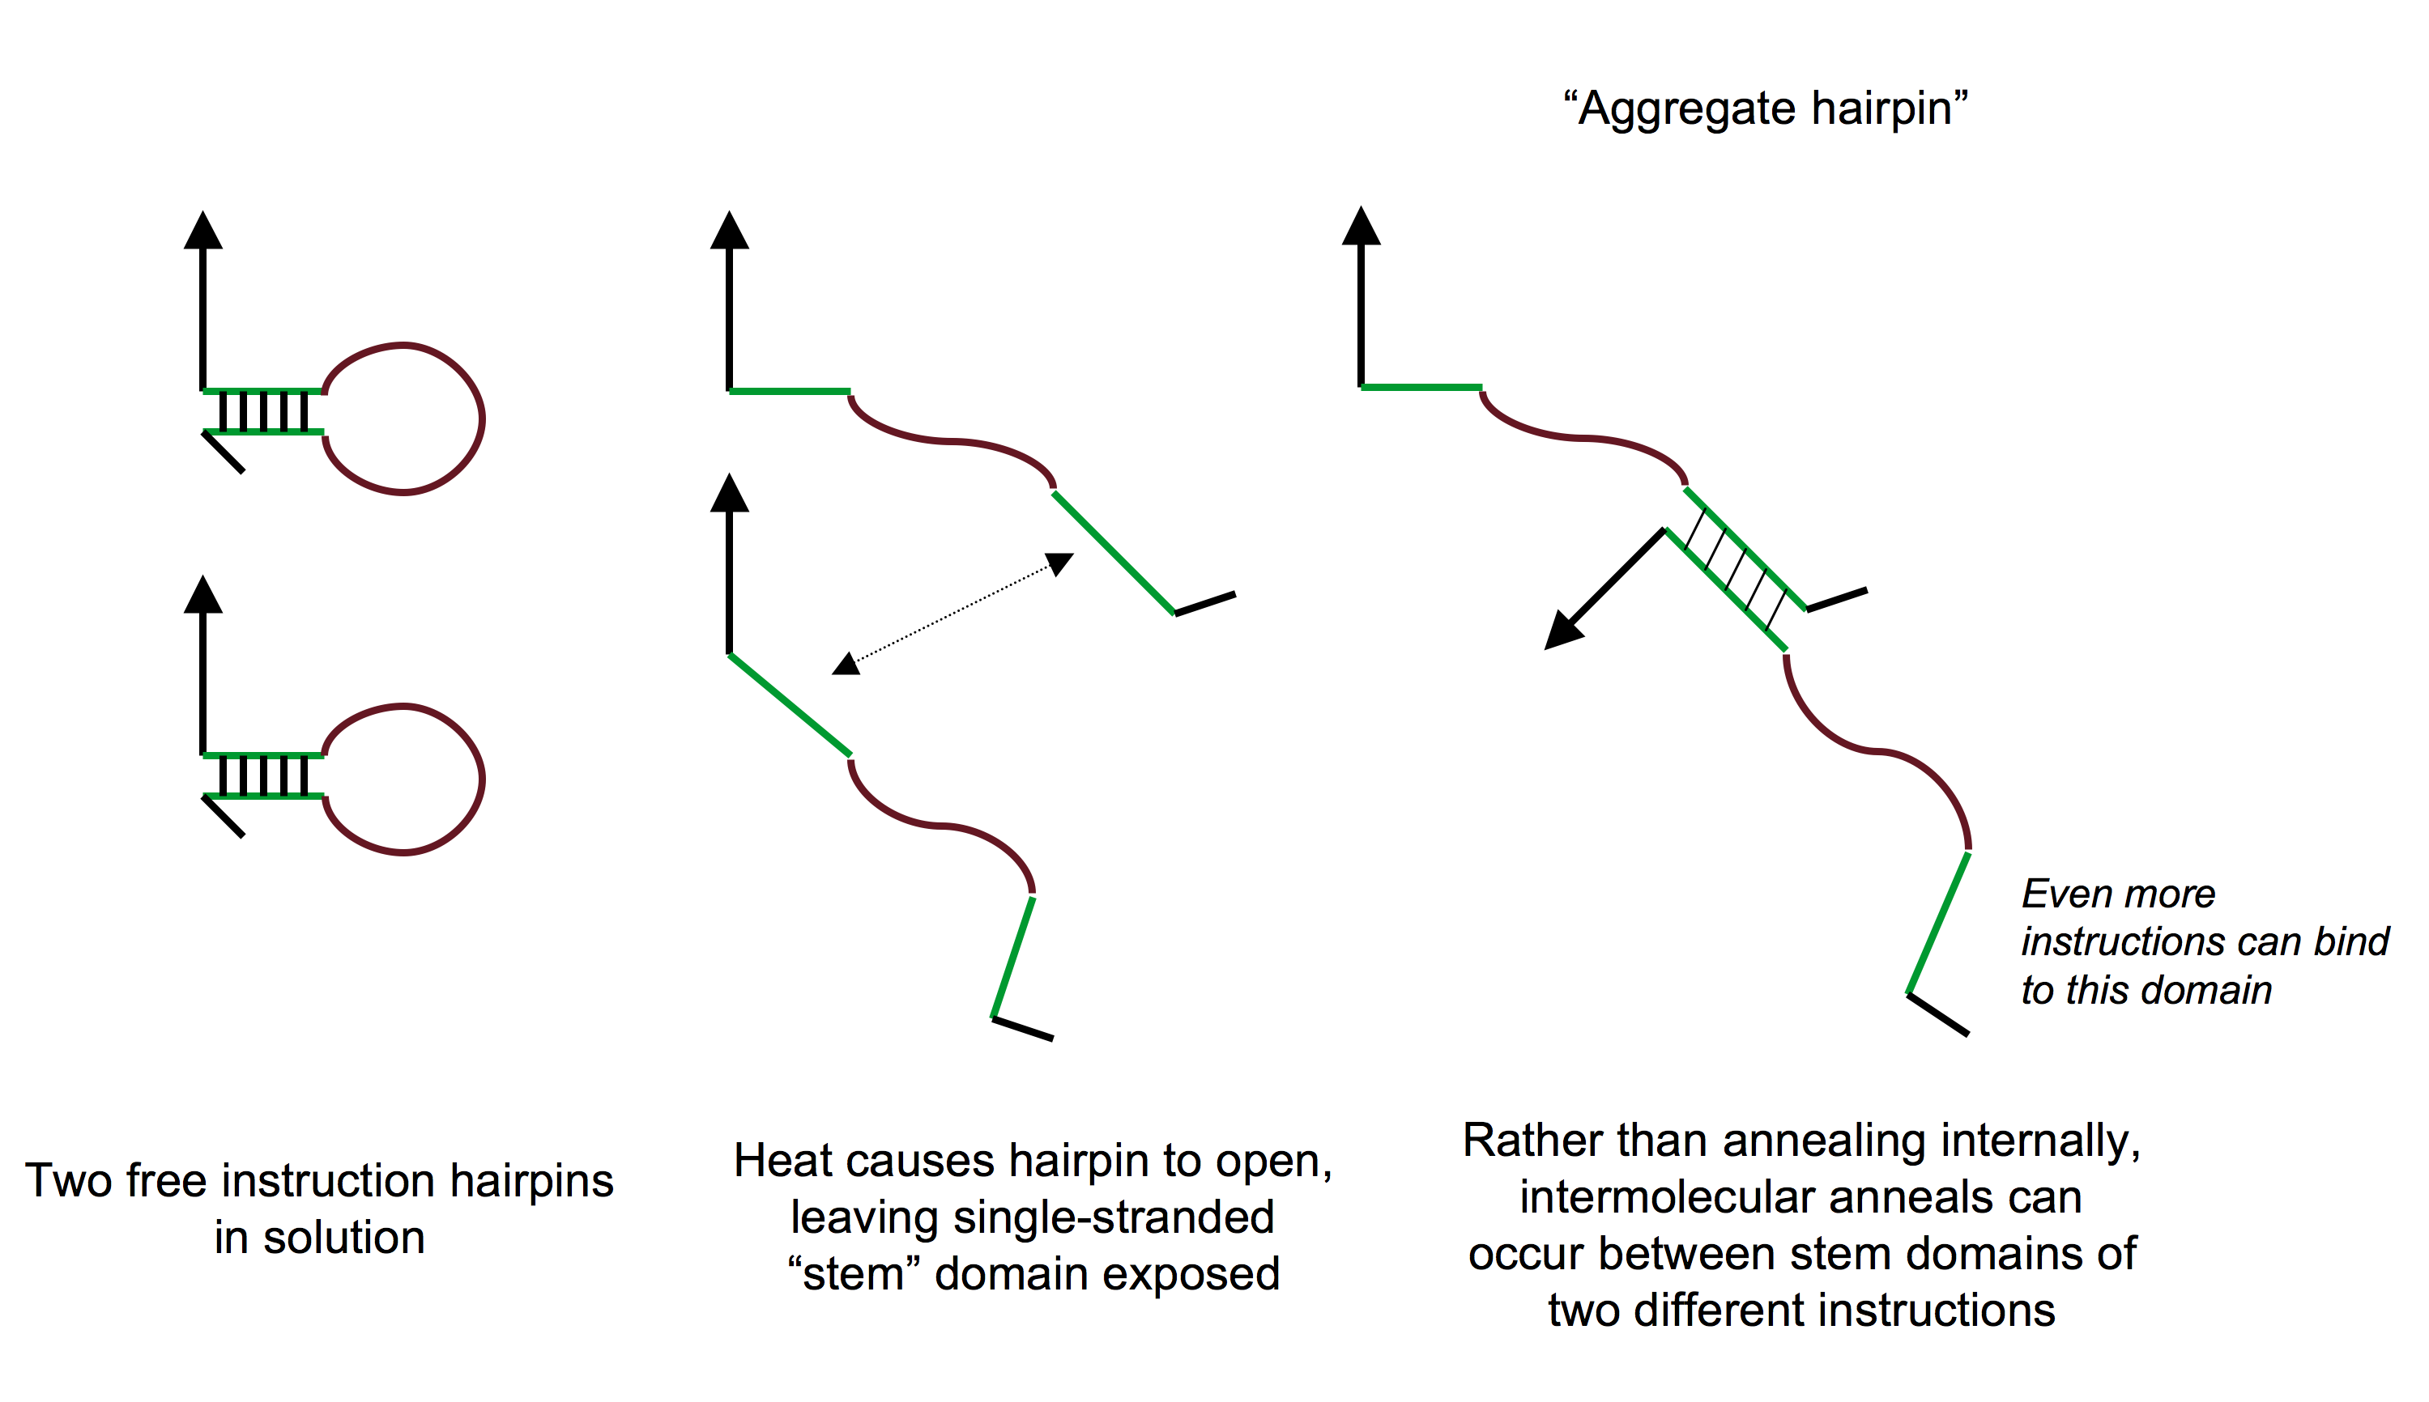

This explains why, in the gel above, we see multiple bands in the lane consisting of construct B. The bands are clear distinct, unlike those observed in the one-pot method, indicating that multiple instructions are being incorporated at once. This is not due to any chain reaction, since no anti-tick had been added to that vessel, but was rather due to the incorporation of aggregate hairpins to the base strands, yielding bands at various multiples of the size of one instruction strand. This throws off the results for subsequent intermediates, because instructions of variable size have led to intermediates of varying size as well. Despite this, when we look at the band in the B lane representing only one instruction added (the band just above the one representing slight excess of intermediate A), we see there is a band just above it in the lane containing C, indicating that the annealing of a stoichiometric amount of anti-tick might not have caused a chain reaction addition.

In order to confirm this, we decided to perform the experiment with an additional heat shock step to separate aggregate hairpins. Before we added hairpins to any reaction vessel, we would heat the hairpin strands to a high temperature. This would open all hairpin stems, and thereby separate all aggregate hairpins. Then, we would quickly cool the strands on dry ice. This quick cooling would favor intramolecular annealing over intermolecular annealing, ensuring all instructions would be single. These instructions were then annealed to the growing constructs with favorable results (shown below).

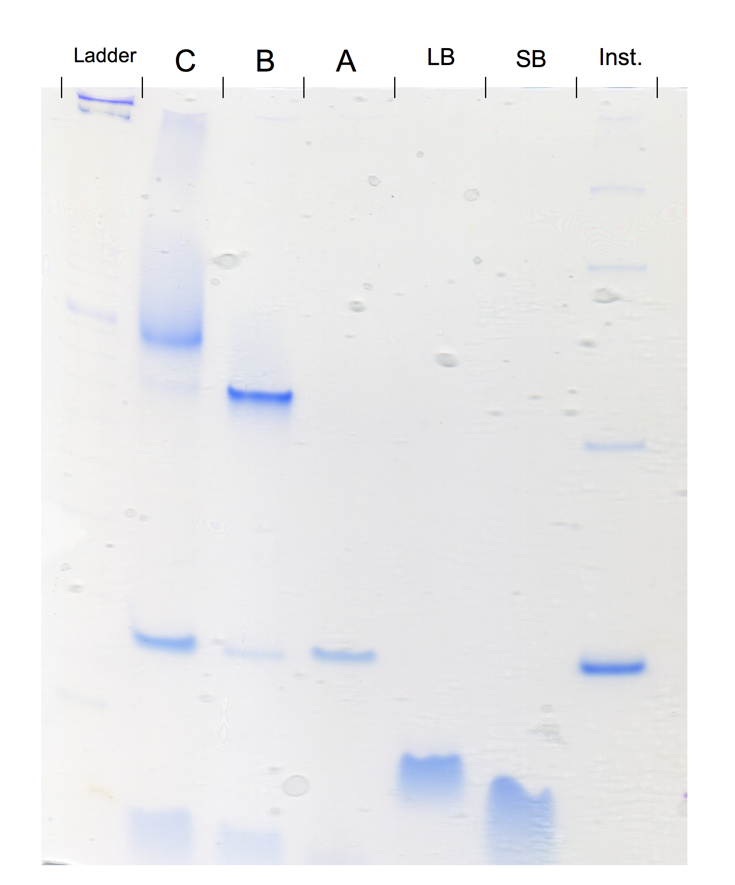

The gel shows a dramatic decrease in the aggregation of instructions when compared to the previous two. In addition, because the instruction strands used in the annealing reactions were used immediately and the ones run in the gel had rested some time since the heat shock, the aggregation observed in the gel run was likely less present in the annealing reactions. The single, clear band in the lane for B indicates the incorporation of a single instruction onto the base.

The smearing observed around the band in lane C indicates some amount of chain reaction addition following the annealing of anti-tick strands. However, the smearing is far lighter than in the first gel and the band density is clearly focused slightly above the band for B, indicating the incorporation of a single 16bp anti-tick strand is the major product.

Please add in a section here summarizing the final protocol you used.

Conclusions/Future directions

The limited experimentations we have been able to perform show promise, but still leave many more questions to be answered. We have demonstrated that constructing silos requires a sequential addition process to produce silos of a determinate length. We have also demonstrated that through simple stoichiometry, we are able to greatly limit the amount of chain reactions that occur with excess instruction and anti-tick strands during construction. This may also have implications for silo deconstruction, where we seek to curb similar chain reactions with tick and tock strands. We have also demonstrated the need for heat shock treatment of hairpin strands to ensure that aggregates are not incorporated into the silos. This will be a concern if instructions are indeed encoded as hairpins instead of single-strands.

We have yet to determine how large we can make these silos and how reliably we can control chain reactions at larger sizes. As they grow, native polyacrilamide gels may not be an informative enough means of visualization, as they are not capable of resolving small differences in size beyond a certain point. This may not be a concern, as fine-grained accuracy is less important for our purposes, especially at a certain size, but it is a worthwhile consideration.

We would like to determine how large we can build these silos reliably, and how well we can deconstruct them – particularly with locks in place. Much more remains to be experimentally verified, and for the sake of simplification we may want to proceed using single-stranded instructions instead of hairpins, since the nature of the instruction encoding has no large bearing as of yet.

