NSF 20-563
CPS: Medium: Robust Localization for Firefighter UAV Swarms using Machine Learning and Millimeter Wave Wireless

TODOS:
- NSF Bio and Current and Pending Support (Esther)

The CPS program aims to develop the core research needed to engineer these complex CPS, some of which may also require dependable, high- confidence, or provable behaviors. Advances in CPS should enable capability, adaptability, scalability, resilience, safety, security, and usability far beyond what is available in the simple embedded systems of today
Core research areas of the program include control, data analytics, and machine learning—including real-time learning for control, autonomy, design, IoT, mixed initiatives including human-in- or human-on-the-loop, networking, privacy, real-time systems, safety, security, and verification.
Core research areas of this call:
Autonomy
Control
Data analytics and machine learning
Internet of things (IoT)
Networking
Real-time systems
Safety
Verification.
The program also supports effective use of testbeds that spur innovations and accelerate research by providing scalable and open environments for experimentation. Researchers should consider using existing testbeds that include virtual simulation environments for early experimentation, higher fidelity hardware-in-the-loop environments, and live platforms. The program strongly encourages proposers to describe how their research may take advantage of such testbeds as a means for experimental validation and maturation in realistic environments.
CPS are becoming data-rich enabling new and higher degrees of automation and autonomy. Traditional ideas in CPS research are being challenged by new concepts emerging from artificial intelligence and machine learning. The integration of artificial intelligence with CPS especially for real-time operation creates new research opportunities with major societal implications.
The advent of IoT allows CPS components to communicate with other devices through cloud-based infrastructure, and to interact with (potentially) safety-critical systems, posing new research challenges in safety, security, and dependability.
CPS are becoming data-rich enabling new and higher degrees of automation and autonomy. Traditional ideas in CPS research are being challenged by new concepts emerging from artificial intelligence and machine learning. New methods to combine data-driven machine leaning and model-based leaning for decision and real-time control of cyber-physical systems are encouraged. Similarly, what do high confidence and verification mean in the context of autonomous systems that learn from their experiences? How does one reconcile the concepts of machine learning and data-driven modeling with approaches used in model-based design and formal methods?

Research Description
This is the intellectual heart of the Project Description. The Research Description section must describe the technical rationale and technical approach of the CPS research. It should describe the challenges that drive the research problem. It must identify how the research integrates cyber and physical components. It must explain how the proposal goes beyond sensing and how the system "closes the loop." For research focusing on "tools for CPS design or verification", the proposal must show how these tools are applicable to CPS, which have cyber and physical components that "close the loop." This section should describe specific activities for performing the research. It should provide the project research plan including descriptions of major tasks, the primary organization responsible for each task, and the milestones.

Introduction

Unmanned Aerial Vehicles (UAV) have gained increased attention due to the potential use cases they facilitate. Accurate and reliable positioning systems in dense urban environments are a key challenge for autonomous vehicles since GPS (Global Position System) fails in street canyons where satellite signals are blocked or reflected from buildings, and is unavailable in indoor and underground environments due to lack of direct satellite signal. Alternative localization solutions include the use of video cameras, inertial sensors, radar systems, fingerprinting, as well as localization based on signaling from 3GPP base stations on rooftops. However, none of the alternatives to GPS are able to achieve the high accuracy and reliability requirements of UAV applications under NLOS (Non-line-of-sight propagation) conditions, the predominant case in dense urban environments. Yet, a relatively dense deployment of small cells with 5G millimeter wave (mmWave) will lead to a paradigm shift in wireless positioning, due to the directionality of mmWave beams and the high bandwidth availability. In addition to the smaller cells and wide bandwidths, edge computing at 5G base stations (BSs) will allow for low latency processing of computationally expensive algorithms.

Real-time 3D simulation of UAVs in their surroundings is an essential tool for the planning and execution of autonomous UAV swarm missions. Similarly, raytracing simulations use a 3D model to determine and predict the multipath propagation of mmWave beams, taking into account the reflective and scattering properties of surrounding objects. Combined with situational awareness of moving objects and suitable ML decision-making, real-time raytracing simulations allow for optimal antenna beam-selection schemes in dynamic environments. Moreover, recent research [1] reveals the possibility of using mmWave raytracing for highly accurate positioning in rich multipath environments, under the condition that a minimum of mmWave beams can be maintained between communicating nodes. Vice versa, ML-based antenna beam-selection schemes benefit significantly from more reliable and accurate positioning estimates. To achieve beneficial multipath conditions and additional beams between UAVs, small adjustments of the UAV location in the 3D space can have a great effect. Consequently, an integrated approach for both beam-selection and flight control of a UAV swarm is reasonable. This self-contained mmWave solution integrates accurate positioning with communication of UAV sensor and control data, a system that brings complex UAV mission for public safety applications closer to reality.

This project envisions a drone-based machine learning millimeter wave system capable of (i) locating fires in buildings and characterizing them, (ii) [maybe] fighting the fire/rescuing people. The ultimate goal of this project is a demonstration of the developed solution as part of the COSMOS testbed in NYC. Automated driving in dense urban environments would also benefit from an integrated mmWave-based positioning and communication system.

Several fire departments, including our partner the Fire Department of New York (FDNY), have started a drone (i.e. UAV) program to improve situational awareness of their firefighters. In the future, firefighter operations will be further enhanced with cooperative, sensor-equipped autonomously flying swarms, which will improve efficiency and effectiveness of these public safety forces.

Motivation

According to the National Fire Protection Association (NFPA) report - “Fire loss in the United States,” the U.S. fire departments responded to an estimated 1,318,500 fires in 2018. These fires caused 3,655 civilian fire fatalities, 15,200 civilian fire injuries, 64 firefighter on-duty deaths, 58,900 firefighter injuries, and an estimated $25.6 billion in direct property loss [2]. Most importantly, four of every five fire deaths and three-quarters of all reported fire injuries were caused by home structure fires. The majority of U.S. Fire Service (70% volunteer) are continuously challenged by the available resources in terms of manpower, equipment, and budgets while responding to these fires in a timely manner [3].

Since the 1970s the number of structure fires per year has dropped more than 50%. Also, turnout gear is much better; the amount of training firefighters receive has increased; and firefighting equipment and technology have improved significantly. Based on these facts, many of us would believe that the fire-ground has become a safer place. Unfortunately this has not happened and in fact, the rate of traumatic deaths on the fire-ground has increased from 1.8 per 100,000 fires during the 1970s to 3 per 100,000 today [4]. As per the NFPA report – “Patterns of Firefighter Fireground Injuries,” residential fires account for about eight out of ten firefighter fire-ground injuries [5].

The fire dynamics encountered during modern residential fires differ greatly from those in the past decades. The size and open layout of modern single-family homes, new construction materials and techniques, and high heat release-rate furnishings are increasing the risk to firefighters. The cumulative effects of these changes are faster fire propagation, excessive volume of smoke, shorter escape times, decreased time to flashover, shorter times to structural collapse, and a reduction in time available for effective fire-ground operations [6], [7]. Numerous Line-of-Duty Death (LODD) reports from the National Institute for Occupational Safety and Health (NIOSH) Firefighter Fatality Investigation and Prevention Program recommend that firefighters have a sound understanding of fire behavior, fire development indicators, and the potential for extreme fire conditions. This deficiency decreases situational awareness and negatively influences strategic decision-making during fire-ground operations [8-12].

Background and Prior Work

Current navigation solutions in outdoor settings rely mostly on the use of GPS data, which is not sufficient to provide stable and reliable navigation. Fully autonomous operation in cities or other dense environments requires autonomous helicopters to fly at low altitudes, where GPS signals are often shadowed or indoors where GPS signal is absent. In recent years, research on autonomy for aerial vehicles focused on the ability to use on-board sensors such as cameras and inertial measurement units (IMUs), compatible with power constraints, to enable autonomous navigation [13-17]. Recently, some autonomous-flight demonstrations have been achieved using just cameras and inertial sensors [18] [14]. Even though camera-based solutions may appear to offer a viable and affordable solution to the navigation problem, their use is very dependent on light conditions and on the type of environment. Moreover, in the presence of smoke, fog and low light or dark operating conditions, it is very difficult to extract characteristic landmarks used for localization in the environment.

UAVs connected to the cellular network are promising technology and pose several interesting research questions [19]. The use case of cellular-connected UAVs is mostly being discussed in the context of 5G and the Third Generation Partnership Project (3GPP) standardization body is working on related releases [20]. Some work suggests using 5G-LTE for communications within UAV swarms [21]. However, recent publications suggest to use mmWave for UAV communications [22-28], a technology promising due to its bandwidth availability, low latency and the advantageous mmWave propagation conditions in high altitudes with few or no obstructing objects. UAVs are often foreseen as a flying base station and novel schemes are proposed to serve users on the ground [25, 26]. The main challenges of mmWave UAV communications are the high mobility of UAVs, which requires fast beam training and tracking. Furthermore, wind and the fault of attitude control lead to unstable beam pointing and require countermeasures [27]. Also, dependent on the distance to the users, the ideal number and widths of beams has to be selected [28]. Due to their flexibility, UAVs can achieve LOS conditions to other UAVs or to a base station through appropriate movements [29, 30]. Hence, some work suggests to adjust the UAV position for better wireless performance [31] or combine UAV mission goals with wireless performance objectives in dense urban environments [32, 33]. The particular behavior of blockage effects for mmWave-enabled UAVs is described in[29]. Advanced communication capabilities can be achieved with UAVs forming a chain to enable wireless relays while taking into account the topology of the urban environment [34, 35] [36].

Some publications describe firefighter missions such as cooperative fire detection [37] or monitoring of firefighters using multiple UAVs [38]. However, the proposed solutions are dependent on the availability GPS and are not applicable to dense urban environments, where the performance of GPS is poor [39-41]. Alternative solutions for urban positioning have been proposed, either through combining precise GPS, vision, radar, and inertial sensing [42] or through multipath fingerprinting [43] [44], some specifically designed for UAV positioning [45]. However, fingerprinting-based localization techniques require a labor-intensive offline fingerprint database creation phase. Moreover, the offline database needs to be rebuilt if the propagation environment changes [46].

Current 3GPP positioning solutions assume LOS operation [47, 48] and do not provide sub-meter accurate localization. Recent research reveals the possibility of using mmWave for accurate localization [49-53], which is possible due to the large available bandwidth that permits precise on-the-fly time of flight measurements using conventional air interface standards [54]. In addition, narrow antenna beamwidths may be used to determine the angles of arrival (AoA) and angles of departure (AoD) of the multipath components between the base station and mobile users. Existing mmWave localization techniques assume the presence of a LOS path or an obstructed LOS path [55], or assume very simple rectangular geometry of rooms [56]. The NLOS localization technique discussed in [57] only considers single-bounce reflections. However, at mmWave frequencies, strong multi-bounce reflections exist and can be used to detect the underlying ambient information, including the specific layout of potential reflectors. Exploiting the radar capability of mmWave antenna array, this approach can accomplish ambient perception through location-based sparse channel reconstruction [58].

Machine learning and wireless networks are becoming more and more integrated [59]. Conventional mmWave beam sweeping solutions often have large overhead and are not suitable for dynamic communication scenarios. However, interfacing a vehicle traffic simulator with a raytracing simulator can generate a specific dataset for investigations of ML-based beam-selection techniques on vehicle-to-infrastructure scenarios [60]. Learning-based solutions leverage sensor data, for instance position information, to identify beam directions, which enable good beam pairing quickly [61]. Combining machine learning with situational awareness in vehicular settings can improve the prediction accuracy with almost zero overhead [62]. Hence, ML-based beam-selection has the potential to reliably maintain mmWave connectivity in dynamic scenarios by predicting ideal beam-steering strategies based on situational awareness and knowledge about the surrounding environment. [Dennis is assuming that the machine learning for location of the drones is done by someone else.]

Potentials and Challenges

In dense urban environments, GPS cannot achieve the high accuracy and reliability requirements of UAV applications under the Non-line-of-sight propagation (NLOS) conditions. Recent research developments in 5G mmWave demonstrate accurate wireless positioning due to the directionality of mmWave beams and the wide bandwidths available at mmWave frequencies, which may be exploited for accurate positioning [63]. In addition to the wide bandwidths at mmWave frequencies, the large antenna arrays deployed at mmWave BSs and MIMO capabilities on UAVs produce narrow beamwidths. Large antenna arrays with N = 256 antenna elements are commercially available at 26 GHz [64]. Assuming a 2D uniform square array configuration, the half-power beamwidth of such an antenna array is 1.78/$\sqrt{N}$ ~ 6.4⁰ [65] allow accurate estimation of the angle of arrival and departure of mmWave beams.

[If we are doing outdoor location only, then we don’t need this.] In a multipath rich environment, source rays arrive at the receiver via a direct path as well as along paths, where the source rays suffer multiple reflections. With knowledge of the angles at which the source rays arrive at the receiver, the time-of-flight (ToF) of the source rays and a 3-D map of the surrounding environment, the receiver may determine the location of the source. By combining accurate temporal and angular information of multipath components with a 3- D map of the environment (that may be built by each user or downloaded a-priori), robust localization is possible, even in NLOS environments. Localization is possible using a single BS when at least two multipath components arrive at the user. The user need not be in LOS of the BS.

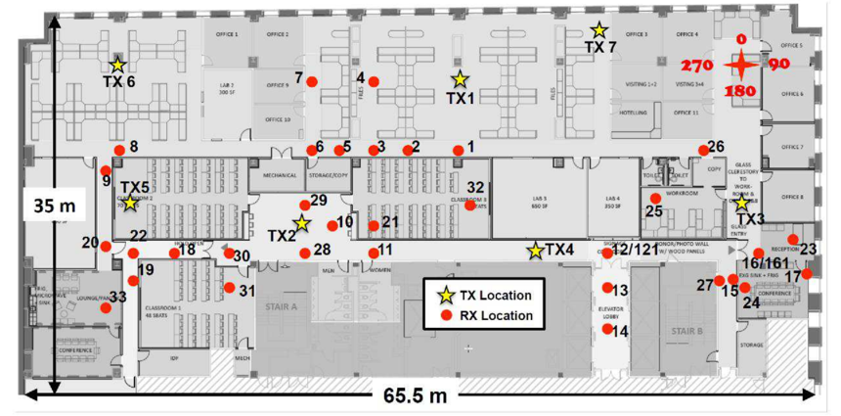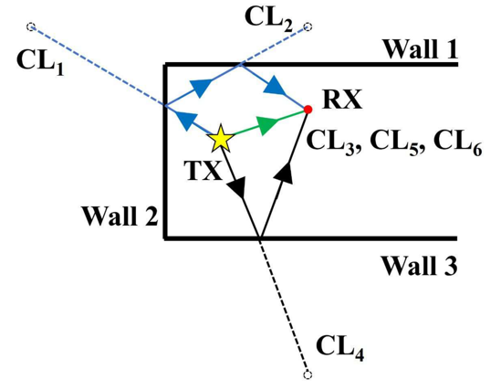
Figure 1 - Left: Map depicting the indoor locations where propagation measurements were conducted at 28 GHz and 73 GHz [66]. Right: Three multipath components arrive at the user (RX) shown above - one LOS component (in green) and two NLOS components (in blue and black). Of the six candidate locations for the user, based on AoD and ToF measurements at the BS (CL1 − CL6), three candidate locations (CL3, CL5, CL6) correspond to the actual location of the user. The position of the user is estimated to be the modal candidate location (i.e. CL3, CL5, CL6).

NYURay, an accurate 3-D mmWave ray tracer was developed calibrated to real-world mmWave measurements at 28 GHz and 140 GHz in an indoor office environment [63]. The work demonstrated how the fusion of angle of departure and time of flight information in concert with a 3-D map of a typical large office. Based on simulations conducted at 100 uniformly distributed user locations with distances ranging from 1.5 m to 24.5 m, a mean localization accuracy of 17.2 cm in LOS and 22.3 cm in NLOS was achieved in a typical large office environment using a single BS per user. By using three BSs, the localization error for LOS users remained the same while the localization error for NLOS users dropped to 5.5 cm.

Distance Tx-Rx | Propagation Condition | Mean localization error
1.5 m - 24.5 m | LOS – 1 base station | 17.2 cm
1.5 m - 24.5 m | NLOS – 1 base station | 22.3 cm
1.5 m - 24.5 m | NLOS – 3 base stations | 5.5 cm
Table 1 – Mean localization errors based on mmWave measurements in an indoor environment [63]

Real-time electric beam steering algorithms facilitate scanning of room features in a matter of seconds. As a result, 5G user equipment of the future will likely be able to generate detailed 3-D maps on the fly or will download them from the cloud [1]. NLOS objects (around corners) may be “viewed” by first rapidly scanning the environment via beam steering, in order to determine all the reflecting obstructions in the surroundings. The reflecting obstructions can then be distinguished from the target NLOS object to be “viewed” by taking advantage of the fine temporal resolution at mmWave and sub-THz frequencies to create a 3-D map of the local environment [1], [67], [68]. The 3-D maps may be utilized (in conjugation with AoD from the known BSs and ToF measurements) to calculate, back-solve or estimate the actual paths that the multipath components take to reach the user. The paths taken by the multipath components that reach the user contain sufficient information to localize a user in NLOS, even in the absence of LOS multipath signals.

The recent advances in computing, sensing, and perception algorithms provide the ability to run most of the autonomous components on board of the small-scale aerial vehicles. Current controllers for quadrotor or, in general, Vertical Take-off and Landing (VTOL) commercial vehicles are composed of an inner loop and an outer loop [58, 59]. The inner loop is responsible for stabilizing the attitude dynamics of the platform, whereas the outer control loop is used to control the position of the robot. If the inner loop runs on the vehicle, then current communication technologies, such as Wi-Fi and LTE, already provide the ability to remotely run the position control on a ground station or some perception algorithms. Under these conditions, despite the system being slower, it is still possible to demonstrate the stability of the overall quadrotor system. To show this property, it is possible to model the system as a double integrator, with independent subsystems for each Cartesian component, and assuming that the inner attitude loop is faster than the outer one. The time scale separation between inner and outer loops is a common assumption in the literature. Nonetheless, by using 5G and mmWave communications, it is possible to obtain better performance, particularly in terms of control system reactiveness both outsourcing the control and perception algorithms. The internal processing needed to solve the perception problem still takes around 10 to 20 ms [16], [69]. By exploiting the sub-ms latency and the high bandwidth of mmWave links, it is possible to efficiently offload the computation to edge-based systems, e.g., in the 5G base stations, thus overcoming the limits in computational power of the on-board processing units and solving the perception problem in a short time interval. This provides more robustness and reactivity to the autonomous vehicle. The usage of off-board processors has also the potential to reduce the scale and size of the platforms with the inherent additional benefit to increase users’ safety. Thus, the new low-latency solution proposed in this manuscript based on mmWave can certainly complement and enhance current autonomous aerial navigation techniques increasing localization robustness and precision.

The use of VTOL platforms like quadrotors, equipped with onboard sensors, can be a viable and cost-effective solution for autonomous inspection of cluttered, confined, and hazardous remote nuclear or radioactive GPS-denied environments. Autonomous drones have the potential to outperform human pilots in terms of safety, reliability, and mission duration [18]. Their ability to fly in 3D space and hover in place makes them a very versatile and attractive type of platform. Moreover, their small scale and low weight make them safe for humans and infrastructures to inspect. The price-performance ratio of processors, sensors, and networking infrastructure, which has dropped significantly over the last decade, has contributed to the rapid transition of these platforms from research laboratories to real-world scenarios. Their use in research laboratories, equipped with motion capture systems, has allowed researchers to focus on control strategies [70, 71], ignoring the issues of perception typical of unknown and unstructured environments. Recent research on autonomy for VTOLs has yielded a number of significant results.

The decreasing cost of UAVs, increasing ease to operate them and the fact that vast varieties of sensors can be mounted on them makes it an ideal technology for mobile and aerial urban sensing platforms for civil protection and smart city application, in general. Across the nation, firefighters respond to a wide variety of emergencies ranging from fires to hazardous material incidents to motor vehicle accidents to medical emergencies, and deadly active mass shooting incidents in some cases. Information about an emergency is shared with firefighters through a computer-aided dispatch system (CAD) as they drive towards the scene with additional information being shared over radios. ML-based autonomous UAVs can help firefighters in improving their situational awareness by continuously collecting the data of fire incidents and wirelessly transmitting it to the incident commander. For example, upon receiving a fire emergency call at 9-1-1 call center, the autonomous UAVs quickly fly to the incident by avoiding the traffic issues, immediately provide a birds-eye view of the situation, and share it with the call center and, subsequently, firefighters responding to the incident. Typically, as soon as firefighters arrive on-scene, they must perform a 360-degree size-up of the structure of interest. The sensor system of UAV swarms can perform the 360-degree size-up more efficiently, accurately depict the fire environment, and wirelessly transmit the data as firefighters are driving to the scene. Additionally, the thermal imaging and other sensors integrated in the UAVs can provide live fire development indicators, evaluate local wind and weather conditions, location of fire hydrants, etc. that can be viewed by firefighters on tablets inside the fire-truck, and will enable them to focus on building a strategy before or as they arrive on-scene. Our “non-human firefighters” can reassure the civilians that ‘help is on the way’ and try to pacify the situation or avoid chaos. As firefighters respond to the fire incident, the UAV swarm system can continue to provide data that will improve the situational awareness and strategic decision-making process in a continuously evolving fire-scenario. For example, UAVs can inform the incident commander of the fire situation at a roof-level or at the back of the structure where firefighters do not have a clear view. Emergency medical services (EMS) can also benefit tremendously from the information provided by the UAVs, and prepare to efficiently help the injured.

When firefighters enter the structure on-fire for search and rescue or putting water on the seat of the fire, numerous times they themselves get trapped or become the victim of floor/structure collapse or flashover. Inside the structure, firefighters crawl at floor level below the neutral plane to avoid the hot smoke and flames at the ceiling level above the neutral plane. Similarly, the autonomous UAVs can fly along the floor level below the neutral plane inside the structure and with its thermal imaging capabilities provide the most accurate picture of fire conditions inside the structure, locate trapped occupants and the seat of the fire, etc. This will not only help the firefighters in extinguishing the fire more efficiently but also in the search and rescue operation which will enhance the safety of civilians and firefighters, and reduce the damage of property. Overall, an optimum system of UAVs can save a tremendous amount of time and effort of firefighters, avoid the injuries and deaths of civilians and firefighters, reduce financial losses, and have the huge potential in benefiting the society.

In a multi-UAV system, UAVs need to observe the surroundings, continuously evaluate their own observations and information received from other UAVs, and reason from them, and act in an effective way. Key issues in these systems include determining which UAV should perform which task (task allocation) in order to maximize the efficiency of the team and the matrix to ensure the proper coordination among team members to successfully complete the mission. Therefore, an efficient sensing, communication, and coordination are three important aspects and challenges of the research [72].

Research Thrusts

Gantt chart which lays out the sequence of major activities and their inter-dependencies.

Thrust 1: CPS Research on [CPS goals]
It is essential that proposals not simply describe the development of a CPS, but also emphasize the areas of CPS-focused research contributing to this development in which novel and foundational research contributions are being made.

UAV swarm missions for firefighter operations. Identify UAV swarm missions for firefighter operations and develop appropriate ML approaches. Definition of ML solutions for relevant firefighter UAV swarm missions using mmWave.

Research Tasks: (i) We will define relevant firefighter UAV swarm missions with localization problems. (ii) We will develop new UAV swarm solutions using ML approaches, taking into account mmWave capabilities. (iii) We will simulate initial concepts, evaluate first results and identify the most promising solutions to focus on.

Integrated 3D simulator for real-time ML decision making. Combine different simulators to investigate best solution approaches. Evaluate and iterate improvements. Comprehensive simulation results with selection of most promising approach for integrated solution.

Research tasks: (i) We will develop an integrated simulator, which involves a ray-tracer, detailed 3D models, UAV swarm simulation and ML capabilities. (ii) We will implement for each area of expertise current state-of-the-art solutions, investigate interdependencies and develop an integrate solution. (iii) We will simulate approaches developed in Thrust 1, evaluate results and select most promising solutions.

Thrust 2: Evaluation, Experimentation and Validation

Applicability to 5G wireless edge networks. Real-world experimentation and demonstration of feasibility.
Validation of key solutions at appropriate test sites and dissemination of results.

Research tasks: (i) We will evaluate availability and suitability of relevant hardware (mmWave transceiver, mobile base station, UAVs etc.) and implement key components for validation purposes. (ii) We will design and conduct validation experiments at appropriate locations (COSMOS testbed, NYU labs, FDNY facility) for solutions selected in Thrust 2. (iii) We will demonstrate feasibility of final solution and disseminate results through various channels.

CPS Research Focus on [TBD] - Thrust 1
The CPS Research Focus subsection of the Research Description is where the PI describes how the research is driven by the unique cyber-physical system attributes of the challenge problem and clearly identifies the core CPS research areas addressed (as listed in the Project Summary section above) in which the novel and foundational research contributions are being made.
incl. challenges that drive the research problem and how the research integrates cyber and physical components
must identify how the research integrates cyber and physical components. It must explain how the proposal goes beyond sensing and how the system "closes the loop."
describes how the research is driven by the unique cyber-physical system attributes of the challenge problem and clearly identifies the core CPS research areas addressed (as listed in the Project Summary section above) in which the novel and foundational research contributions are being made.
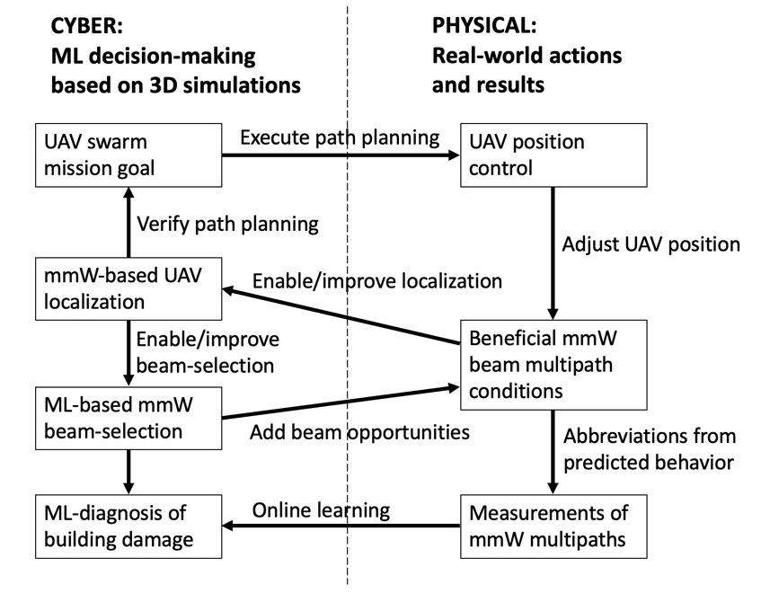
Figure 2 - Draft of cyber-physical state diagram and interdependencies of research components.

This research study aims to develop a self-contained system comprising of an ML-based and 5G mmWave-enabled localized UAV swarm system to assist the fire service in responding to calls efficiently. The system will be developed by closely working with the end-users - the fire departments of New York, Chicago, Houston, Bloomington (MN), and Los Angeles. The system will be tested in controlled burn experiments, revised based on the feedback from fire service, and if successful, will be implemented in collaboration from these leading fire departments in the nation.

Uniqueness of the proposal:
- Solution development based on long-term fire research and requirements of firefighters.
- Combining mmWave positioning with beam-selection and UAV swarm control.
- Comprehensive simulations including mmWave raytracing, UAV control and ML: realistic mmWave ray tracer due to NYU channel sounding data and HD 3D maps; simulation of structural damage through ray tracing; integrated UAV swarm control simulation; adaptive online learning with constraints of 5G wireless edge network.
- Validation using the COSMOS 5G testbed and as part of suitable burn experiments.

UAV swarm missions for firefighter operations

Machine Learning Approach to Achieving Overall Situational Awareness

According to firefighting doctrine, one of the first tasks of firefighters upon arriving at a burning building is to circle the building to determine which parts are burning as can be seen from the exterior. Of course, conditions can change, so it would be useful to obtain an ongoing readout of the exterior temperature profile. Our two approaches to this problem depend on the number of drones available relative to the geometry of the building and surrounding structures. In order to obtain an uninterrupted readout of the temperature profile of the building, we need to solve the following problem:

Given a three-dimensional shape S (a building) surrounded by other shapes S', S'', .... find a set of points P outside S (but without being blocked or occluded by other shapes S', S'',...) such that for every point s on the surface of S there is an unobstructed line of sight from some p in P.

Though this is an NP-complete problem (reduction from Hitting Set), there are heuristics in two and three dimensions for polyhedra based on the art gallery problem [73]. Further, for buildings with simple geometries (e.g. rectanguloids) without high neighbors, the upper floors can be handled by just four drones, one for each side. If there are insufficient drones to give a continuous view of every exterior point of the structure (or if the drones are needed elsewhere), then the available drones could be sent in a spiral fashion around the building from the top to bottom in order to give an interrupted but frequent measurement of the exterior temperature profile.

So far, this approach gives uniform attention to every exterior point. However, once a fire has been located, it’s useful to give more attention to that area and areas to which that fire can spread. Knowledge of where the fire can spread depends on the layout, materials, and usage of the building [74]. For example, a fire can easily spread through a warehouse of combustibles, but much less through a swimming pool. From such data, one can construct/enhance machine-learning models of the likelihood of fire propagation within the building based on geometry and materials. Because the influences on propagation will involve relatively few material type and geometries, a random forest model would likely be an appropriate machine learning method. This would have the benefit over neural nets of explainability and the ranking of features based on importance.

Machine Learning to Identify Structural Failure Inside Burning Buildings

The narrow beam propagation of millimeter waves enable them to be well modeled by ray-tracing. Imagine that a drone has penetrated the building, staying low so it can be in the cooler part of a burning room and emits a signal in a direction that can be captured by one or more external drones. Those drones would measure the time that it took for the signal (normally, a pulse) to arrive and the angle from the arriving signal. If the times and angles were different than expected based on the ray-tracing model, then that would be a strong indication of structural damage in that area.

For example, suppose that external drones at positions p1, p2, … pn received a signal from a drone inside the building at a particular (x,y,z) location with particular altitude and directional angles (a1, a2). In the windy environment of a fire, it may be hard for the drone to maintain its position. So the drone may have to transmit several times and the external receivers may have to determine which of several measurements is closest to what the external drones detected from the drone at (x,y,z) whose beams were steered at (a1, a2).

There are two machine learning problems given the disagreement that might arise in location and angle between the fly-through within a ray-tracing model and the fly-through of a burning building.
- How small must the disagreement be for it to be possible to correctly diagnose whether a structural change has occurred in a burning building?
- Even given zero disagreement, is it possible to distinguish among substantially different structural changes (e.g. a wall is half burnt vs. a ceiling collapse vs. a desk is on fire)?

We note that a robust diagnosis that a substantive structural change has taken place is already useful because such an indication might influence the rescue path taken by firefighters. Moreover, the model should be generalizable to buildings for which the internal structure is known from architectural plans. For example, a generalized machine learning model may be able to distinguish the collapse of a non-supporting wall from the collapse of a supporting wall.

Constructing such models will entail constructing an extensive database [75] with continuous and interacting features. For this purpose, a two-dimensional convolutional neural network with decreasing kernel sizes, a softmax activation function, and an entropy-based loss function would be most appropriate. Though neural nets give less explainability than random forests, occlusion techniques can help identify important features (e.g. are angle disagreements more or less important than positional disagreements for different geometries).

Machine Learning to Identify Victims

Millimeter waves are blocked by human bodies which also provide no reflectance. For this reason, even in the absence of visual identification, due to smoke, the absence of a signal from an expected direction may be an indication of the presence of a water-carrying entity like a person.

Integrated 3D simulator for real-time ML decision-making

NYURay is a 3-D mmWave ray tracer based on real-world mmWave measurements at 28 GHz and 73 GHz conducted in [66]. This hybrid ray tracer combines shooting bouncing rays (SBR) [76], [77] with geometry-based ray tracing [78], [79]. A SBR ray tracer launches rays uniformly in all directions and then traces the path of each launched ray, as the ray interacts with various obstructions in the environment. Each launched ray represents a continuous wave front and its carried power [77]. Advantages of NYURay are the verified channel properties and full access to the software source code. Apart from NYURay, we will also work with the commercial Wireless InSite 3D software, a suite of ray-tracing models and high-fidelity electromagnetic solvers for the analysis of site-specific radio wave propagation and wireless communication systems. The radio frequency propagation software provides efficient and accurate predictions of electromagnetic propagation and communication channel characteristics in complex urban, indoor and mixed path environments. Both ray tracers, NYURay and Wireless InSite, will be evaluated with respect to objectives of the proposed project, required accuracy of the propagation simulation, applicability to 5G edge networks and other aspects. The more suitable ray tracer will be interfaced with available and pre-existing 3-D models of cities and indoor environments.

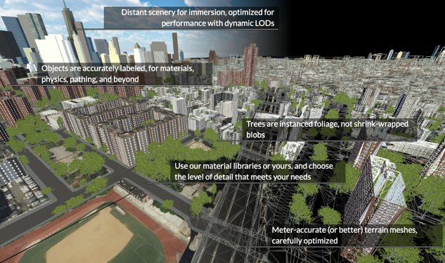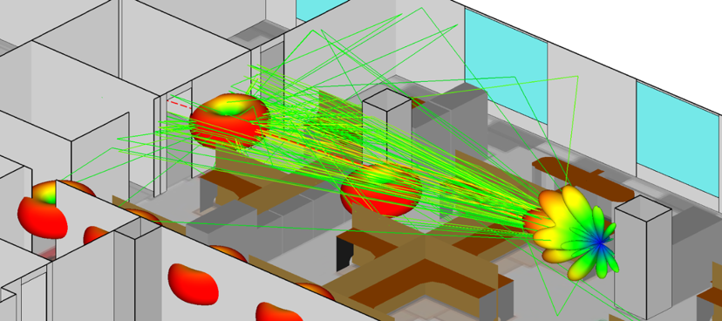

Figure 4 - Left: High definition 3D model of NYC available for advanced simulations (Geopipe Inc.). Right: Raytracing simulation tool for mmWave propagation (Remcom’s Wireless InSite).

The key advantages of mmWave communication are identified in the high bandwidth and narrow antenna beamwidths available, which may be exploited to provide high precision, low latency localization to UAVs. The problem shall be approached considering the recent localization technique for millimeter wave systems proposed in [63]. To make the problem tractable, we will initially assume that the position of the transmitter, as well as the environment configuration, is known. In these cases, without assuming receivers and transmitters within the line of sight, ray-tracing can be employed to provide an estimate of the receiver location. This technique allows to identify potential changes in the environments updating maps without the need for cameras or lasers. The absence of reflection at a given location is an indicator of a change in the environment that allows updating maps in real-time.

In the second stage, we will develop novel approaches to extend localization capabilities in unknown environments using multiple receivers. The problem can be approached in two different ways. In the first alternative, the transmitter can act as a radar and reconstruct the local environment. The use of multiple transmitter can reveal the environment structure reducing the problem to the initial known environment case. A more appealing strategy is related to instantaneous ray-tracing simulations considering the known relative position between the UAVs and updated measurements of AoA, AoD, and ToF. By employing a multipath model that incorporates the additional uncertainty deriving from the fact that the environment is unknown, new knowledge about the environment can be inferred.

To be resilient with respect to localization errors of the mmWave system or to enhance its accuracy and precision, it is possible to integrate the mmWave position information with other sensors available on the robot. Specifically, drones are generally equipped with inertial sensors, cameras, and Laser scanners. These sensors can be used not only to provide prior information to the mmWave localization system as previously specified, but they can be employed as well to generate perception algorithms able to localize the vehicle in the environment. The different information, eventually redundant, about the state of the drones can be fused in a probabilistic manner. To achieve this goal, we need to be able to merge heterogeneous data at different rates. We propose to incorporate the positioning measurement in a multi-rate multi-sensor fusion Kalman filter framework [14] [15]. This approach has the great potential to fuse asynchronous and heterogeneous measurements in terms of characteristics and rate. While, previous works have been proposed used ultra-wideband technology [16], none has investigated the proposed approach and its impact on long-range navigation solutions that the mmWave technology can provide. The use of additional sensors in a Kalman filter framework can help as well to resolve the ray-tracing problem in unknown environments. The proposed approach will provide robustness to the system in terms of autonomous capabilities. Further, another benefit is the ability to exploit the low latency that is provided by the proposed technology. The benefits can be shown with improved transmission latency of critical sensor data, from a platform to a remote untrained user. In this area, we plan study the minimum latency requirements to control the UAVs once the overall perception and control pipelines are outsourced to the cloud.

Evaluation, Experimentation and Validation Plan – Thrust 2
This section should describe how the research concepts proposed will be demonstrated and validated. It should present metrics for success. It should identify critical experiments, and describe how the research will be demonstrated, including through simulation, prototyping, and integration with real (including sub-scale) cyber-physical systems. For Medium and Frontier projects, the validation plan must include experimentation on an actual cyber-physical system.
COSMOS is a joint project involving Rutgers, Columbia and NYU, funded in part by NSF and by the PAWR Industry Consortium. The COSMOS project is aimed at the design, development, and deployment of a city-scale advanced wireless testbed in order to support real-world experimentation on next-generation wireless technologies and applications. The architecture of COSMOS (Cloud Enhanced Open Software Defined Mobile Wireless Testbed for City-Scale Deployment) has a particular focus on ultra-high bandwidth and low latency wireless communication tightly coupled with edge cloud computing. A key feature of the COSMOS platform is the integration of fully-programmable, high-performance software-defined radio nodes with mmWave phased arrays. While there has been significant industrial and academic research, it is only recently that we are seeing commercial-grade mmWave phased arrays suitable for deployment in testbeds. The goal of COSMOS is to offer real-world tests of cutting-edge communication technology and to enable innovative applications. This testbed in upper Manhattan and its unique cloud-enable mmWave testing capabilities are ideal to validate the results of this proposal. According to the COSMOS deployment plan, the final stage of the testbed will be reached by November 2021. We assume that by then suitable mmWave user equipment will be available to allow localization tests within COSMOS.

Current mmWave antennas might not be directly deployed onboard aerial vehicles. These antennas are still heavy, consume relevant power, and cumbersome. In our validation and experimentation process, we plan to mitigate this aspect and validate the localization approaches in several ways. First, we will consider the localization problem in an indoor environment. To support this experimentation, we will have multiple receivers and transmitters with occlusions and collect data which can be re-used to run multiple tests offline. Second, the data will be fused with multi-sensor suites with cameras, laser scanners, and inertial sensors to validate the multi-sensor fusion approaches. Third, we will fly our aerial vehicles in indoor and outdoor spaces, and we will incorporate flight traces and UAV data within our mmWave simulator. This will be used to test the effectiveness of the localization techniques and concurrently identify the flight requirements to guarantee persistent connectivity since the signal is transmitted in narrow, electrically steerable beams.

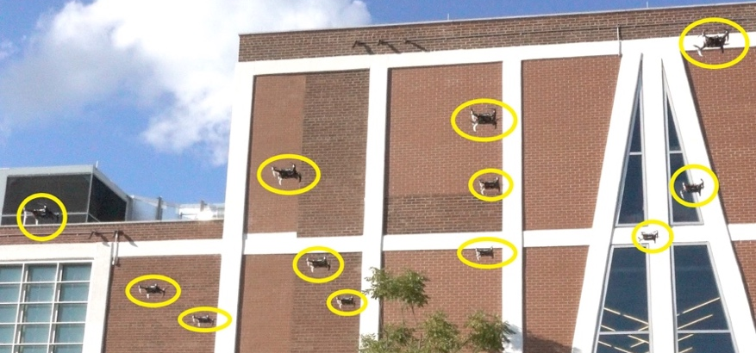
Figure 5 - A fleet of autonomous quadrotors in outdoor environment, implementation of NYU’s Agile Robotics and Perception Lab.

We shall validate this work using the autonomous aerial platform available with onboard sensing and computation at NYU’s Agile Robotics and Perception Lab (ARPL). The quadrotor platform will be used to generate workload data, including traces of transmission of critical time-sensitive data for decentralized cooperative planning and navigation, transmission of high-resolution images and video (e.g. malicious targets, areas of interest, images), and transmission of legacy-band signaling data used in the proposed networking protocols. These traces will be used in simulations with the proposed measurement-based channel models and networking techniques to validate airborne data.

The developed system will be tested and refined by conducting controlled experiments in cooperation with the partnering fire departments before transferring the technology to the end-users and other stakeholders. Our partner, the Fire Department of New York City (FDNY) has 27 acres training facility on Randall’s Island, NY. This training facility has different structures that are used to simulate fires in residential structures, high-rise structures, commercial shops, tunnels/subways, etc. for training purposes. These structures can be easily reconfigured or transformed into various other types of structures. The Fire Research Group at NYU has been working with FDNY for more than a decade and conducted several controlled experiments in these training structures in the previous research studies.

In the proposed study, from the fire service perspective, the team needs to tests the efficacy of UAVs for two tasks (a) exterior size-up (b) interior fire behavior assessment. These experiments/scenarios will be performed in FDNY’s training facility on Randall’s Island. Population density on this island is very low and will allow us to conduct our experiment without disturbing the civilians.

A base station for UAV swarms will be established on Randall’s Island. An emergency will be simulated by triggering a fire alarm in the residential structure at fire academy. The coordinates of location will be provided to the UAV system upon which the swarms will fly to the location. As UAVs arrive at the emergency location and circle around the structure to perform a 360-degree size-up of the situation, their capabilities to collect the data, record fire development indicators, analyze the fire behavior, and transmitting the data in a firefighter-friendly manner will be investigated. Other parameters including but not limited to safe operational distance from the heat and smoke, optimum operational height with respect to the structure of interest, response time, an optimum distance between the swarms for effective communication will be quantified with the help of inputs from fire service partners. Such scenario will be repeated for different types of structures at the fire academy which will create huge amount of data that will enable us in making our algorithms and machine learning models more accurate and reliable for exterior size-up task.

Interior fire behavior assessment by UAVs can be more challenging primarily due to the heat and smoke present inside the structure. A fire in a residential structure constitutes a neutral plane above which the heat and combustion gases are exhausted, and below it fresh air is drawn into the structure. When firefighters enter the structure for search and rescue or fire extinguishment, they crawl below the neutral plane where conditions are tenable. Our “non-human firefighters” - the UAVs - will be programmed to navigate throughout the structure at a floor level and depict the fire environment. The thermal resistance of UAVs mostly depends on the materials used, its design, and the enclosure which is not a part of an investigation in this proposal. Therefore, in order to avoid the failure of UAVs solely due to heat inside the structure, we will not create a real fire. Rather, emergency situations will be developed by simulating different fire scenarios (such as kitchen fire, basement fire, attic fire, etc.). Mannequins as trapped victims will be placed at different locations inside the structure. Floor collapse or failure of the wall will be simulated by removing the support elements. Several high-temperature surfaces will be placed above the neutral plane to quantify the capability of thermal imaging cameras installed on the UAVs. As UAVs navigate throughout the structure, their capabilities to perform real-time mapping of inside environment, floor layout and other obstacles, recognizing the wall/floor collapse, location of trapped victims, heat signatures or location of the fire will be quantified. Tests including multiple scenarios in various types of structures will ensure efficient sensing, communication, and coordination between multiple UAVs.

Project Management and Collaboration Plan
This section should summarize how the project team is appropriate to realize the project goals and how the team will assure effective collaboration. It should provide a compelling rationale for any multi-institution structure of the project, if appropriate. The plan should identify organizational responsibilities and how the project will be managed, including approaches for meeting project goals. Specific information should include: 1) the specific roles of the project participants in all involved organizations; 2) information on how the project will be managed across all the investigators, institutions, and/or disciplines; 3) approaches for integration of research components throughout the project and, 4) identification of the specific coordination mechanisms that will enable cross-investigator, cross- institution, and/or cross-discipline scientific integration. In the case of Frontier projects, the plan should also identify a single individual who will be responsible for executing the management and collaboration plan, identify any specific roles for, and the amount of the budget to be allocated for project administration. Frontier projects must also include a kick-off meeting with all participants in coordination with NSF, as well as at least annual in-progress meetings with NSF. For Frontier projects, PIs and all co-PIs must be present in-person for the kick-off meeting. NSF also strongly prefers that PIs and all co-PIs for each Frontier project (including collaborative projects) be present in-person for annual in-progress meetings.

Prof. Rappaport will be the Lead PI and is the official leader of the project. He will meet regularly with Co-PIs in intervals of 3 months to discuss main research steps and to ensure the overall progress of the project. Based on the objectives of this proposal, the Principal Investigators will take the responsible roles for their respective research expertise as follows:

mmW Theodore S. Rappaport NYU Wireless
FIRE Sunil Kumar NYU Fire Research
UAV Giuseppe Loianno NYU Agile Robotics and Perception Lab
ML Dennis Shasha NYU Courant Computer Science, NYU Wireless

The PIs are active in research, especially in mmWave communications, fire engineering, applied machine learning and UAV swarms. The PIs plan to have quarterly research exchanges, which can be conveniently scheduled given the proximity in New York. They will be invited to attend annual Brooklyn 5G Summit, co-organized by PI Rappaport’s NYU Wireless and Nokia Research. The project work will be showcased at this 5G summit which is attended by leading researchers in wireless communications around the world, including invitees from academia and industry.

For an additional support of the interactions within the project and to enhance the interdisciplinary success of this project, Prof. Rappaport will be assisted by Dr. Mahler, a Smart Cities Postdoc affiliated to both NYU Wireless and NYU’s Center for Urban Science and Progress (CUSP). CUSP is an interdisciplinary research center dedicated to the application of science, technology, engineering, and mathematics in the service of urban communities across the globe. To benefit the city and other partners, NYU CUSP’s research is both mission- and impact-oriented. The interdisciplinary research teams bring together experts in the physical and natural sciences, computer and data science, the social sciences, engineering, and professional fields such as policy, design, and finance. Dr. Mahler has numerous years of experience leading interdisciplinary teams in applied research projects. He will be effective in the proposed research project by regularly meeting with the PhD students envisioned for this project. We envision bi-weekly meetings with all students and additional individual meetings as needed. He will report to the Lead PI, all Co-PIs, and fire department partners on a monthly basis.

To ensure the interdisciplinary character of the envisioned work, all 5 PhD students will be co-advised by multiple Co-PIs. Although each PhD student is affiliated with one of the Co-PI’s field of experience (see below in bold), the students are expected to seek advice from multiple Co-PIs, as indicated with % in brackets:

- UAV Swarm Mission (UAV 40%, FIRE 50%, mmWave 10%) Thrust 1 and 2
- Distributed ML solutions (ML 60%, mmWave 20%, UAV 20%) Thrust 1 and 2
- Localization and UAV control (mmWave 60%, UAV 40%) Thrust 2 and 3
- Real-time 3D Raytracing, Beam Selection (mmWave 60%, ML 40%) Thrust 2 and 3
- 5G and Firefighter Validation (FIRE 50%, mmWave 50%) Thrust 1 and 3

Based on their work assignment, each PhD student is associated with two of the Thrusts defined in the proposed research project.

In summary, the success of the proposed project will be ensured based on the following components:

- Clear definition of specific roles among the project participants and dedicated leaders
- Dedicated Co-PI for coordination of research and interdisciplinary success of project
- Co-advice of PhD students by multiple PIs with a clear set of expectations
- Proximity on NYU campus in Brooklyn and also to other participants/facilities in NYC
- Established personal relationships between participants and also with the supporters
- Commitment, support, and active involvement of the end users – the fire departments of New York, Chicago, Bloomington (MN), Houston, Los Angeles to ensure the applicability of the proposed study to nationwide first responders.

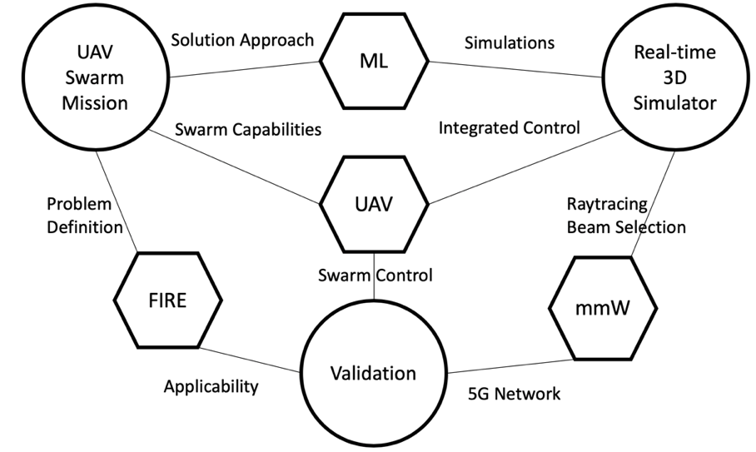
Figure 3 – Diagram displaying the relationship between fields of expertise and research thrusts.

Broader Impacts
In addition to the specific information required in the PAPPG, this section should provide plans for integrating research outcomes into education and more broadly advancing CPS education. It should also describe how the research and education outcomes will be disseminated in a manner that enables the CPS research community and others to use the results in ways that go beyond traditional academic publications. For Frontier proposals, the education and outreach discussion should be described within a separate subsection titled Education and Outreach Plan, within Broader Impacts, and must provide significant detail on the planned activities to explain how it will have meaningful impact.
The initial 5G market rollout has started and will continue in phases over the next years according to 3GPP releases. Market analysts see the US as the worldwide prime market for 5G mmWave, mainly due to its high traffic density, a high average revenue per user and a shortage of spectrum in the 3.5 GHz range [80]. It is evident that network operators will deploy 5G mmWave base stations in areas where they expect the largest need for high capacity of mobile communication, i.e. the best business case. Consequently, mmWave deployments can be expected at hotspots in dense urban areas and in crowded indoor environments, such as airports, shopping mall etc. Later deployments may involve smart factories, office buildings or mmWave small cells mounted for instance on lampposts along busy streets in downtown areas with high buildings. The broad impact of this proposal and its core technology comes from the fact that the most probable areas for mmWave deployment have limited reliance and poor accuracy of GPS. Thus, smartphone applications and other 5G user equipment would gain tremendously from a reliable and highly accurate localization solution. Not only would mmWave-based localization enable new location-based services or help humans to better navigate through labyrinthine areas. It would also improve mmWave beam-tracking itself with exact position estimates for ML-based beam-selection, which has the potential to reliably maintain mmWave connectivity in dynamic scenarios by exploiting situational awareness and predicting ideal beam-steering strategies.

Generally, autonomous vehicles are in need of reliable and accurate localization systems. While autonomous positioning capabilities should not be dependent on the availability of mmWave infrastructure, autonomous vehicles would gain enormously from an urban infrastructure that combines mmWave connectivity with mmWave localization. Such system could drastically improve safety due to a redundant localization solution and in addition could increase autonomous perception capabilities through low-latency exchange of high definition sensor data. Also, due to the directionality of mmWave beams, security aspects (spoofing, jamming etc.) can be tackled on a Physical Layer level with novel approaches.

Robust localization based on mmWave can be a key enabler for aerial vehicles in dense urban environments. Companies like Uber Elevate and Volocopter foresee future urban transportation systems that move people using aerial vehicles, so-called urban air mobility. Safety of these systems is the most important objective enabling these ambitious services, and reliable localization is a key technology in that respect. Although it remains unclear whether we will ever see these advanced applications, we know that UAVs are already supporting public safety forces today, in disaster responses and law enforcement operations. To our understanding, UAV swarms for firefighter operations have the most urgent need for the technology of this proposal.

Each year, structure fires cause more than 50% Line-of-Duty-Deaths (LODD) and fire-ground injuries of firefighters. Structural collapse caused 180 firefighter deaths between 1979 and 2002, of which one-third occurred in residential structures [81]. As recommended by NIOSH firefighter fatality investigation reports, fire service needs efficient tools that can improve their situational awareness and assist them with the strategic decision-making process on the fire-ground. Rapidly advancing capabilities of Machine Learning techniques, enhancements in communication & network platforms due to 5G mmWave inventions, the decreasing cost of UAVs, increasing ease to operate them with vast varieties of sensors makes it an ideal technology for fire service. For example, in 2018, there were more than 2.8 million false alarms (more than twice the actual fire-incident calls) [2]. ML-trained UAVs can fly to the incident location, perform an early reconnaissance for the firefighters to assess the emergency. In case of a false alarm, this obviates the waste of fire department’s effort, time, and money allowing firefighters to respond to actual fire incidents efficiently. As per the officials from UAS & Robotics Program at FDNY, even if the proposed technology helps the FDNY to reduce 50% of false alarms in NYC, the return on investment (project funding) can be achieved in the first year of implementation. Other nationwide fire departments will follow FDNY’s lead and their early adoption will be the nucleus upon which interest within the community of nationwide firefighters will be built.

As mentioned in the letter of support from FDNY, their current GPS enabled drone program has numerous issues related to the accuracy and reliability of communication, wireless positioning, manual controls, etc. that can be eliminated by the technology proposed in this proposal. The support and commitment from career and volunteer fire departments from various parts of the nation (LA, Chicago, Houston, Bloomington) will significantly improve the applicability of the proposed study to first responders nationwide. The present proposal can have a huge impact on the safety of civilians, firefighters, and property. The NYU Fire Research Group shares a strong bond with fire departments, and the current project represents a significant commitment from them and other research centers at NYU. The Fire Research Group at NYU has proven experience of translating the fire research into real-life practice.

The undergraduate and graduate students from various NYU schools and centers will be part of the research team. The present proposal is unique, timely and multi-disciplinary. Various aspects of the present research can be part of their senior design projects, M.Sc./Ph.D. thesis, or summer research internships. The faculties involved in the projects teach several graduate and undergraduate level subjects in which various critical concepts learned from proposed can be integrated and become part of the educational curriculum.

